

**ABOUT COMPANY**

|  |  |
| --- | --- |
| **1. ABOUT COMPANY**  header | |
| COMPANY NAME | Dynamic Dreamz |
| COMPANY ADDRESS | 3rd Floor, Tirupati Chambers, Opp. Sub Jail, Ring Road, Surat-  395002 |
| COMPANY CEO | Mr. Virag Shah  Mr. Gaurav Shah |
| EMAIL | [info@dynamicdreamz.com](mailto:info@dynamicdreamz.com) |
| CONTACT NO. | +91-9327642007 |
| **DYNAMIC DREAMZ** is Software Company. We run Web Designing and Software Development. We develop different types of Software on the platform of PHP and different SCRIPT languages. The foundation was laid by Mr. Virag Shah and Mr. Gaurav Shah. We deliver cost effective and reliable solutions worldwide. Our expertise in IT in General and Software in particular is our competitive edge.  We are not just another Software Development Company or Web Design Company-We are Analysts. We know that success involves a lot more than just being competent in a specific language or Application Development Tool. Our success comes from analysis and specification, perfectly established Test-Driven Development process, Export Management and strong experience with the latest technologies. We are a Software Company dedicated to quality, a company that will always give you our money’s worth.  Advancing beyond the conventional project by project model, We provide clients with Full-Time resources on a long term basis. A dedicated development team of more than 7, headed by Mr. Sanket Patel. Using a dedicated team, we will get access to specific skills, gain better control over the entire software and have the accumulated expertise transferred back in-House. | |

* WEBSITE DESIGNING

We are specialized in developing website’s work. We have the proven experience and expertise in designing website that success by bringing in Enquiries, which generate sales and are an asset to your business. As a website design company we offer Full-Circle approach in website design & web development. Our website designing services cover Strategic Planning, Business Intelligence, Creative, Application Development, Product/Service Promotion and Solution Maintenance.

* SOFTWARE DEVELOPMENT

Our ability to help you go beyond writing code. We are great at designing user interfaces and defining product features. Our teams significant experience in both products and services allow us to make suggestions of your product plans. We are also highly capable of producing great Technical Documentation to satisfy internal or external customers. We have history of successful communication and work with our customers. Overall the structure is tailored to provide cost effectiveness and flexibility, which enables us to promptly respond to rapidly changing plans and requirement of our customers.



**PROJECT PROFILE**

|  |  |
| --- | --- |
| **2. PROJECT PROFILE** | |
| PROJECT TITLE | B2B Portal |
| PROJECT DURATION | 1st Jan 2012 to 1st Jun 2012 |
| TEAM SIZE | 2 People |
| PROJECT PROGRAMMERS | Mr. Viral S. Patel  Ms. Pooja S. Mevada |
| COMPANY NAME | Dynamic Dreamz |
| PURPOSE | Provides immense knowledge about the products one wishes to  buy or sell through or give information regarding their products, profiles, services etc. |
| PLATFORM | Windows 7 |
| FRONT – END | PHP |
| BACK – END | MY-SQL |
| EXTERNAL GUIDE | Mr. Sanket S. Patel & Miss. Dency Modi |
| INTERNAL GUIDE | Miss. Arti Chauhan |
| SUBMITTED TO | Bhagwan Mahavir College Of Management (MCA), Surat. |
|  | |



**ENVIRONMENT SPECIFICATIONS**

|  |  |
| --- | --- |
| **3. ENVIRONMENT SPECIFICATIONS**   * 1. **HARDWARE SPECIFICATIONS** :   PC with 2 GB hard-disk and 256 MB RAM.   * 1. **SOFTWARE SPECIFICATIONS** : | |
| Windows 7/98/XP with MS-office | Operating system developed by the global giant Microsoft. An operating system can be understood as a software program designed to facilitate the communication between computer hardware and  software. |
| Front - end : Adobe Dreamweaver for PHP | This is necessary for developing PHP coding. |
| Back - end : WAMP SERVER (Apache, PHP, MY-SQL) | MySQL the most popular Open Source SQL database management system. It is very fast,  reliable, and easy to use. |
| **3.3 THIRD PARTY TOOLS :**  Edraw Max : Edraw helps to create professional-looking diagrams such as flowcharts, organizational charts, network diagrams, business diagrams and more for understanding, documenting and analyzing information and presenting. | |

## 3.4 TECHNOLOGY USED :

* **PHP Language:**

PHP means hypertext pre processor programming language, is a widely used open source general-purpose scripting language that is especially suited for web development and can be embedded into HTML. PHP files can contain text, HTML tags and scripts. PHP files are returned to the browser as plain HTML. PHP files have a file extension of “.php”, “.php3”, or “.phtml”. PHP is a server-side scripting language. PHP scripts are executed on the server. PHP supports many databases (MYSQL, Informix, Oracle, Sybase, Solid, PostgreSQL, Generic ODBC, etc.) PHP is an open source software. PHP is free to download and use.

## MySQL:

MySQL is a database server. MySQL is ideal for both small and large applications. MySQL supports standard SQL. MySQL compiles on a number of platforms. MySQL is free to download and use. PHP combined with MySQL are cross-platform (we can develop in windows and serve on a Unix platform). MySQL is currently the most popular open source database server in existence. On top of that, it is very commonly used in conjunction with php scripts to create powerful and dynamic server-side applications.

## JavaScript:

JavaScript lets us to create documents that run over the internet. Using JavaScript, we can create Dynamic HTML pages that process user input and maintain persistent data using special objects, files and relational databases. We can build applications ranging from internal corporate information management and intranet publishing to Mass-Market Electronic Transactions and Commerce. Through JavaScript’s live connect functionality, our applications can access Java and CORBA distributed object applications.

The Javascript language is relatively easy to learn and comprises of syntax that is close to English. It uses the DOM model that provides plenty of prewritten functionality to the various objects on pages making it a breeze to develop a script to solve a custom purpose. As the code is executed on the user's computer, results and processing is completed almost instantly depending on the task (tasks in javascript on web pages are usually simple so as to prevent being a memory hog) as it does not need to be processed in the site's web server and sent back to the user consuming local as well as server bandwidth.

You can validate user input before sending the page off to the server. This saves server traffic, which means fewer loads on your server. They don't have to wait for a page reload to see if they have forgotten to enter something.You can create interfaces that react when the user hovers over them with a mouse or activates them via the keyboard.You can use JavaScript to include such items as drag-and-drop components and sliders to give a Rich Interface to your site visitors.

## JQuery:

jQuery is a coding language that is a branch from JavaScript. jQuery works like JavaScript where its used to help with interaction and effects with your development code. jQuery hasn’t been around very long, it was released in January 2006 and only on version 1.4.0. jQuery is a new and exciting technology that is catching on quickly and making the internet more interactive and enjoyable.

jQuery is great library for developing ajax based application. jQuery is great library for the JavaScript programmers, which simplifies the development of web applications. You can use jQuery to develop cool web 2.0 applications. jQuery helps the programmers to keep code simple and concise. The jQuery library is designed to keep the things very simple and reusable.

It is [free, open source software,](http://en.wikipedia.org/wiki/Free_and_open_source_software) [dual-licensed](http://en.wikipedia.org/wiki/Dual-licensing) under the [MIT License](http://en.wikipedia.org/wiki/MIT_License) or the [GNU General](http://en.wikipedia.org/wiki/GNU_General_Public_License_Version_2) [Public License, Version 2](http://en.wikipedia.org/wiki/GNU_General_Public_License_Version_2). jQuery's syntax is designed to make it easier to navigate a document, select [DOM](http://en.wikipedia.org/wiki/Document_Object_Model) elements, create [animations](http://en.wikipedia.org/wiki/Animation), handle [events](http://en.wikipedia.org/wiki/Event_(computing)), and develop [Ajax](http://en.wikipedia.org/wiki/Ajax_(programming)) [applications](http://en.wikipedia.org/wiki/Ajax_(programming)).

jQuery also provides capabilities for developers to create [plug-ins](http://en.wikipedia.org/wiki/Plug-in_(computing)) on top of the JavaScript library. This enables developers to create [abstractions](http://en.wikipedia.org/wiki/Abstraction_(computer_science)) for low-level interaction and animation, advanced effects and high-level, theme-able widgets. The modular approach to the jQuery library allows the creation of powerful [dynamic web pages](http://en.wikipedia.org/wiki/Dynamic_web_page) and web applications.

You can use simple JavaScript to perform all the functions that jQuery provides. Then why use jQuery? The jQuery library is providing many easy to use functions and methods to make rich applications. These functions are very easy to learn and even a designer can learn it fast. Due to these features jQuery is very popular and in high demand among the developers.

You can use jQuery in all the web based applications irrespective of the technology.

The best featuring for jQuery is the effects you can accomplish, with less code than what it would take with JavaScript. Most common jQuery effects are drop down menus, drag and drop elements, animations and form validation. Developers have also connected this with other coding languages like JSP, ASP, PHP and CGI.

jQuery is almost like a type of framework you can work off of. You download a package from the internet and then install a library of scripts on your server. This library has jQuery function that you can embed to your scripts. This will help you keep the file size down, create scripts faster and keep your code smaller.

* **AJAX (ASYNCHRONOUS JAVASCRIPT AND XML)**

AJAX is a technique for creating fast and dynamic web pages. AJAX allows web pages to be updated asynchronously by exchanging small amounts of data with the server behind the scenes. This means that it is possible to update parts of a web page, without reloading the whole page.

Classic web pages, (which do not use AJAX) must reload the entire page if the content should change. Examples of applications using AJAX: Google Maps, Gmail, Youtube, and Facebook tabs.

AJAX is based on internet standards, and uses a combination of:

* + XMLHttpRequest object (to exchange data asynchronously with a server)
  + JavaScript/DOM (to display/interact with the information)
  + CSS (to style the data)
  + XML (often used as the format for transferring data) AJAX applications are browser and platform independent

AJAX allows intuitive and natural user interaction, wherein no clicking is required and Mouse movement is a sufficient event trigger. "Partial screen update" replaces the "click, wait, and refresh" user interaction model. Only user interface elements that contain new information are updated asynchronously (no interruption to user operation). The rest of the user interface remains displayed without interruption (no loss of operational context). It is Data-driven (as opposed to page-driven). The UI is handled in the client while the server provides data

The Asynchronous communication replaces "synchronous request/response model". A user can continue to use the application while the client program requests information from the server in the background. Thus, it separates the displaying from data fetching.

AJAX provides real-time server-side input form data validation for User IDs, serial numbers, postal codes and it removes the need to have validation logic at both client side for user responsiveness and at server side for security and other reasons.

AJAX provides auto-completion for email address, name, or city name as the user types. Also, based on a user selection, more detailed information can be fetched and displayed. It even provides advanced GUI widgets and controls, such as tree controls, menus, and progress bars, that do not require page refreshes.



**SYSTEM DESCRIPTION**

* 1. **INTRODUCTION**

# SYSTEM DESCRIPTION

Portal (fiction), a magical or technological doorway that connects two different locations in time or space. B2B Portal is a “platform” where manufacturers, suppliers, distributors and exporters meet through with the help of search engines. Search Engines are basically a web tool designed to search for information on the world wide web. “B2B Portal” meaning information or databases of “business to business” marketing. B2B Portal is the hub of marketing tools through which search engine scrolls databases available on the net. B2B Portal therefore provides immense knowledge about the products one wishes to buy or sell through or give information regarding their products, profiles, services etc. B2B Portal offers wide benefits to the manufacturers, suppliers, buyers, exporters as well as importers.

* + PROBLEM SUMMARY

In many countries, there is a huge price difference of products from conception to the reach of the customer. Also in many commodity related products, farmers & production sources are exploited by a chain of middlemen. To address these problems Business to Business (B2B) websites have been formed. There are several B2B websites who claim to have the largest business databases in the world. But all of them are concentrating only on high scale industries that can fetch them money through memberships. The problem still exists for the lower sized companies. Also they are limited by the boundaries and are not providing much of global trading. There are deviating from their main purpose of serving the micro and small scale industries. Price difference still exists high in the market.

* + SOLUTION AND VALUE PROPOSITION

Our project has proposed a solution to bridge the gap between the buyer and the seller, replacing several middlemen. Its user friendly website and features enable even a farmer to obtain the best benefits by selling his commodities. It emphasizes more on cutting down the costs of the products in the market benefiting both the buyer and seller. It is to be noted that comparison of products always reduces prices. So buyers are exposed to a wide variety of products based on their price range and quality on our website. They can make a wise choice by selecting their desired product.



* 1. **FEATURES**

FRONT END FEATURES :

* Multilevel categories for convenient browsing
* Category ordering can be defined by admin or set to alphabetic
* Product Catalog
* Company profiles
* Sell Offers
* Buy Offer
* Image gallery for products, sell offers and buy offers
* Logo uploading for company profiles
* Trade alerts in email
* Complete internal messaging
* Inbox for messages
* Contact list
* Block list
* Contact seller/buyer
* Three membership levels : Gold, Silver and Bronze
* Access rights of each level are configurable from the admin panel
* Maintain company profile
* Post/Edit/Remove/Relist sell offers, buy offers, catalog items
* editor for HTML formatted item description
* Front page display and special exposure to gold member listings
* Advanced search
* Search based on keywords, categories, posting dates, etc.
* Front page display for listing categories and Gold member listings
* Inquire about multiple product
* Inquiry basket
* Site usage stats
* Extensive Members control panel
* Contact us form for getting feedback from visitors
* Favorite list management system
* Email verification (Can be switched on/off from admin panel)
* Password retrieval system
* In built ad management system
* Support for ads.



ADMIN PANEL FEATURES :

* Recent stats for offers posted today, yesterday and in last 7 days
* Similar stats are available for catalog items, profiles and new signups
* Categories management console (multilevel)
* Add / edit / remove categories
* Category ordering for display on front end
* Shift listings from one category to another.
* Highly configurable site parameters.
* Highly configurable layout parameters
* Full control over site color scheme (directly from admin panel)
* Create / Edit / Save as many color schemes as you like
* Fully customizable graphic elements (directly from admin panel)
* Create / Edit / Save as many icon sets as you like
* Switch ON-OFF email verification process
* Configure all outgoing emails
* Cleanup routines
* Configure fees for different membership levels
* Extensive member management console
* View/Edit/Delete Members
* Search members
* Manage currencies
* Bad word filter
* Extensive catalog management console
* Search/edit/delete/approve products in catalog
* Extensive company profile management console
* Search/view/edit/approve company profiles
* Extensive buy offers management console
* Search/edit/delete/approve buy offers
* Extensive sell offers management console
* Search/edit/delete/approve sell offers
* Search/edit/delete messages sent through site
* Visitor feedbacks section
* Support for banner ads, text ads and affiliate ads
* Admin can Add/Edit/Delete/Approve/Disapprove any ad

## BENEFITS

* One stop marketplace for sellers and buyers.
* Makes Trading more easy and convenient.
* Provides better opportunity for manufacturers, suppliers and convenient shopping for buyers.
* Time saving and fastest mode of trading through online.
* Cost saving and reduce elevated cost.
* Increase sale volume by providing various online trading tools by web portals.
* Increase productivity and hence generate revenue to the company by providing techniques and more advanced method of online trading.

Therefore, B2B Portal is a huge market hub for manufacturers, buyers, suppliers, importers and exporters. This provides an opportunity to trade better and avail new businesses or services by just browsing sites through online.

Business nowadays involves many more complexities and intricacies includes Govt Rules & Regulations, Country Trading Laws, EXIM Policy and Other Trade Laws & Associations. So, business opportunities becomes very essential as it saves time and helps in avoiding business complexities.



**PROJECT PLANNING**

# PROJECT PLANNING

* 1. **PROCESS MODEL** : INCREMENTAL MODEL

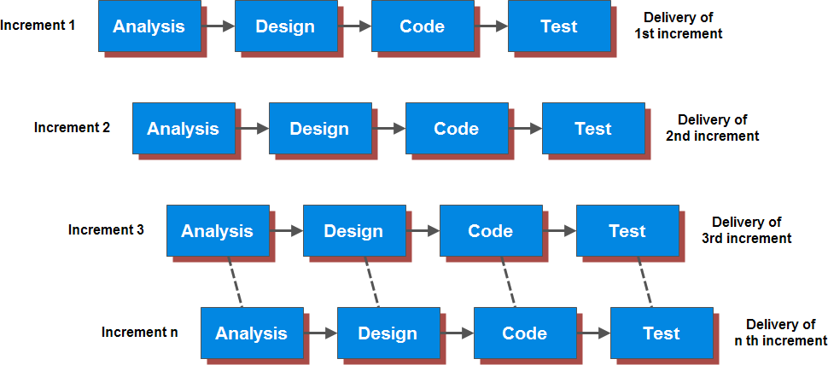

Fig. 5.1 INCREMENTAL PROCESS MODEL

The incremental model combines elements of linear and parallel process flows. Each linear sequence produces deliverable increments of the software in a manner that is similar to the increments produced by an evolutionary process flow.

CHARACTERISTICS :

* Specification, design and implementation broken into small increment.
* Hybrid model which combines waterfall and evolutionary paradigms.
* Highest priority requirements tackled early.

STRENGTH :

* More flexible rather than waterfall process.
* Expand later version of software.
* Develop high risk of business features.
* Customers can respond to each build.
* Lower initial delivery cost.
* Initial product delivery is faster.
* Risks of changing requirements are reduced.
* All requirements are gathered for software.
* More spending money for workers in each small increment.
* Mapping requirements not easily.

WEAKNESS :

* All requirements are gathered for software.
* More spending money for workers in each small increment.
* Mapping requirements not easily.

APPLICABILITY :

* For word processing software.
* When it is possible to develop the software part by part.
* On a project with a new technology.
* On a project which have length development schedules.
* A need to get basic functionality early.
  1. **SCOPE & OBJECTIVES**

B2B portals have helped the sellers reach their targeted buyers. Internet has made the world a global village wherein sellers and buyers meet over the net from across the globe.

Substantial growth of B2B portals all over the World augments the Global sales through cross border enquiries. With the popularity of internet throughout the world, reaching every house, hardly you will find anyone who isn’t making use of it. Indian b2b portal have therefore become very popular as it is a common place on the internet where Indian manufacturer, suppliers, distributors get to know each other needs, get an idea of the current market scenario. Indian b2b portal have become a major marketing tool and every distributor, manufacturer, supplier want to make full use of it. It has become a perfect place for all the trading purposes which can be done with minimum effort. It is the ease of use and convenience which has made Indian b2b portal a very popular place. We live in a world where time is considered as money and b2b portals enables you to save your precious time thereby saving your hard earned money. By making use of new advanced trading methods and time efficient steps is helps in generating revenue and also adds productivity. B2B trading has completely changed the way trading was done; it has brought efficiency in every aspect of trading. This was one of the major hurdles Indian manufacturer faced and lagged from international competitors but with the emergence of Indian B2B portals, there is greater scope to the manufacturers to cater to suppliers, distributors not just in India but throughout the world. It totally eliminates business complexities and enables you to crack deals with large business houses, dealers, importers, exporters, suppliers. Indian b2b portal can make full use of the untapped corners of India by displaying products on the internet thereby inviting manufacturers, dealers, importers and exporters to go through various available products. It has provided a far wider platform ranging from one corner of the world to the other. By registering in b2b portal, an Indian manufacturer can give a full detailed description about the products he has to offer. This will make others to check out the various products thereby making trading reach more and more people. With a price and minimum order for every product on display makes things systematic and gives a very positive impression on clients. This process is hugely gaining popularity and will give your business a sure shot success. B2b sellers numbers are on a rise because of the huge profit margins one can gains. Right from apparels, machinery, electronic goods, engineering machinery, health and beauty products, food and beverage, construction and real estate, mineral ns metals, sports and entertainment, office supplies and many more. The advantage with b2b online trading is its user friendliness and fast paced trading techniques. You can directly link to any Indian manufacturer eliminating middlemen thereby lowering prices on every product.

A Work Portal which contains the following detailed modules which itself describes it's scope and objective.

* + - Account Management System
    - Product categories and services System
    - sale offer and buy offer System
    - Communication System
    - Search System
    - Help System
    - Advertising System

## FEASIBILITY REPORT

All projects are feasible, provided that unlimited resources and infinite time are available. However, in the world that can sound like a dream. Especially computer based systems are likely to be bound by limited resources as well as time. Feasibility and risk analysis is related in many ways. If the risk is great than feasibility of producing quality software is reduced. During system engineering we concentrated our attention on three primary areas of interest.

* + - OPERATIONAL FEASIBILITY

There are two aspects to the operational feasibility of a system. One aspect is that of technical performance and the other is acceptance. Technical performances determine whether a system can provide correct and timely information at the required place to the organization personnel. Computerizing the existing system manual system and make it user friendly.

* + - TECHNICAL FEASIBILITY

This technical feasibility study of a system determines whether the technology needed for the proposed system is available and this technology can be integrated into the organization. Technical evaluation must also access whether the existing system can be upgraded to use the new technology and whether the organization has the expertise to use it. The organization is already well-equipped width the required hardware and software.

* + - FINANCIAL AND ECONOMICAL FEASIBILITY

The economic feasibility needs to be checked the study must determine whether the project goals can be achieved within the resource limits allocates to it. It must also determine whether it is worthwhile to proceed with the project at all or whether the benefits obtained from the new system are not worth the cost. In case of computerized system the above expenses are reduced on the longer scale. If the system is computerized the expenses of the telephone, stationary and register are totally to computerization. Firstly the money required is high but if we compare the monthly expenses for long period, it is found that we required very less amount then previous.



**RISK ANALISIS**

# RISK ANALISIS

Introduction of risk is very necessary before technical work initiate. We have described following type of risk, management stage. Some of the major risk discovered by our team during system analysis and the measures taken to prevent them are as under.

* + - Risk associated with the inability to meet the deadline.

Our deadline was predefined, so we limited the scope of our project in such a way that we could realistically meet the deadline. Existing system provided number of services but we limited ourselves to achieving the specific. We aim to improve these basic services to the optimum rather than covering all the services and providing the product with no measures of quality.

* + - Risk associated with technical failure.

Since technology used is open source and not continuously changes so technical risk in future is minimal. Risk is a potential problem- it may occur, it might be not. But regards of the outcome, it’s a good practice to identify the risks, access its probability of occurrence, estimate it impact, and develop a plan to manage these risks should they become a reality. We adopted proactive measures to prevent the risks from becoming the reality.

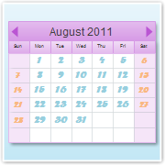

**PROJECT SCHEDULING**

# PROJECT SCHEDULING

**7.1 SYSTEM WORK FLOW** : DATA FLOW DIAGRAM

A data flow diagram (DFD) shows the functional relationships of the values computed by a system, including input values, output values & internal data stores. A data flow diagram is a graph showing the flow of data values from their sources in objects through processes that transform them to their destinations in other objects. A data flow diagram does not show control information, such as the time at which processes are executed or decisions among alternate data paths; this information belongs to the dynamic model. A data flow diagram does not show the organization of values into objects; this information belongs to the object model.

A data flow diagram contains processes that transform data, data flows that move data, actor objects that produce & data store objects that store data passively.

Process

Actor

Data Flow

Data Store

Fig. 7.1 : CONTEXT LEVEL

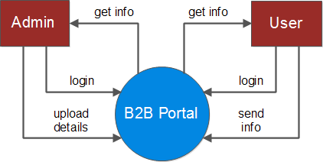

Fig. 7.2 : 1st LEVEL DFD FOR USER

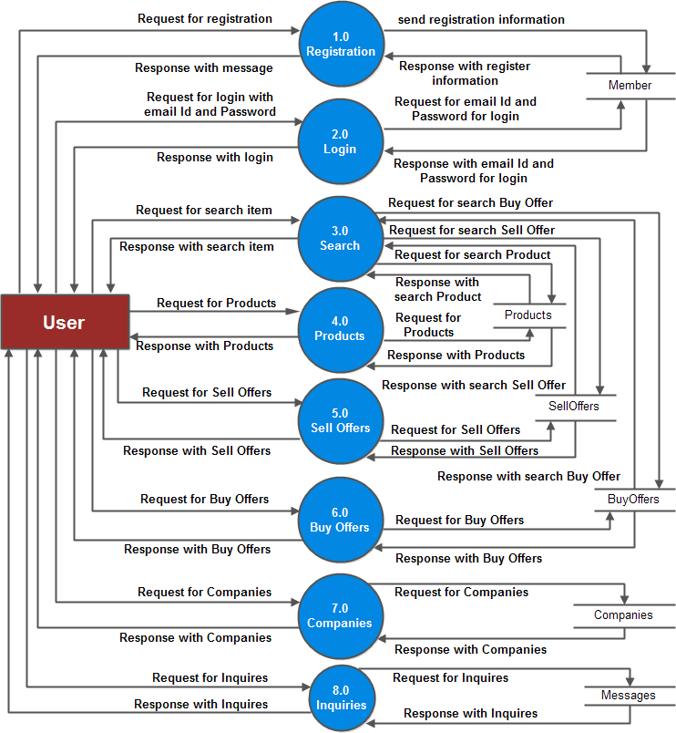

Fig. 7.3 : 1st LEVEL DFD FOR ADMIN

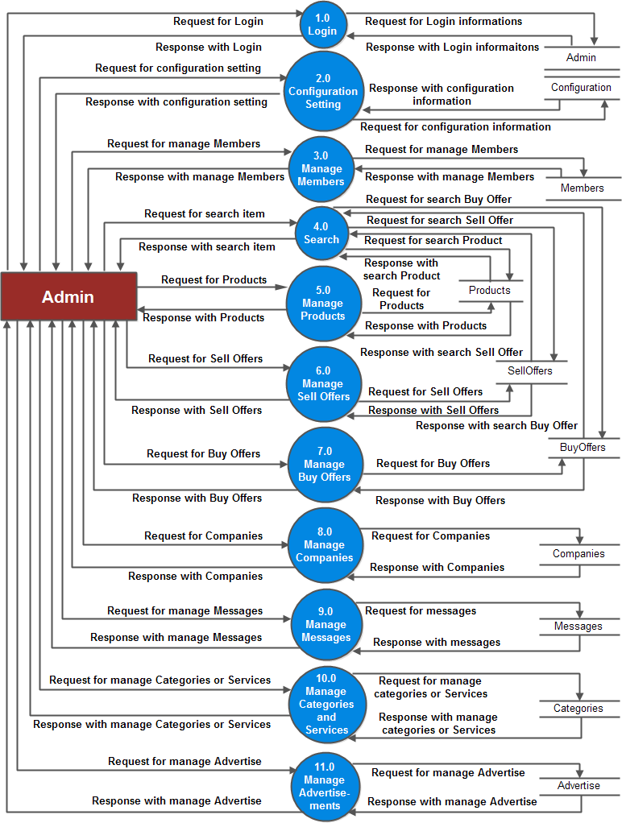

Fig. 7.4 : 2nd LEVEL FOR USER REGISTRATION

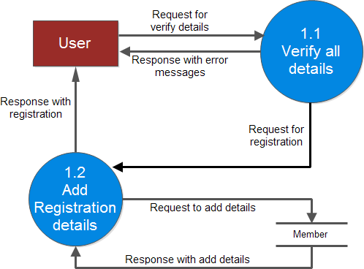

Fig. 7.5 : 2nd LEVEL DFD FOR USER LOGIN

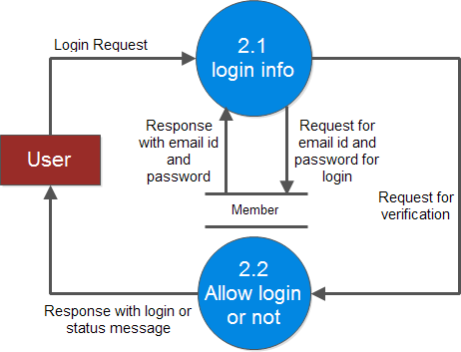

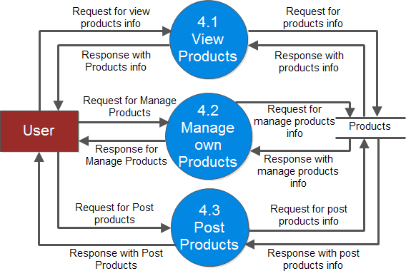Fig. 7.6 : 2nd LEVEL DFD FOR PRODUCTS

Fig. 7.7 : 2nd LEVEL DFD FOR SELL OFFERS

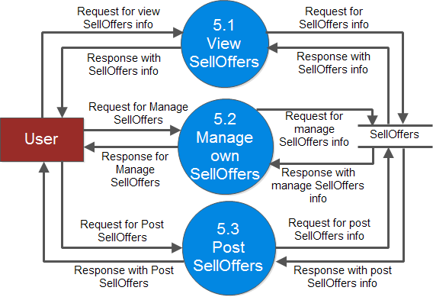

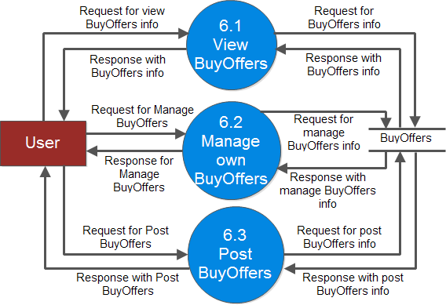Fig. 7.8 : 2nd LEVEL DFD FOR BUY OFFERS

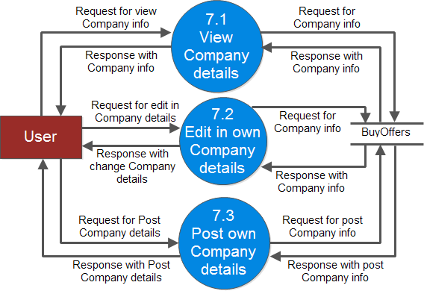Fig. 7.9 : 2nd LEVEL DFD FOR COMPANIES

Fig. 7.10 : 2nd LEVEL DFD FOR USER INQUIRIES

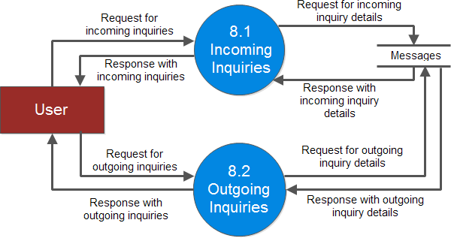

Fig. 7.11 : 2nd LEVEL DFD FOR ADMIN LOGIN

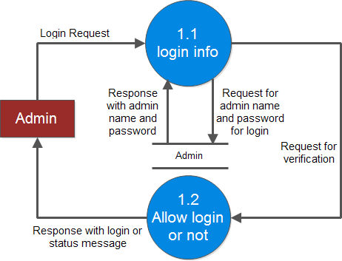

Fig. 7.12 : 2nd LEVEL DFD FOR MANAGE MEMBERS BY ADMIN

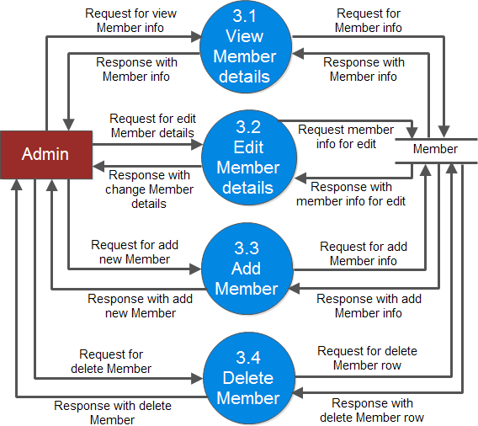

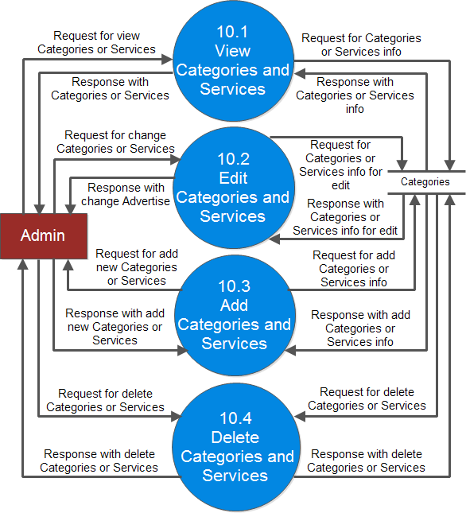Fig. 7.13 : 2nd LEVEL DFD FOR MANAGE CATEGORIES AND SERVICES

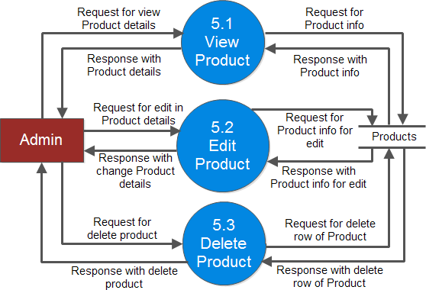Fig. 7.14 : 2nd LEVEL DFD FOR MANAGE PRODUCTS BY ADMIN

Fig. 7.15 : 2nd LEVEL DFD FOR MANAGE SELL OFFERS BY ADMIN

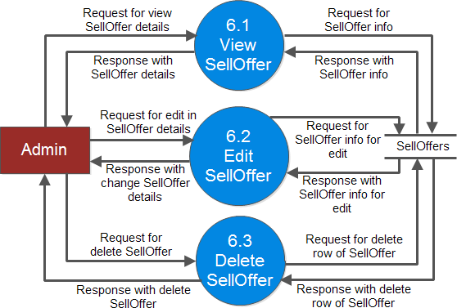

Fig. 7.16 : 2nd LEVEL DFD FOR MANAGE BUY OFFERS BY ADMIN

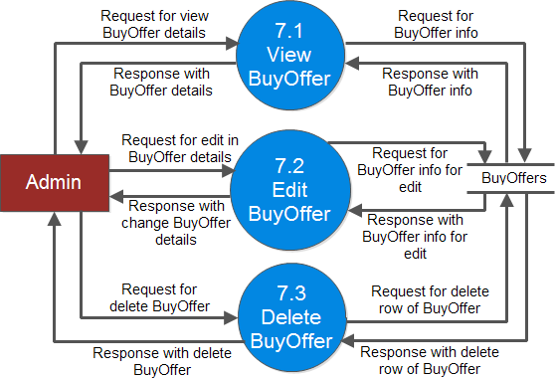

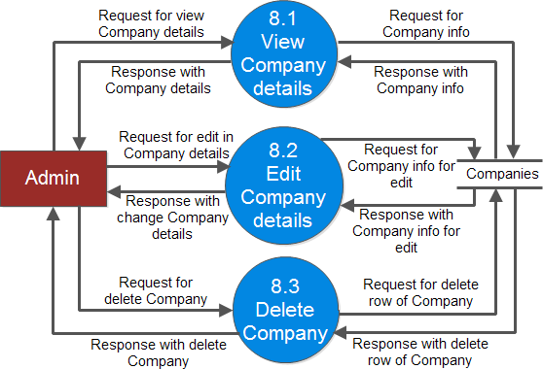Fig. 7.17 : 2nd LEVEL DFD FOR MANAGE COMPANIES BY ADMIN

Fig. 7.18 : 2nd LEVEL DFD FOR MANAGE MESSAGES BY ADMIN

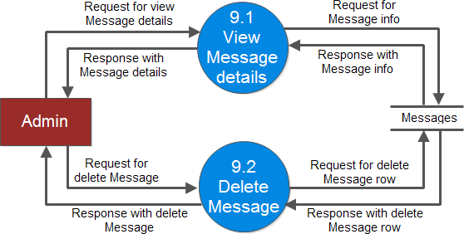

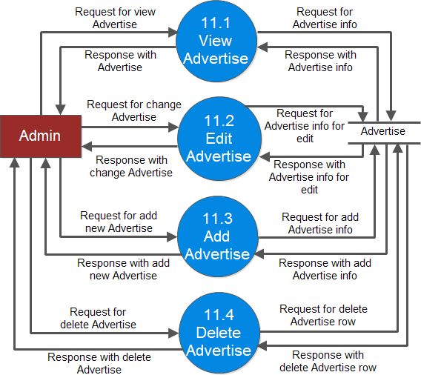Fig. 7.19 : 2nd LEVEL DFD FOR MANAGE ADVERTISE BY ADMIN

Fig. 7.20 : 3rd LEVEL DFD FOR MANAGE PRODUCTS BY USER

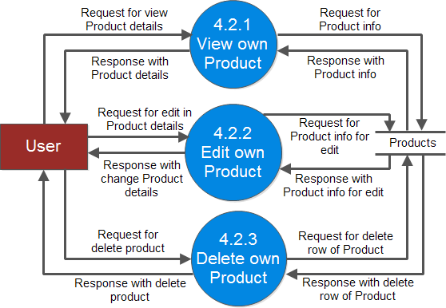

Fig. 7.21 : 3rd LEVEL DFD FOR MANAGE SELL OFFERS BY USER

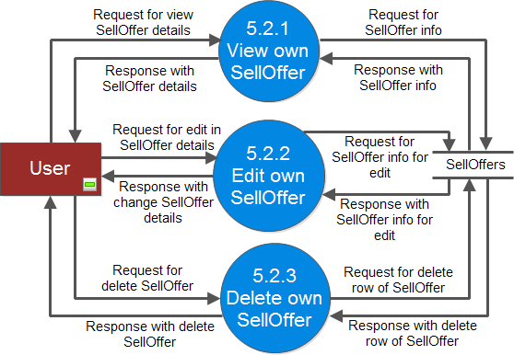

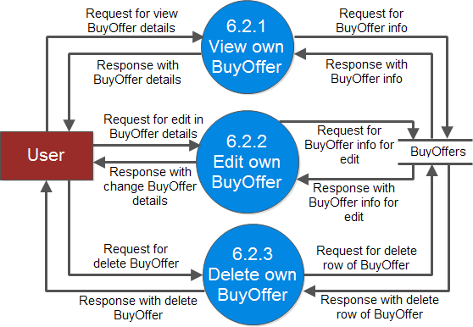Fig. 7.22 : 3rd LEVEL DFD FOR MANAGE BUY OFFERS BY USER

|  |  |  |  |  |  |  |  |  |  |  |  |  |  |  |  |  |  |  |  |  |
| --- | --- | --- | --- | --- | --- | --- | --- | --- | --- | --- | --- | --- | --- | --- | --- | --- | --- | --- | --- | --- |
| **7.2 TIMING DIAGRAM :** | | | | | | | | | | | | | | | | | | | | |
| **TIME LINE CHART** | | | | | | | | | | | | | | | | | | | | |
| **Task** | **Time Span** | | | | | | | | | | | | | | | | | | | |
|  | **January** | | | | | | | | | | | | | | | | | | | |
|  | **1** | **2** | **3** | **4** | **5** | **6** | **7** | **8** | **9** | **10** | **11** | **12** | **13** | **14** | **15** | **16** | **17** | **18** | **19** | **20** |
| Study of PHP |  |  |  |  |  |  |  |  |  |  |  |  |  |  |  |  |  |  |  |  |
| Study the admin side control  panel |  |  |  |  |  |  |  |  |  |  |  |  |  |  |  |  |  |  |  |  |
| personal info registration  page make using database |  |  |  |  |  |  |  |  |  |  |  |  |  |  |  |  |  |  |  |  |
| General class for insert,  update, delete, select |  |  |  |  |  |  |  |  |  |  |  |  |  |  |  |  |  |  |  |  |
| Add, edit, delete start for  PHP pages |  |  |  |  |  |  |  |  |  |  |  |  |  |  |  |  |  |  |  |  |
|  | **January** | | | | | | | | | | | **February** | | | | | | | | |
|  | **21** | **22** | **23** | **24** | **25** | **26** | **27** | **28** | **29** | **30** | **31** | **1** | **2** | **3** | **4** | **5** | **6** | **7** | **8** | **9** |
| General paging class for PHP  pages |  |  |  |  |  |  |  |  |  |  |  |  |  |  |  |  |  |  |  |  |
| Ordering for PHP pages |  |  |  |  |  |  |  |  |  |  |  |  |  |  |  |  |  |  |  |  |
| How to split site page |  |  |  |  |  |  |  |  |  |  |  |  |  |  |  |  |  |  |  |  |
| Work on admin side for  property sale |  |  |  |  |  |  |  |  |  |  |  |  |  |  |  |  |  |  |  |  |
| Work on client side for  property sale |  |  |  |  |  |  |  |  |  |  |  |  |  |  |  |  |  |  |  |  |
| visited and study other B2B site for reference before  start our B2B project site |  |  |  |  |  |  |  |  |  |  |  |  |  |  |  |  |  |  |  |  |
| Work on home page |  |  |  |  |  |  |  |  |  |  |  |  |  |  |  |  |  |  |  |  |
| work for home page display  latest sell and buy leads |  |  |  |  |  |  |  |  |  |  |  |  |  |  |  |  |  |  |  |  |
| create header and footer for  all pages |  |  |  |  |  |  |  |  |  |  |  |  |  |  |  |  |  |  |  |  |
| create sell offer detail page  which display sell offer detail |  |  |  |  |  |  |  |  |  |  |  |  |  |  |  |  |  |  |  |  |
| create buy offer page which display all buy offers with  some details |  |  |  |  |  |  |  |  |  |  |  |  |  |  |  |  |  |  |  |  |

|  |  |  |  |  |  |  |  |  |  |  |  |  |  |  |  |  |  |  |  |  |
| --- | --- | --- | --- | --- | --- | --- | --- | --- | --- | --- | --- | --- | --- | --- | --- | --- | --- | --- | --- | --- |
|  | | | | | | | | | | | | | | | | | | | | |
| **TIME LINE CHART** | | | | | | | | | | | | | | | | | | | | |
| **Task** | **Time Span** | | | | | | | | | | | | | | | | | | | |
|  | **February** | | | | | | | | | | | | | | | | | | | |
|  | **10** | **11** | **12** | **13** | **14** | **15** | **16** | **17** | **18** | **19** | **20** | **21** | **22** | **23** | **24** | **25** | **26** | **27** | **28** | **29** |
| set order for sell offer page |  |  |  |  |  |  |  |  |  |  |  |  |  |  |  |  |  |  |  |  |
| set order for buy offer page |  |  |  |  |  |  |  |  |  |  |  |  |  |  |  |  |  |  |  |  |
| Create paging |  |  |  |  |  |  |  |  |  |  |  |  |  |  |  |  |  |  |  |  |
| Set ordering with paging |  |  |  |  |  |  |  |  |  |  |  |  |  |  |  |  |  |  |  |  |
| Set images for sell offer and  product page |  |  |  |  |  |  |  |  |  |  |  |  |  |  |  |  |  |  |  |  |
| Select options for vendor  and service directory options |  |  |  |  |  |  |  |  |  |  |  |  |  |  |  |  |  |  |  |  |
| Working on search options |  |  |  |  |  |  |  |  |  |  |  |  |  |  |  |  |  |  |  |  |
| Create page for product detail and also set ordering  and paging |  |  |  |  |  |  |  |  |  |  |  |  |  |  |  |  |  |  |  |  |
| Create page for company profile detail and set  ordering and paging |  |  |  |  |  |  |  |  |  |  |  |  |  |  |  |  |  |  |  |  |
| Create contact us page for  client to contact to admin |  |  |  |  |  |  |  |  |  |  |  |  |  |  |  |  |  |  |  |  |
| Create member registration  page |  |  |  |  |  |  |  |  |  |  |  |  |  |  |  |  |  |  |  |  |
| Create sign in page for  member of site |  |  |  |  |  |  |  |  |  |  |  |  |  |  |  |  |  |  |  |  |
| Start to create userhome  page |  |  |  |  |  |  |  |  |  |  |  |  |  |  |  |  |  |  |  |  |
|  | **March** | | | | | | | | | | | | | | | | | | | |
|  | **1** | **2** | **3** | **4** | **5** | **6** | **7** | **8** | **9** | **10** | **11** | **12** | **13** | **14** | **15** | **16** | **17** | **18** | **19** | **20** |
| Create pages for Inquiries |  |  |  |  |  |  |  |  |  |  |  |  |  |  |  |  |  |  |  |  |
| Create page for manage  contact |  |  |  |  |  |  |  |  |  |  |  |  |  |  |  |  |  |  |  |  |
| Create page for block list |  |  |  |  |  |  |  |  |  |  |  |  |  |  |  |  |  |  |  |  |
|  | | | | | | | | | | | | | | | | | | | | |

|  |  |  |  |  |  |  |  |  |  |  |  |  |  |  |  |  |  |  |  |  |
| --- | --- | --- | --- | --- | --- | --- | --- | --- | --- | --- | --- | --- | --- | --- | --- | --- | --- | --- | --- | --- |
|  | | | | | | | | | | | | | | | | | | | | |
| **TIME LINE CHART** | | | | | | | | | | | | | | | | | | | | |
| **Task** | **Time Span** | | | | | | | | | | | | | | | | | | | |
|  | **March** | | | | | | | | | | | | | | | | | | | |
|  | **1** | **2** | **3** | **4** | **5** | **6** | **7** | **8** | **9** | **10** | **11** | **12** | **13** | **14** | **15** | **16** | **17** | **18** | **19** | **20** |
| Create pages for manage  products |  |  |  |  |  |  |  |  |  |  |  |  |  |  |  |  |  |  |  |  |
| Create pages for post  product |  |  |  |  |  |  |  |  |  |  |  |  |  |  |  |  |  |  |  |  |
| Create pages for manage buy  offers |  |  |  |  |  |  |  |  |  |  |  |  |  |  |  |  |  |  |  |  |
| Create pages for post buy  offers |  |  |  |  |  |  |  |  |  |  |  |  |  |  |  |  |  |  |  |  |
| Create pages for sell offers |  |  |  |  |  |  |  |  |  |  |  |  |  |  |  |  |  |  |  |  |
| Create pages for post sell  offers |  |  |  |  |  |  |  |  |  |  |  |  |  |  |  |  |  |  |  |  |
| Work on images for manage  product page |  |  |  |  |  |  |  |  |  |  |  |  |  |  |  |  |  |  |  |  |
| Work on images for manage  sell offers page |  |  |  |  |  |  |  |  |  |  |  |  |  |  |  |  |  |  |  |  |
|  | **March** | | | | | | | | | | | **April** | | | | | | | | |
|  | **21** | **22** | **23** | **24** | **25** | **26** | **27** | **28** | **29** | **30** | **31** | **1** | **2** | **3** | **4** | **5** | **6** | **7** | **8** | **9** |
| Work on images for buy  offers page |  |  |  |  |  |  |  |  |  |  |  |  |  |  |  |  |  |  |  |  |
| Create page for edit  company profile |  |  |  |  |  |  |  |  |  |  |  |  |  |  |  |  |  |  |  |  |
| Create page for edit personal  profile |  |  |  |  |  |  |  |  |  |  |  |  |  |  |  |  |  |  |  |  |
| Create page for change  password |  |  |  |  |  |  |  |  |  |  |  |  |  |  |  |  |  |  |  |  |
| Create page for change email |  |  |  |  |  |  |  |  |  |  |  |  |  |  |  |  |  |  |  |  |
| Create page for favorite list |  |  |  |  |  |  |  |  |  |  |  |  |  |  |  |  |  |  |  |  |
| Create page for Search  result save |  |  |  |  |  |  |  |  |  |  |  |  |  |  |  |  |  |  |  |  |
| Set the links for user home |  |  |  |  |  |  |  |  |  |  |  |  |  |  |  |  |  |  |  |  |
| We have designed a new b2b  portal in html |  |  |  |  |  |  |  |  |  |  |  |  |  |  |  |  |  |  |  |  |
|  | | | | | | | | | | | | | | | | | | | | |

|  |  |  |  |  |  |  |  |  |  |  |  |  |  |  |  |  |  |  |  |  |
| --- | --- | --- | --- | --- | --- | --- | --- | --- | --- | --- | --- | --- | --- | --- | --- | --- | --- | --- | --- | --- |
|  | | | | | | | | | | | | | | | | | | | | |
| **TIME LINE CHART** | | | | | | | | | | | | | | | | | | | | |
| **Task** | **Time Span** | | | | | | | | | | | | | | | | | | | |
|  | **March** | | | | | | | | | | | **April** | | | | | | | | |
|  | **21** | **22** | **23** | **24** | **25** | **26** | **27** | **28** | **29** | **30** | **31** | **1** | **2** | **3** | **4** | **5** | **6** | **7** | **8** | **9** |
| Design on home page |  |  |  |  |  |  |  |  |  |  |  |  |  |  |  |  |  |  |  |  |
| Design footer for all pages |  |  |  |  |  |  |  |  |  |  |  |  |  |  |  |  |  |  |  |  |
| Design sell offer page |  |  |  |  |  |  |  |  |  |  |  |  |  |  |  |  |  |  |  |  |
| Design buy offer page |  |  |  |  |  |  |  |  |  |  |  |  |  |  |  |  |  |  |  |  |
|  | **April** | | | | | | | | | | | | | | | | | | | |
|  | **10** | **11** | **12** | **13** | **14** | **15** | **16** | **17** | **18** | **19** | **20** | **21** | **22** | **23** | **24** | **25** | **26** | **27** | **28** | **29** |
| Design edit sell offer page |  |  |  |  |  |  |  |  |  |  |  |  |  |  |  |  |  |  |  |  |
| Design edit buy offer page |  |  |  |  |  |  |  |  |  |  |  |  |  |  |  |  |  |  |  |  |
| Design company detail page |  |  |  |  |  |  |  |  |  |  |  |  |  |  |  |  |  |  |  |  |
| Design product detail page |  |  |  |  |  |  |  |  |  |  |  |  |  |  |  |  |  |  |  |  |
| member registration page |  |  |  |  |  |  |  |  |  |  |  |  |  |  |  |  |  |  |  |  |
| coding in edit sell offer page |  |  |  |  |  |  |  |  |  |  |  |  |  |  |  |  |  |  |  |  |
| Make class of manage |  |  |  |  |  |  |  |  |  |  |  |  |  |  |  |  |  |  |  |  |
| Make class for sell offer table |  |  |  |  |  |  |  |  |  |  |  |  |  |  |  |  |  |  |  |  |
| Make class for categories |  |  |  |  |  |  |  |  |  |  |  |  |  |  |  |  |  |  |  |  |
| edit sell offer using class |  |  |  |  |  |  |  |  |  |  |  |  |  |  |  |  |  |  |  |  |
| sell offer display page |  |  |  |  |  |  |  |  |  |  |  |  |  |  |  |  |  |  |  |  |
| Make popup window |  |  |  |  |  |  |  |  |  |  |  |  |  |  |  |  |  |  |  |  |
| display sell offer page |  |  |  |  |  |  |  |  |  |  |  |  |  |  |  |  |  |  |  |  |
| use Ajax for searching |  |  |  |  |  |  |  |  |  |  |  |  |  |  |  |  |  |  |  |  |
| Set ordering with searching |  |  |  |  |  |  |  |  |  |  |  |  |  |  |  |  |  |  |  |  |
| Start work on paging |  |  |  |  |  |  |  |  |  |  |  |  |  |  |  |  |  |  |  |  |
| Set ordering and edit  company profile page |  |  |  |  |  |  |  |  |  |  |  |  |  |  |  |  |  |  |  |  |
|  | | | | | | | | | | | | | | | | | | | | |



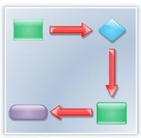

**SYSTEM ANALISIS**

# SYSTEM ANALISIS

## 8.1 USE CASE DIAGRAM

Fig. 8.1 : USE CASE FOR ADMIN

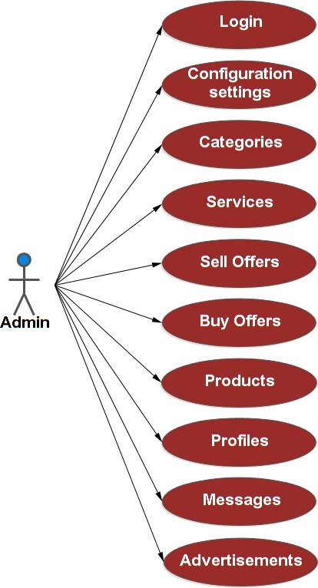

Fig. 8.2 : USE CASE FOR USER

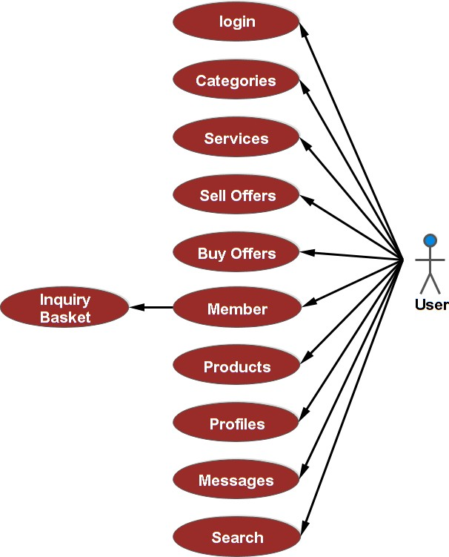

Fig. 8.2 : SUB USE CASE FOR USER

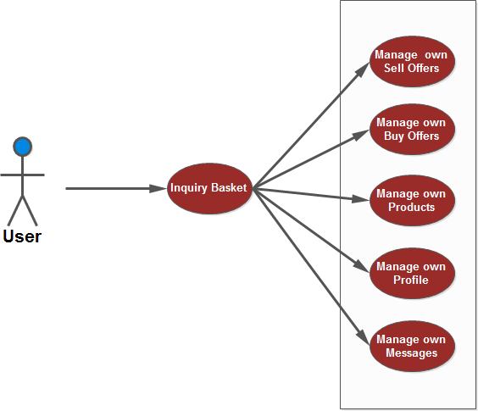



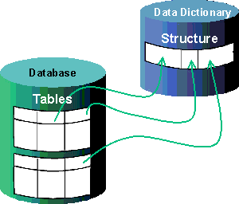

**SYSTEM DESIGN**

## DATA BASE TABLES INFORMATION

|  |  |  |  |
| --- | --- | --- | --- |
| **NO** | **FIELD TYPE** | **DATA TYPE** | **DESCRIPTION** |
|  | | | |
| **1) v2b_admin :** Used for admin login – name and password | | | |
| 1. | sb_id (primary key) | Bigint(20) | Id of admin |
| 2. | sb_admin_name | Varchar(255) | Name of admin |
| 3. | sb_pwd | Varchar(255) | Password of admin |
|  | | | |
| **2) v2b_ads :** Used for advertise url to display advertise | | | |
| 1. | Subtitle | varchar(255) | Title of advertisement |
| 2. | Id (primary key) | bigint(20) | Id of advertisement |
| 3. | url | varchar(255) | url for advertisement |
| 4. | Bannerurl | varchar(255) | Bannerurl for image display |
| 5. | Credits | bigint(20) | Credits for advertisement |
| 6. | Displays | bigint(20) | Displays for advertisement |
| 7. | Approved | varchar(255) | Approved or not for advertisement |
|  | | | |
| **3)** [**v2b_affiliate_banner**](http://localhost/phpmyadmin/sql.php?db=ven2buy&table=v2b_affiliate_banner&token=308024ca0f1b669285b81f372984f604) : Used for advertise banner for advertisement. | | | |
| 1. | sbaff_id (primary key) | bigint(20) | Id of affiliate advertisement |
| 2. | sbaff_title | varchar(255) | Title of affiliate advertisement |
| 3. | sbaff_text | Longtext | Text for affiliate advertisement |
| 4. | sbaff_active | varchar(255) | Active or not for affiliate  advertisement |
|  | | | |
| **4)** [**v2b_banned_words**](http://localhost/phpmyadmin/sql.php?db=ven2buy&table=v2b_banned_words&token=308024ca0f1b669285b81f372984f604) : Used to banned bad words on site to display. | | | |
| 1. | [sb_id](http://localhost/phpmyadmin/sql.php?db=ven2buy&table=v2b_banned_words&sql_query=SELECT%2B%2A%2BFROM%2B%60v2b_banned_words%60%2BORDER%2BBY%2B%60v2b_banned_words%60.%60sb_id%60%2BASC&token=73ce3a1fd01eba9099c5d353e497db85) (primary key) | bigint(20) | Id of banned words |
| 2. | [sb_word](http://localhost/phpmyadmin/sql.php?db=ven2buy&table=v2b_banned_words&sql_query=SELECT%2B%2A%2BFROM%2B%60v2b_banned_words%60%2BORDER%2BBY%2B%60v2b_banned_words%60.%60sb_word%60%2BASC&token=73ce3a1fd01eba9099c5d353e497db85) | varchar(255) | banned words |
| 3. | [sb_type](http://localhost/phpmyadmin/sql.php?db=ven2buy&table=v2b_banned_words&sql_query=SELECT%2B%2A%2BFROM%2B%60v2b_banned_words%60%2BORDER%2BBY%2B%60v2b_banned_words%60.%60sb_type%60%2BASC&token=73ce3a1fd01eba9099c5d353e497db85) | varchar(255) | Type of banned words |

|  |  |  |  |
| --- | --- | --- | --- |
| **NO** | **FIELD TYPE** | **DATA TYPE** | **DESCRIPTION** |
|  | | | |
| **5)** [**v2b_blocked**](http://localhost/phpmyadmin/sql.php?db=ven2buy&token=73ce3a1fd01eba9099c5d353e497db85&table=v2b_blocked&pos=0) : Used for block some user to send messages. | | | |
| 1. | [sb_id](http://localhost/phpmyadmin/sql.php?db=ven2buy&table=v2b_blocked&sql_query=SELECT%2B%2A%2BFROM%2B%60v2b_blocked%60%2BORDER%2BBY%2B%60v2b_blocked%60.%60sb_id%60%2BASC&token=73ce3a1fd01eba9099c5d353e497db85) (primary key) | bigint(20) | Id of blocked |
| 2. | [sb_uid](http://localhost/phpmyadmin/sql.php?db=ven2buy&table=v2b_blocked&sql_query=SELECT%2B%2A%2BFROM%2B%60v2b_blocked%60%2BORDER%2BBY%2B%60v2b_blocked%60.%60sb_uid%60%2BASC&token=73ce3a1fd01eba9099c5d353e497db85) | bigint(20) | User id of blocked |
| 3. | [sb_blocked_id](http://localhost/phpmyadmin/sql.php?db=ven2buy&table=v2b_blocked&sql_query=SELECT%2B%2A%2BFROM%2B%60v2b_blocked%60%2BORDER%2BBY%2B%60v2b_blocked%60.%60sb_blocked_id%60%2BASC&token=73ce3a1fd01eba9099c5d353e497db85) | bigint(20) | Blocked id |
| 4. | [sb_desc](http://localhost/phpmyadmin/sql.php?db=ven2buy&table=v2b_blocked&sql_query=SELECT%2B%2A%2BFROM%2B%60v2b_blocked%60%2BORDER%2BBY%2B%60v2b_blocked%60.%60sb_desc%60%2BASC&token=73ce3a1fd01eba9099c5d353e497db85) | varchar(255) | Description of blocked |
|  | | | |
| **6)** [**v2b_blocked_countries**](http://localhost/phpmyadmin/sql.php?db=ven2buy&table=v2b_blocked_countries&token=308024ca0f1b669285b81f372984f604) : Used for block user from particular country. | | | |
| 1. | [sb_id](http://localhost/phpmyadmin/sql.php?db=ven2buy&table=v2b_blocked&sql_query=SELECT%2B%2A%2BFROM%2B%60v2b_blocked%60%2BORDER%2BBY%2B%60v2b_blocked%60.%60sb_id%60%2BASC&token=73ce3a1fd01eba9099c5d353e497db85) (primary key) | bigint(20) | Id of blocked countries |
| 2. | [sb_uid](http://localhost/phpmyadmin/sql.php?db=ven2buy&table=v2b_blocked&sql_query=SELECT%2B%2A%2BFROM%2B%60v2b_blocked%60%2BORDER%2BBY%2B%60v2b_blocked%60.%60sb_uid%60%2BASC&token=73ce3a1fd01eba9099c5d353e497db85) | bigint(20) | Userid of blocked countries |
| 3. | [sb_blocked_id](http://localhost/phpmyadmin/sql.php?db=ven2buy&table=v2b_blocked&sql_query=SELECT%2B%2A%2BFROM%2B%60v2b_blocked%60%2BORDER%2BBY%2B%60v2b_blocked%60.%60sb_blocked_id%60%2BASC&token=73ce3a1fd01eba9099c5d353e497db85) | bigint(20) | Blocked id |
| 4. | [sb_desc](http://localhost/phpmyadmin/sql.php?db=ven2buy&table=v2b_blocked&sql_query=SELECT%2B%2A%2BFROM%2B%60v2b_blocked%60%2BORDER%2BBY%2B%60v2b_blocked%60.%60sb_desc%60%2BASC&token=73ce3a1fd01eba9099c5d353e497db85) | varchar(255) | Description of blocked countries |
|  | | | |
| **7)** [**v2b_**](http://localhost/phpmyadmin/sql.php?db=ven2buy&token=73ce3a1fd01eba9099c5d353e497db85&table=v2b_blocked&pos=0)**businesstypes** | | | |
| 1. | [sb_id](http://localhost/phpmyadmin/sql.php?db=ven2buy&table=v2b_blocked&sql_query=SELECT%2B%2A%2BFROM%2B%60v2b_blocked%60%2BORDER%2BBY%2B%60v2b_blocked%60.%60sb_id%60%2BASC&token=73ce3a1fd01eba9099c5d353e497db85) (primary key) | bigint(20) | Id of businesstypes |
| 2. | [sb_](http://localhost/phpmyadmin/sql.php?db=ven2buy&table=v2b_blocked&sql_query=SELECT%2B%2A%2BFROM%2B%60v2b_blocked%60%2BORDER%2BBY%2B%60v2b_blocked%60.%60sb_uid%60%2BASC&token=73ce3a1fd01eba9099c5d353e497db85)businesstype | varchar(255) | Businesstypes |
|  | | | |
| **8)** [**v2b_categories**](http://localhost/phpmyadmin/sql.php?db=ven2buy&token=73ce3a1fd01eba9099c5d353e497db85&table=v2b_blocked&pos=0) : Give the information about Categories and Services. | | | |
| 1. | [sb_id](http://localhost/phpmyadmin/sql.php?db=ven2buy&table=v2b_blocked&sql_query=SELECT%2B%2A%2BFROM%2B%60v2b_blocked%60%2BORDER%2BBY%2B%60v2b_blocked%60.%60sb_id%60%2BASC&token=73ce3a1fd01eba9099c5d353e497db85) (primary key) | bigint(20) | Id of categories |
| 2. | [sb_](http://localhost/phpmyadmin/sql.php?db=ven2buy&table=v2b_blocked&sql_query=SELECT%2B%2A%2BFROM%2B%60v2b_blocked%60%2BORDER%2BBY%2B%60v2b_blocked%60.%60sb_uid%60%2BASC&token=73ce3a1fd01eba9099c5d353e497db85)cat_name | varchar(255) | Category name |
| 3. | [sb_pid](http://localhost/phpmyadmin/sql.php?db=ven2buy&table=v2b_blocked&sql_query=SELECT%2B%2A%2BFROM%2B%60v2b_blocked%60%2BORDER%2BBY%2B%60v2b_blocked%60.%60sb_blocked_id%60%2BASC&token=73ce3a1fd01eba9099c5d353e497db85) | bigint(20) | Product id of category |
| 4. | [sb_order_index](http://localhost/phpmyadmin/sql.php?db=ven2buy&table=v2b_blocked&sql_query=SELECT%2B%2A%2BFROM%2B%60v2b_blocked%60%2BORDER%2BBY%2B%60v2b_blocked%60.%60sb_desc%60%2BASC&token=73ce3a1fd01eba9099c5d353e497db85) | bigint(20) | Order index for category |
| 5. | sb_visit_sell | bigint(20) | No of times visit sell offers |
| 6. | sb_visit_buy | bigint(20) | No of times visit buy offers |
| 7. | sb_visit_product | bigint(20) | No of times visit products |
| 8. | sb_visit_profile | bigint(20) | No of times visit company profiles |

|  |  |  |  |
| --- | --- | --- | --- |
| **NO** | **FIELD TYPE** | **DATA TYPE** | **DESCRIPTION** |
|  | | | |
| **9)** [**v2b_companyprofiles**](http://localhost/phpmyadmin/sql.php?db=ven2buy&token=73ce3a1fd01eba9099c5d353e497db85&table=v2b_blocked&pos=0) : Give all company details. | | | |
| 1. | [sb_id](http://localhost/phpmyadmin/sql.php?db=ven2buy&table=v2b_blocked&sql_query=SELECT%2B%2A%2BFROM%2B%60v2b_blocked%60%2BORDER%2BBY%2B%60v2b_blocked%60.%60sb_id%60%2BASC&token=73ce3a1fd01eba9099c5d353e497db85) (primary key) | bigint(20) | Id of company profiles |
| 2. | [sb_companyname](http://localhost/phpmyadmin/sql.php?db=ven2buy&table=v2b_blocked&sql_query=SELECT%2B%2A%2BFROM%2B%60v2b_blocked%60%2BORDER%2BBY%2B%60v2b_blocked%60.%60sb_uid%60%2BASC&token=73ce3a1fd01eba9099c5d353e497db85) | varchar(255) | Company name |
| 3. | sb_logo | varchar(255) | logo image of company profiles |
| 4. | [sb_businesstype](http://localhost/phpmyadmin/sql.php?db=ven2buy&table=v2b_blocked&sql_query=SELECT%2B%2A%2BFROM%2B%60v2b_blocked%60%2BORDER%2BBY%2B%60v2b_blocked%60.%60sb_blocked_id%60%2BASC&token=73ce3a1fd01eba9099c5d353e497db85) | bigint(20) | Businesstypes of company profiles |
| 5. | [sb_services](http://localhost/phpmyadmin/sql.php?db=ven2buy&table=v2b_blocked&sql_query=SELECT%2B%2A%2BFROM%2B%60v2b_blocked%60%2BORDER%2BBY%2B%60v2b_blocked%60.%60sb_desc%60%2BASC&token=73ce3a1fd01eba9099c5d353e497db85) | Longtext | Services of company profiles |
| 6. | sb_yearestablished | bigint(20) | Year of company established |
| 7. | sb_markets | varchar(255) | Market places |
| 8. | sb_othermarkets | varchar(255) | Other market places |
| 9. | sb_productfocus | bigint(20) | Main focus on product |
| 10. | sb_uid | bigint(20) | User id of company profiles |
| 11. | sb_employees | bigint(20) | No of employees |
| 12. | sb_companyprofile | Longtext | Details of company profiles |
| 13. | sb_ceo | varchar(255) | Name of company ceo |
| 14. | sb_website | varchar(255) | Website name |
| 15. | sb_type | bigint(20) | Type of business |
| 16. | sb_phone | varchar(255) | Phone no of company |
| 17. | sb_fax | varchar(255) | Fax no of company |
| 18. | sb_approved | varchar(255) | Approved or not |
| 19. | sb_featured | varchar(255) | Feature of company profiles |
| 20. | sb_viewed | bigint(20) | No of times viewed |
| 21. | Tempdate | Timestamp | Temp date of company profiles |
| 22. | sb_postedon | Timestamp | Posted date of company profiles |

|  |  |  |  |
| --- | --- | --- | --- |
| **NO** | **FIELD TYPE** | **DATA TYPE** | **DESCRIPTION** |
|  | | | |
| **10)** [**v2b_config**](http://localhost/phpmyadmin/sql.php?db=ven2buy&token=73ce3a1fd01eba9099c5d353e497db85&table=v2b_blocked&pos=0) : Used for configure site structure. | | | |
| 1. | [sb_id](http://localhost/phpmyadmin/sql.php?db=ven2buy&table=v2b_blocked&sql_query=SELECT%2B%2A%2BFROM%2B%60v2b_blocked%60%2BORDER%2BBY%2B%60v2b_blocked%60.%60sb_id%60%2BASC&token=73ce3a1fd01eba9099c5d353e497db85) (primary key) | bigint(20) | Id of configuration |
| 2. | [sb_admin_email](http://localhost/phpmyadmin/sql.php?db=ven2buy&table=v2b_blocked&sql_query=SELECT%2B%2A%2BFROM%2B%60v2b_blocked%60%2BORDER%2BBY%2B%60v2b_blocked%60.%60sb_uid%60%2BASC&token=73ce3a1fd01eba9099c5d353e497db85) | varchar(255) | Admin email id of configuration |
| 3. | [sb_site_name](http://localhost/phpmyadmin/sql.php?db=ven2buy&table=v2b_blocked&sql_query=SELECT%2B%2A%2BFROM%2B%60v2b_blocked%60%2BORDER%2BBY%2B%60v2b_blocked%60.%60sb_blocked_id%60%2BASC&token=73ce3a1fd01eba9099c5d353e497db85) | varchar(255) | Control text in title bar of browser |
| 4. | sb_site_root | varchar(255) | Control website address |
| 5. | sb_html_header1 | Longtext | Control html header |
| 6. | sb_html_footer1 | Longtext | Control html footer |
| 7. | sb_style_list | bigint(20) | Control color scheme for front end |
| 8. | sb_recperpage | int(11) | records per page |
| 9. | sb_icon_list | bigint(20) | Control icons for front end |
| 10. | sb_recent_count | int(11) | Control no of rows for featured product catalogs and featured company profiles to be shown on front page |
| 11. | sb_feature_count | int(11) | Control no of rows for featured  offers and profiles |
| 12. | sb_th_width | bigint(20) | Control width of thumbnails |
| 13. | sb_th_width2 | bigint(20) | Control width of thumbnails |
| 14. | sb_image_magik | varchar(255) | Image magik |
| 15. | sb_water_marking | varchar(255) | Watermarking |
| 16. | sb_approval_type_offe  r | varchar(255) | Approval type offer |
| 17. | sb_profile_approval | varchar(255) | Profile approval |
| 18. | sb_date_format | bigint(20) | Format of date |
| 19. | sb_time_format | bigint(20) | Format of time |
| 20. | sb_memtype | bigint(20) | Configures member type to be  assigned to new sign up |

|  |  |  |  |
| --- | --- | --- | --- |
| **NO** | **FIELD TYPE** | **DATA TYPE** | **DESCRIPTION** |
| 21. | sb_mem_approval | varchar(255) | Setting this to Auto, automates the approval process for new signed up members otherwise Admin has to approve every new signup |
| 22. | sb_expiry_sell | bigint(20) | Sell offer expiry duration in months |
| 23. | sb_expiry_buy | bigint(20) | Buy offer expiry duration in months |
| 24. | sb_description_length | bigint(20) | Control the length for the descriptions for all type of listing |
| 25. | sb_image_size | bigint(20) | Image size in bytes |
| 26. | sb_null_char | varchar(255) | It will be displayed if some value is not available/missing |
| 27. | sb_latest_news_cnt | bigint(20) | Latest news count |
| 28. | sb_cat_featured | int(11) | Category featured |
| 29. | sb_how_to_sell | Longtext | Help for how to sell |
| 30. | sb_how_to_buy | Longtext | Help for how to buy |
| 31. | sb_legal | Longtext | Legal policy |
| 32. | sb_terms | Longtext | Terms of use |
| 33. | sb_privacy | Longtext | Privacy policy |
| 34. | sb_signup_verification | varchar(255) | Signup verification yes or no |
| 35. | sb_logo | varchar(255) | Image logo |
| 36. | sbfee_bs | decimal(10,2) | Fees of bronze to silver |
| 37. | sbfee_bg | decimal(10,2) | Fees of bronze to ultimate |
| 38. | sbfee_sg | decimal(10,2) | Fees of silver to ultimate |
| 39. | sb_site_keywords | varchar(255) | Site keywords |
| 40. | sb_cat_listing | varchar(255) | Category listing |
| 41. | Tempdate | Timestamp | Temp date |

|  |  |  |  |
| --- | --- | --- | --- |
| **NO** | **FIELD TYPE** | **DATA TYPE** | **DESCRIPTION** |
| 42. | sb_last_sent | Timestamp | Last sent date |
|  | | | |
| **11)** [**v2b_contacts**](http://localhost/phpmyadmin/sql.php?db=ven2buy&token=73ce3a1fd01eba9099c5d353e497db85&table=v2b_blocked&pos=0) : Used for add contacts. | | | |
| 1. | [sb_id](http://localhost/phpmyadmin/sql.php?db=ven2buy&table=v2b_blocked&sql_query=SELECT%2B%2A%2BFROM%2B%60v2b_blocked%60%2BORDER%2BBY%2B%60v2b_blocked%60.%60sb_id%60%2BASC&token=73ce3a1fd01eba9099c5d353e497db85) (primary key) | bigint(20) | Id of contacts |
| 2. | [sb_uid](http://localhost/phpmyadmin/sql.php?db=ven2buy&table=v2b_blocked&sql_query=SELECT%2B%2A%2BFROM%2B%60v2b_blocked%60%2BORDER%2BBY%2B%60v2b_blocked%60.%60sb_uid%60%2BASC&token=73ce3a1fd01eba9099c5d353e497db85) | bigint(20) | User id of contacts |
| 3. | [sb_contact_id](http://localhost/phpmyadmin/sql.php?db=ven2buy&table=v2b_blocked&sql_query=SELECT%2B%2A%2BFROM%2B%60v2b_blocked%60%2BORDER%2BBY%2B%60v2b_blocked%60.%60sb_blocked_id%60%2BASC&token=73ce3a1fd01eba9099c5d353e497db85) | bigint(20) | Contact id |
|  | | | |
| **12)** [**v2b_country**](http://localhost/phpmyadmin/sql.php?db=ven2buy&token=73ce3a1fd01eba9099c5d353e497db85&table=v2b_blocked&pos=0) : Used for name of all countries. | | | |
| 1. | Country | varchar(255) | Country name |
| 2. | [id](http://localhost/phpmyadmin/sql.php?db=ven2buy&table=v2b_blocked&sql_query=SELECT%2B%2A%2BFROM%2B%60v2b_blocked%60%2BORDER%2BBY%2B%60v2b_blocked%60.%60sb_uid%60%2BASC&token=73ce3a1fd01eba9099c5d353e497db85) (primary key) | bigint(20) | Country id |
|  | | | |
| **13)** [**v2b_currencies**](http://localhost/phpmyadmin/sql.php?db=ven2buy&token=73ce3a1fd01eba9099c5d353e497db85&table=v2b_blocked&pos=0) : Used for currencies’ symbols display. | | | |
| 1. | [sbcur_id](http://localhost/phpmyadmin/sql.php?db=ven2buy&table=v2b_blocked&sql_query=SELECT%2B%2A%2BFROM%2B%60v2b_blocked%60%2BORDER%2BBY%2B%60v2b_blocked%60.%60sb_id%60%2BASC&token=73ce3a1fd01eba9099c5d353e497db85) (primary key) | bigint(20) | Id of currencies |
| 2. | [sbcur_symbol](http://localhost/phpmyadmin/sql.php?db=ven2buy&table=v2b_blocked&sql_query=SELECT%2B%2A%2BFROM%2B%60v2b_blocked%60%2BORDER%2BBY%2B%60v2b_blocked%60.%60sb_uid%60%2BASC&token=73ce3a1fd01eba9099c5d353e497db85) | varchar(255) | Symbols of currencies |
| 3. | [sbcur_name](http://localhost/phpmyadmin/sql.php?db=ven2buy&table=v2b_blocked&sql_query=SELECT%2B%2A%2BFROM%2B%60v2b_blocked%60%2BORDER%2BBY%2B%60v2b_blocked%60.%60sb_blocked_id%60%2BASC&token=73ce3a1fd01eba9099c5d353e497db85) | varchar(255) | Name of currencies |
|  | | | |
| **14)** [**v2b_dateformats**](http://localhost/phpmyadmin/sql.php?db=ven2buy&token=73ce3a1fd01eba9099c5d353e497db85&table=v2b_blocked&pos=0) : Used for date format | | | |
| 1. | [sb_id](http://localhost/phpmyadmin/sql.php?db=ven2buy&table=v2b_blocked&sql_query=SELECT%2B%2A%2BFROM%2B%60v2b_blocked%60%2BORDER%2BBY%2B%60v2b_blocked%60.%60sb_id%60%2BASC&token=73ce3a1fd01eba9099c5d353e497db85) (primary key) | bigint(20) | Id of date formats |
| 2. | [sb_format](http://localhost/phpmyadmin/sql.php?db=ven2buy&table=v2b_blocked&sql_query=SELECT%2B%2A%2BFROM%2B%60v2b_blocked%60%2BORDER%2BBY%2B%60v2b_blocked%60.%60sb_uid%60%2BASC&token=73ce3a1fd01eba9099c5d353e497db85) | varchar(255) | date formats |
|  | | | |
| **15)** [**v2b_employees**](http://localhost/phpmyadmin/sql.php?db=ven2buy&token=73ce3a1fd01eba9099c5d353e497db85&table=v2b_blocked&pos=0) : Used for no of employees. | | | |
| 1. | [sb_id](http://localhost/phpmyadmin/sql.php?db=ven2buy&table=v2b_blocked&sql_query=SELECT%2B%2A%2BFROM%2B%60v2b_blocked%60%2BORDER%2BBY%2B%60v2b_blocked%60.%60sb_id%60%2BASC&token=73ce3a1fd01eba9099c5d353e497db85) (primary key) | bigint(20) | Id of employees |
| 2. | [sb_e](http://localhost/phpmyadmin/sql.php?db=ven2buy&table=v2b_blocked&sql_query=SELECT%2B%2A%2BFROM%2B%60v2b_blocked%60%2BORDER%2BBY%2B%60v2b_blocked%60.%60sb_uid%60%2BASC&token=73ce3a1fd01eba9099c5d353e497db85)mployees | varchar(255) | No of employees |
|  | | | |
| **16)** [**v2b_favorites**](http://localhost/phpmyadmin/sql.php?db=ven2buy&token=73ce3a1fd01eba9099c5d353e497db85&table=v2b_blocked&pos=0) : Used for add to favorites in account. | | | |
| 1. | [sb_id](http://localhost/phpmyadmin/sql.php?db=ven2buy&table=v2b_blocked&sql_query=SELECT%2B%2A%2BFROM%2B%60v2b_blocked%60%2BORDER%2BBY%2B%60v2b_blocked%60.%60sb_id%60%2BASC&token=73ce3a1fd01eba9099c5d353e497db85) (primary key) | bigint(20) | Id of favorites |

|  |  |  |  |
| --- | --- | --- | --- |
| **NO** | **FIELD TYPE** | **DATA TYPE** | **DESCRIPTION** |
| 2. | [sb_offer_id](http://localhost/phpmyadmin/sql.php?db=ven2buy&table=v2b_blocked&sql_query=SELECT%2B%2A%2BFROM%2B%60v2b_blocked%60%2BORDER%2BBY%2B%60v2b_blocked%60.%60sb_uid%60%2BASC&token=73ce3a1fd01eba9099c5d353e497db85) | bigint(20) | Offer id of favorites |
| 3. | [sb_uid](http://localhost/phpmyadmin/sql.php?db=ven2buy&table=v2b_blocked&sql_query=SELECT%2B%2A%2BFROM%2B%60v2b_blocked%60%2BORDER%2BBY%2B%60v2b_blocked%60.%60sb_blocked_id%60%2BASC&token=73ce3a1fd01eba9099c5d353e497db85) | bigint(20) | User id of favorites |
| 4. | sb_type | varchar(255) | Type like sell,buy,product,profile |
|  | | | |
| **17)** [**v2b_fav_cats**](http://localhost/phpmyadmin/sql.php?db=ven2buy&token=73ce3a1fd01eba9099c5d353e497db85&table=v2b_blocked&pos=0) : Used for favoire category for selloffer,buyoffer,product & profile. | | | |
| 1. | [id](http://localhost/phpmyadmin/sql.php?db=ven2buy&table=v2b_blocked&sql_query=SELECT%2B%2A%2BFROM%2B%60v2b_blocked%60%2BORDER%2BBY%2B%60v2b_blocked%60.%60sb_id%60%2BASC&token=73ce3a1fd01eba9099c5d353e497db85) (primary key) | bigint(20) | Id of favorite category |
| 2. | [cid](http://localhost/phpmyadmin/sql.php?db=ven2buy&table=v2b_blocked&sql_query=SELECT%2B%2A%2BFROM%2B%60v2b_blocked%60%2BORDER%2BBY%2B%60v2b_blocked%60.%60sb_uid%60%2BASC&token=73ce3a1fd01eba9099c5d353e497db85) | bigint(20) | cid of favorite category |
| 3. | [mid](http://localhost/phpmyadmin/sql.php?db=ven2buy&table=v2b_blocked&sql_query=SELECT%2B%2A%2BFROM%2B%60v2b_blocked%60%2BORDER%2BBY%2B%60v2b_blocked%60.%60sb_blocked_id%60%2BASC&token=73ce3a1fd01eba9099c5d353e497db85) | bigint(20) | Mid of favorite category |
| 4. | sb_type | varchar(255) | Types like sell,buy,product,profile |
|  | | | |
| **18)** [**v2b_feedback**](http://localhost/phpmyadmin/sql.php?db=ven2buy&token=73ce3a1fd01eba9099c5d353e497db85&table=v2b_blocked&pos=0) : Used for feedback messages from user. | | | |
| 1. | sb_[id](http://localhost/phpmyadmin/sql.php?db=ven2buy&table=v2b_blocked&sql_query=SELECT%2B%2A%2BFROM%2B%60v2b_blocked%60%2BORDER%2BBY%2B%60v2b_blocked%60.%60sb_id%60%2BASC&token=73ce3a1fd01eba9099c5d353e497db85)(primary key) | bigint(20) | Id for feedback |
| 2. | [sb_fname](http://localhost/phpmyadmin/sql.php?db=ven2buy&table=v2b_blocked&sql_query=SELECT%2B%2A%2BFROM%2B%60v2b_blocked%60%2BORDER%2BBY%2B%60v2b_blocked%60.%60sb_uid%60%2BASC&token=73ce3a1fd01eba9099c5d353e497db85) | varchar(255) | First name for feedback |
| 3. | [sb_lname](http://localhost/phpmyadmin/sql.php?db=ven2buy&table=v2b_blocked&sql_query=SELECT%2B%2A%2BFROM%2B%60v2b_blocked%60%2BORDER%2BBY%2B%60v2b_blocked%60.%60sb_blocked_id%60%2BASC&token=73ce3a1fd01eba9099c5d353e497db85) | varchar(255) | Last name for feedback |
| 4. | sb_email | varchar(255) | Email id for feedback |
| 5. | sb_url | varchar(255) | url for feedback |
| 6. | sb_title | varchar(255) | Title for feedback |
| 7. | sb_comments | Longtext | Comments |
|  | | | |
| **19)** [**v2b_groups**](http://localhost/phpmyadmin/sql.php?db=ven2buy&token=73ce3a1fd01eba9099c5d353e497db85&table=v2b_blocked&pos=0) : Used for different member types. | | | |
| 1. | sb_[id](http://localhost/phpmyadmin/sql.php?db=ven2buy&table=v2b_blocked&sql_query=SELECT%2B%2A%2BFROM%2B%60v2b_blocked%60%2BORDER%2BBY%2B%60v2b_blocked%60.%60sb_id%60%2BASC&token=73ce3a1fd01eba9099c5d353e497db85) (primary key) | bigint(20) | Id of particular member |
| 2. | [sb_memtype](http://localhost/phpmyadmin/sql.php?db=ven2buy&table=v2b_blocked&sql_query=SELECT%2B%2A%2BFROM%2B%60v2b_blocked%60%2BORDER%2BBY%2B%60v2b_blocked%60.%60sb_uid%60%2BASC&token=73ce3a1fd01eba9099c5d353e497db85) | bigint(20) | Membertypes |
| 3. | [sb_sell_cnt](http://localhost/phpmyadmin/sql.php?db=ven2buy&table=v2b_blocked&sql_query=SELECT%2B%2A%2BFROM%2B%60v2b_blocked%60%2BORDER%2BBY%2B%60v2b_blocked%60.%60sb_blocked_id%60%2BASC&token=73ce3a1fd01eba9099c5d353e497db85) | bigint(20) | Maximum sell offers allowed |
| 4. | sb_buy_cnt | bigint(20) | Maximum buy offers allowed |
| 5. | sb_product_cnt | bigint(20) | Maximum product catalogs  allowed |
| 6. | sb_profile | varchar(10) | profiles posting allowed or not |

|  |  |  |  |
| --- | --- | --- | --- |
| **NO** | **FIELD TYPE** | **DATA TYPE** | **DESCRIPTION** |
| 7. | sb_img_cnt | bigint(20) | Maximum images allowed for an  add |
| 8. | sb_cat_cnt | bigint(20) | Maximum categories allowed to  post sell/buy offers |
| 9. | sb_profilecat_cnt | bigint(20) | Maximum categories allowed to  post profiles |
| 10. | sb_posturl | varchar(10) | Website url allowed in company  profile or not |
| 11. | sb_keyword_cnt | varchar(255) | Maximum keywords allowed for  an add |
|  | | | |
| **20)** [**v2b_markets**](http://localhost/phpmyadmin/sql.php?db=ven2buy&token=73ce3a1fd01eba9099c5d353e497db85&table=v2b_blocked&pos=0) : Used for business market places. | | | |
| 1. | sb_[id](http://localhost/phpmyadmin/sql.php?db=ven2buy&table=v2b_blocked&sql_query=SELECT%2B%2A%2BFROM%2B%60v2b_blocked%60%2BORDER%2BBY%2B%60v2b_blocked%60.%60sb_id%60%2BASC&token=73ce3a1fd01eba9099c5d353e497db85) (primary key) | bigint(20) | Id of market places |
| 2. | [sb_](http://localhost/phpmyadmin/sql.php?db=ven2buy&table=v2b_blocked&sql_query=SELECT%2B%2A%2BFROM%2B%60v2b_blocked%60%2BORDER%2BBY%2B%60v2b_blocked%60.%60sb_uid%60%2BASC&token=73ce3a1fd01eba9099c5d353e497db85)market | varchar(255) | Marketplaces like north America,  mid east, word wide. |
|  | | | |
| **21)** [**v2b_icons**](http://localhost/phpmyadmin/sql.php?db=ven2buy&token=73ce3a1fd01eba9099c5d353e497db85&table=v2b_blocked&pos=0) : Used for to set icons for different fields. | | | |
| 1. | sb_[id](http://localhost/phpmyadmin/sql.php?db=ven2buy&table=v2b_blocked&sql_query=SELECT%2B%2A%2BFROM%2B%60v2b_blocked%60%2BORDER%2BBY%2B%60v2b_blocked%60.%60sb_id%60%2BASC&token=73ce3a1fd01eba9099c5d353e497db85) (primary key) | bigint(20) | Id of icon |
| 2. | sb_title | varchar(255) | Title for icon |
| 3. | sb_mem_opt | varchar(255) | Member opt image |
| 4. | sb_how_to_buy | varchar(255) | How to buy image |
| 5. | sb_how_to_sell | varchar(255) | How to sell image |
| 6. | sb_join_now | varchar(255) | Join now image |
| 7. | sb_send_inquiry | varchar(255) | Send inquiry image |
| 8. | sb_contact_list | varchar(255) | Contact list image |
| 9. | sb_block_list | varchar(255) | Block list image |
| 10. | sb_add_fav | varchar(255) | Add favorites image |
| 11. | sb_profile | varchar(255) | Company profile image |
| 12. | sb_mem_area | varchar(255) | Member area image |

|  |  |  |  |
| --- | --- | --- | --- |
| **NO** | **FIELD TYPE** | **DATA TYPE** | **DESCRIPTION** |
| 13. | sb_bar | varchar(255) | Title bar bullet image |
| 14. | sb_more | varchar(255) | More icon image |
| 15. | sb_sell_offers | varchar(255) | Sell offers image |
| 16. | sb_buy_offers | varchar(255) | Buy offers image |
| 17. | sb_products | varchar(255) | Products image |
| 18. | sb_profiles | varchar(255) | Profiles image |
|  | | | |
| **22)** [**v2b_levels**](http://localhost/phpmyadmin/sql.php?db=ven2buy&token=73ce3a1fd01eba9099c5d353e497db85&table=v2b_blocked&pos=0) : Used for member level. | | | |
| 1. | sb_[id](http://localhost/phpmyadmin/sql.php?db=ven2buy&table=v2b_blocked&sql_query=SELECT%2B%2A%2BFROM%2B%60v2b_blocked%60%2BORDER%2BBY%2B%60v2b_blocked%60.%60sb_id%60%2BASC&token=73ce3a1fd01eba9099c5d353e497db85) (primary key) | tinyint(4) | Id of levels |
| 2. | [sb_levelid](http://localhost/phpmyadmin/sql.php?db=ven2buy&table=v2b_blocked&sql_query=SELECT%2B%2A%2BFROM%2B%60v2b_blocked%60%2BORDER%2BBY%2B%60v2b_blocked%60.%60sb_uid%60%2BASC&token=73ce3a1fd01eba9099c5d353e497db85) | int(11) | Level id |
| 3. | [sb_levelname](http://localhost/phpmyadmin/sql.php?db=ven2buy&table=v2b_blocked&sql_query=SELECT%2B%2A%2BFROM%2B%60v2b_blocked%60%2BORDER%2BBY%2B%60v2b_blocked%60.%60sb_blocked_id%60%2BASC&token=73ce3a1fd01eba9099c5d353e497db85) | varchar(255) | Level name |
| 4. | sblevel_text | Longtext | Level text/description |
|  | | | |
| **23)** [**v2b_mails**](http://localhost/phpmyadmin/sql.php?db=ven2buy&token=73ce3a1fd01eba9099c5d353e497db85&table=v2b_blocked&pos=0) : Used for mails. | | | |
| 1. | sb_[id](http://localhost/phpmyadmin/sql.php?db=ven2buy&table=v2b_blocked&sql_query=SELECT%2B%2A%2BFROM%2B%60v2b_blocked%60%2BORDER%2BBY%2B%60v2b_blocked%60.%60sb_id%60%2BASC&token=73ce3a1fd01eba9099c5d353e497db85) (primary key) | bigint(20) | Id of mails |
| 2. | [sb_mailid](http://localhost/phpmyadmin/sql.php?db=ven2buy&table=v2b_blocked&sql_query=SELECT%2B%2A%2BFROM%2B%60v2b_blocked%60%2BORDER%2BBY%2B%60v2b_blocked%60.%60sb_uid%60%2BASC&token=73ce3a1fd01eba9099c5d353e497db85) | bigint(20) | Mail id of mails |
| 3. | [sb_](http://localhost/phpmyadmin/sql.php?db=ven2buy&table=v2b_blocked&sql_query=SELECT%2B%2A%2BFROM%2B%60v2b_blocked%60%2BORDER%2BBY%2B%60v2b_blocked%60.%60sb_blocked_id%60%2BASC&token=73ce3a1fd01eba9099c5d353e497db85)fromid | varchar(255) | From email id |
| 4. | sb_subject | varchar(255) | Subject for mail |
| 5. | sb_mail | Longtext | Mail |
| 6. | sb_status | varchar(255) | Status |
| 7. | sb_html_format | varchar(255) | Html format(yes or no) |
|  | | | |
| **24)** [**v2b_messages**](http://localhost/phpmyadmin/sql.php?db=ven2buy&token=73ce3a1fd01eba9099c5d353e497db85&table=v2b_blocked&pos=0) : Used for messages. | | | |
| 1. | sb_[id](http://localhost/phpmyadmin/sql.php?db=ven2buy&table=v2b_blocked&sql_query=SELECT%2B%2A%2BFROM%2B%60v2b_blocked%60%2BORDER%2BBY%2B%60v2b_blocked%60.%60sb_id%60%2BASC&token=73ce3a1fd01eba9099c5d353e497db85) (primary key) | bigint(20) | Id of messages |
| 2. | sb_fid | bigint(20) | Fid of messages |
| 3. | sb_tid | bigint(20) | tid of messages |

|  |  |  |  |
| --- | --- | --- | --- |
| **NO** | **FIELD TYPE** | **DATA TYPE** | **DESCRIPTION** |
| 4. | sb_subject | mediumtext | Subject of messages |
| 5. | sb_message | Longtext | Message |
| 6. | sb_tempdate | timestamp | Temp date |
| 7. | sb_onstamp | Timestamp | On stamp date |
| 8. | sb_msg_read | varchar(10) | Message read or not |
| 9. | sb_f_del | varchar(10) | F_del or not |
| 10. | sb_t_del | varchar(10) | T_del or not |
|  | | | |
| **25)** [**v2b_news**](http://localhost/phpmyadmin/sql.php?db=ven2buy&token=73ce3a1fd01eba9099c5d353e497db85&table=v2b_blocked&pos=0) : Used for news. | | | |
| 1. | sb_[id](http://localhost/phpmyadmin/sql.php?db=ven2buy&table=v2b_blocked&sql_query=SELECT%2B%2A%2BFROM%2B%60v2b_blocked%60%2BORDER%2BBY%2B%60v2b_blocked%60.%60sb_id%60%2BASC&token=73ce3a1fd01eba9099c5d353e497db85) (primary key) | bigint(20) | Id of news |
| 2. | [sb_](http://localhost/phpmyadmin/sql.php?db=ven2buy&table=v2b_blocked&sql_query=SELECT%2B%2A%2BFROM%2B%60v2b_blocked%60%2BORDER%2BBY%2B%60v2b_blocked%60.%60sb_uid%60%2BASC&token=73ce3a1fd01eba9099c5d353e497db85)subject | varchar(255) | Subject of news |
| 3. | sb_description | Longtext | Description of news |
| 4. | sb_postedon | Timestamp | Posted date of news |
|  | | | |
| **26)** [**v2b_members**](http://localhost/phpmyadmin/sql.php?db=ven2buy&token=73ce3a1fd01eba9099c5d353e497db85&table=v2b_blocked&pos=0) : used for members details. | | | |
| 1. | sb_[id](http://localhost/phpmyadmin/sql.php?db=ven2buy&table=v2b_blocked&sql_query=SELECT%2B%2A%2BFROM%2B%60v2b_blocked%60%2BORDER%2BBY%2B%60v2b_blocked%60.%60sb_id%60%2BASC&token=73ce3a1fd01eba9099c5d353e497db85) (primary key) | bigint(20) | Id of members |
| 2. | [sb_](http://localhost/phpmyadmin/sql.php?db=ven2buy&table=v2b_blocked&sql_query=SELECT%2B%2A%2BFROM%2B%60v2b_blocked%60%2BORDER%2BBY%2B%60v2b_blocked%60.%60sb_uid%60%2BASC&token=73ce3a1fd01eba9099c5d353e497db85)username | varchar(255) | Username of members |
| 3. | sb_password | varchar(255) | Password of members |
| 4. | sb_firstname | varchar(255) | First name of members |
| 5. | sb_lastname | varchar(255) | Last name of members |
| 6. | sb_email | varchar(255) | Email id of members |
| 7. | sb_street | varchar(255) | Street of members |
| 8. | sb_city | varchar(255) | City of members |
| 9. | sb_state | varchar(255) | State of members |
| 10. | sb_zip | varchar(255) | Zip of members |
| 11. | sb_country | bigint(20) | Country of members |

|  |  |  |  |
| --- | --- | --- | --- |
| **NO** | **FIELD TYPE** | **DATA TYPE** | **DESCRIPTION** |
|  | | | |
| 12. | sb_phone | varchar(255) | Phone no of members |
| 13. | sb_fax | varchar(255) | Fax no of members |
| 14. | sb_mobile | varchar(255) | Mobile no of members |
| 15. | Tempdate | Timestamp | Temp date |
| 16. | sb_ondate | Timestamp | On date |
| 17. | sb_expiry_date | Timestamp | Expiry date |
| 18. | sb_memtype | bigint(20) | Member type |
| 19. | sb_lastlogin | Timestamp | Last login of members |
| 20. | sb_suspended | varchar(255) | Suspended or not |
|  | | | |
| **27)** [**v2b_newsletter**](http://localhost/phpmyadmin/sql.php?db=ven2buy&token=73ce3a1fd01eba9099c5d353e497db85&table=v2b_blocked&pos=0) : Used for newsletter. | | | |
| 1. | sb_[id](http://localhost/phpmyadmin/sql.php?db=ven2buy&table=v2b_blocked&sql_query=SELECT%2B%2A%2BFROM%2B%60v2b_blocked%60%2BORDER%2BBY%2B%60v2b_blocked%60.%60sb_id%60%2BASC&token=73ce3a1fd01eba9099c5d353e497db85) (primary key) | bigint(20) | Id of newsletter |
| 2. | [sb_](http://localhost/phpmyadmin/sql.php?db=ven2buy&table=v2b_blocked&sql_query=SELECT%2B%2A%2BFROM%2B%60v2b_blocked%60%2BORDER%2BBY%2B%60v2b_blocked%60.%60sb_uid%60%2BASC&token=73ce3a1fd01eba9099c5d353e497db85)email | varchar(255) | Email id |
|  | | | |
| **28)** [**v2b_offers**](http://localhost/phpmyadmin/sql.php?db=ven2buy&token=73ce3a1fd01eba9099c5d353e497db85&table=v2b_blocked&pos=0) : Used for Sell offer details. | | | |
| 1. | sb_[id](http://localhost/phpmyadmin/sql.php?db=ven2buy&table=v2b_blocked&sql_query=SELECT%2B%2A%2BFROM%2B%60v2b_blocked%60%2BORDER%2BBY%2B%60v2b_blocked%60.%60sb_id%60%2BASC&token=73ce3a1fd01eba9099c5d353e497db85) | bigint(20) | Id of offers |
| 2. | [sb_](http://localhost/phpmyadmin/sql.php?db=ven2buy&table=v2b_blocked&sql_query=SELECT%2B%2A%2BFROM%2B%60v2b_blocked%60%2BORDER%2BBY%2B%60v2b_blocked%60.%60sb_uid%60%2BASC&token=73ce3a1fd01eba9099c5d353e497db85)uid | bigint(20) | User id of offers |
| 3. | sb_title | varchar(255) | Title of offers |
| 4. | sb_description | Longtext | Description of offers |
| 5. | sb_quantity | varchar(255) | Quantity of offers |
| 6. | Tempdate | Timestamp | Temp date of offers |
| 7. | sb_postedon | Timestamp | Posted date of offers |
| 8. | sb_expireson | Timestamp | Expiration date of offers |
| 9. | sb_viewed | bigint(20) | No of times view |
| 10. | sb_keywords | varchar(255) | Keywords for search |
| 11. | sb_location | varchar(255) | Location |

|  |  |  |  |
| --- | --- | --- | --- |
| **NO** | **FIELD TYPE** | **DATA TYPE** | **DESCRIPTION** |
| 12. | sb_min_order | bigint(20) | Minimum order |
| 13. | sb_price_cur_id | bigint(20) | Price currency id of offers |
| 14. | sb_price | float(15,2) | Price of offers |
| 15. | sb_samples_available | varchar(255) | Sample available or not |
| 16. | sb_product_status | varchar(255) | Product status(used or new) |
| 17. | sb_delivery_time | bigint(20) | Delivery time for offers |
| 18. | sb_payment_mode | varchar(255) | Payment mode for offers |
| 19. | sb_other_mode | varchar(255) | Other payment mode of offers |
| 20. | sb_shipping_cost | float(15,2) | Shipping cost for offers |
| 21. | sb_approved | varchar(255) | Approved or not |
| 22. | sb_news | varchar(255) | New or old |
| 23. | sb_featured | varchar(255) | Feature for offers |
|  | | | |
| **29)** [**v2b_offers**](http://localhost/phpmyadmin/sql.php?db=ven2buy&token=73ce3a1fd01eba9099c5d353e497db85&table=v2b_blocked&pos=0)**_buy :** Used for Buy Offer details. | | | |
| 1. | sb_[id](http://localhost/phpmyadmin/sql.php?db=ven2buy&table=v2b_blocked&sql_query=SELECT%2B%2A%2BFROM%2B%60v2b_blocked%60%2BORDER%2BBY%2B%60v2b_blocked%60.%60sb_id%60%2BASC&token=73ce3a1fd01eba9099c5d353e497db85) (primary key) | bigint(20) | Id of buy offers |
| 2. | [sb_](http://localhost/phpmyadmin/sql.php?db=ven2buy&table=v2b_blocked&sql_query=SELECT%2B%2A%2BFROM%2B%60v2b_blocked%60%2BORDER%2BBY%2B%60v2b_blocked%60.%60sb_uid%60%2BASC&token=73ce3a1fd01eba9099c5d353e497db85)uid | bigint(20) | User id of buy offers |
| 3. | sb_title | varchar(255) | Title of buy offers |
| 4. | sb_description | Longtext | Description buy offers |
| 5. | sb_quantity | varchar(255) | Quantity of buy offers |
| 6. | Tempdate | Timestamp | Temp date of buy offers |
| 7. | sb_postedon | Timestamp | Posted date of buy offers |
| 8. | sb_viewed | bigint(20) | No of times viewed |
| 9. | sb_keywords | varchar(255) | Keywords for search |
| 10. | sb_price_cur_id | bigint(20) | Currency price id of buy offers |
| 11. | sb_price | float(15,2) | Price of buy offers |
| 12. | sb_approved | varchar(255) | Approved or not |

|  |  |  |  |
| --- | --- | --- | --- |
| **NO** | **FIELD TYPE** | **DATA TYPE** | **DESCRIPTION** |
| 13. | sb_news | varchar(255) | New or old |
| 14. | sb_featured | varchar(255) | Feature for buy offers |
|  | | | |
| **30)** [**v2b_offer**](http://localhost/phpmyadmin/sql.php?db=ven2buy&token=73ce3a1fd01eba9099c5d353e497db85&table=v2b_blocked&pos=0)**_cats :** Used for company and sell offer | | | |
| 1. | sb_[id](http://localhost/phpmyadmin/sql.php?db=ven2buy&table=v2b_blocked&sql_query=SELECT%2B%2A%2BFROM%2B%60v2b_blocked%60%2BORDER%2BBY%2B%60v2b_blocked%60.%60sb_id%60%2BASC&token=73ce3a1fd01eba9099c5d353e497db85) (primary key) | bigint(20) | Id for sell offers |
| 2. | [sb_](http://localhost/phpmyadmin/sql.php?db=ven2buy&table=v2b_blocked&sql_query=SELECT%2B%2A%2BFROM%2B%60v2b_blocked%60%2BORDER%2BBY%2B%60v2b_blocked%60.%60sb_uid%60%2BASC&token=73ce3a1fd01eba9099c5d353e497db85)offer_id | bigint(20) | Offer id for sell offers |
| 3. | sb_cid | bigint(20) | cid for sell offers |
|  | | | |
| **31)** [**v2b_offer**](http://localhost/phpmyadmin/sql.php?db=ven2buy&token=73ce3a1fd01eba9099c5d353e497db85&table=v2b_blocked&pos=0)**_cats_buy :** Used for company and buy offer | | | |
| 1. | sb_[id](http://localhost/phpmyadmin/sql.php?db=ven2buy&table=v2b_blocked&sql_query=SELECT%2B%2A%2BFROM%2B%60v2b_blocked%60%2BORDER%2BBY%2B%60v2b_blocked%60.%60sb_id%60%2BASC&token=73ce3a1fd01eba9099c5d353e497db85) (primary key) | bigint(20) | Id for buy offers |
| 2. | [sb_](http://localhost/phpmyadmin/sql.php?db=ven2buy&table=v2b_blocked&sql_query=SELECT%2B%2A%2BFROM%2B%60v2b_blocked%60%2BORDER%2BBY%2B%60v2b_blocked%60.%60sb_uid%60%2BASC&token=73ce3a1fd01eba9099c5d353e497db85)offer_id | bigint(20) | Offer id for buy offers |
| 3. | sb_cid | bigint(20) | cid for buy offers |
|  | | | |
| **32)** [**v2b_offer**](http://localhost/phpmyadmin/sql.php?db=ven2buy&token=73ce3a1fd01eba9099c5d353e497db85&table=v2b_blocked&pos=0)**_images :** Used for sell offer images | | | |
| 1. | sb_[id](http://localhost/phpmyadmin/sql.php?db=ven2buy&table=v2b_blocked&sql_query=SELECT%2B%2A%2BFROM%2B%60v2b_blocked%60%2BORDER%2BBY%2B%60v2b_blocked%60.%60sb_id%60%2BASC&token=73ce3a1fd01eba9099c5d353e497db85) (primary key) | bigint(20) | Id for sell offers |
| 2. | [sb_](http://localhost/phpmyadmin/sql.php?db=ven2buy&table=v2b_blocked&sql_query=SELECT%2B%2A%2BFROM%2B%60v2b_blocked%60%2BORDER%2BBY%2B%60v2b_blocked%60.%60sb_uid%60%2BASC&token=73ce3a1fd01eba9099c5d353e497db85)offer_id | bigint(20) | Offer id for sell offers |
| 3. | sb_img_url | varchar(255) | Images for sell offers |
|  | | | |
| **33)** [**v2b_o**](http://localhost/phpmyadmin/sql.php?db=ven2buy&token=73ce3a1fd01eba9099c5d353e497db85&table=v2b_blocked&pos=0)**nline :** Used for user online time. | | | |
| 1. | sb_i[p](http://localhost/phpmyadmin/sql.php?db=ven2buy&table=v2b_blocked&sql_query=SELECT%2B%2A%2BFROM%2B%60v2b_blocked%60%2BORDER%2BBY%2B%60v2b_blocked%60.%60sb_id%60%2BASC&token=73ce3a1fd01eba9099c5d353e497db85) | varchar(255) | Ip for online |
| 2. | [sb_](http://localhost/phpmyadmin/sql.php?db=ven2buy&table=v2b_blocked&sql_query=SELECT%2B%2A%2BFROM%2B%60v2b_blocked%60%2BORDER%2BBY%2B%60v2b_blocked%60.%60sb_uid%60%2BASC&token=73ce3a1fd01eba9099c5d353e497db85)ontime | Timestamp | On time for online |
| 3. | sb_uid | bigint(20) | Uid for online |
|  | | | |
| **34)** [**v2b_**](http://localhost/phpmyadmin/sql.php?db=ven2buy&token=73ce3a1fd01eba9099c5d353e497db85&table=v2b_blocked&pos=0)**productfocus :** Used for product focus categories | | | |
| 1. | sb_[id](http://localhost/phpmyadmin/sql.php?db=ven2buy&table=v2b_blocked&sql_query=SELECT%2B%2A%2BFROM%2B%60v2b_blocked%60%2BORDER%2BBY%2B%60v2b_blocked%60.%60sb_id%60%2BASC&token=73ce3a1fd01eba9099c5d353e497db85) (primary key) | bigint(20) | Id for product focus |
| 2. | [sb_](http://localhost/phpmyadmin/sql.php?db=ven2buy&table=v2b_blocked&sql_query=SELECT%2B%2A%2BFROM%2B%60v2b_blocked%60%2BORDER%2BBY%2B%60v2b_blocked%60.%60sb_uid%60%2BASC&token=73ce3a1fd01eba9099c5d353e497db85)productfocus | varchar(255) | Product focus categories |

|  |  |  |  |
| --- | --- | --- | --- |
| **NO** | **FIELD TYPE** | **DATA TYPE** | **DESCRIPTION** |
| **35)** [**v2b_**](http://localhost/phpmyadmin/sql.php?db=ven2buy&token=73ce3a1fd01eba9099c5d353e497db85&table=v2b_blocked&pos=0)**product_images :** Used for product Images | | | |
| 1. | sb_[id](http://localhost/phpmyadmin/sql.php?db=ven2buy&table=v2b_blocked&sql_query=SELECT%2B%2A%2BFROM%2B%60v2b_blocked%60%2BORDER%2BBY%2B%60v2b_blocked%60.%60sb_id%60%2BASC&token=73ce3a1fd01eba9099c5d353e497db85) (primary key) | bigint(20) | Id for products |
| 2. | [sb_](http://localhost/phpmyadmin/sql.php?db=ven2buy&table=v2b_blocked&sql_query=SELECT%2B%2A%2BFROM%2B%60v2b_blocked%60%2BORDER%2BBY%2B%60v2b_blocked%60.%60sb_uid%60%2BASC&token=73ce3a1fd01eba9099c5d353e497db85)offer_id | bigint(20) | Offer id for products |
| 3. | sb_img_url | varchar(255) | Image for products |
|  | | | |
| **36) v2b_product_cats :** Used for Product categories. | | | |
| 1. | sb_[id](http://localhost/phpmyadmin/sql.php?db=ven2buy&table=v2b_blocked&sql_query=SELECT%2B%2A%2BFROM%2B%60v2b_blocked%60%2BORDER%2BBY%2B%60v2b_blocked%60.%60sb_id%60%2BASC&token=73ce3a1fd01eba9099c5d353e497db85) (primary key) | bigint(20) | Id for product categories |
| 2. | [sb_](http://localhost/phpmyadmin/sql.php?db=ven2buy&table=v2b_blocked&sql_query=SELECT%2B%2A%2BFROM%2B%60v2b_blocked%60%2BORDER%2BBY%2B%60v2b_blocked%60.%60sb_uid%60%2BASC&token=73ce3a1fd01eba9099c5d353e497db85)offer_id | bigint(20) | Offer id for product categories |
| 3. | sb_cid | bigint(20) | cids for product categories |
|  | | | |
| **37)** [**v2b_**](http://localhost/phpmyadmin/sql.php?db=ven2buy&token=73ce3a1fd01eba9099c5d353e497db85&table=v2b_blocked&pos=0)**products :** Used for product details. | | | |
| 1. | sb_[id](http://localhost/phpmyadmin/sql.php?db=ven2buy&table=v2b_blocked&sql_query=SELECT%2B%2A%2BFROM%2B%60v2b_blocked%60%2BORDER%2BBY%2B%60v2b_blocked%60.%60sb_id%60%2BASC&token=73ce3a1fd01eba9099c5d353e497db85) (primary key) | bigint(20) | Id of products |
| 2. | [sb_](http://localhost/phpmyadmin/sql.php?db=ven2buy&table=v2b_blocked&sql_query=SELECT%2B%2A%2BFROM%2B%60v2b_blocked%60%2BORDER%2BBY%2B%60v2b_blocked%60.%60sb_uid%60%2BASC&token=73ce3a1fd01eba9099c5d353e497db85)uid | bigint(20) | Uid of products |
| 3. | sb_title | varchar(255) | Title of products |
| 4. | sb_description | Longtext | Description of products |
| 5. | sb_quantity | varchar(255) | Quantity of products |
| 6. | Tempdate | Timestamp | Temp date of products |
| 7. | sb_postedon | Timestamp | Posted date of products |
| 8. | sb_expireson | Timestamp | Expire date of products |
| 9. | sb_viewed | bigint(20) | No of times viewed |
| 10. | sb_keywords | varchar(255) | Keywords for search |
| 11. | sb_location | varchar(255) | Location |
| 12. | sb_min_order | bigint(20) | Minimum order |
| 13. | sb_price_cur_id | bigint(20) | Currency id of products |
| 14. | sb_price | float(15,2) | Price of products |
| 15. | sb_samples_available | varchar(255) | Samples available or not |

|  |  |  |  |
| --- | --- | --- | --- |
| **NO** | **FIELD TYPE** | **DATA TYPE** | **DESCRIPTION** |
|  | | | |
| 16. | sb_product_status | varchar(255) | Product status |
| 17. | sb_delivery_time | bigint(20) | Delivery time for products |
| 18. | sb_payment_mode | varchar(255) | Payment mode for products |
| 19. | sb_other_mode | varchar(255) | Other payment mode for products |
| 20. | sb_shipping_cost | float(15,2) | Shipping cost for products |
| 21. | sb_approved | varchar(255) | Approved or not |
| 22. | sb_[new](http://localhost/phpmyadmin/sql.php?db=ven2buy&table=v2b_blocked&sql_query=SELECT%2B%2A%2BFROM%2B%60v2b_blocked%60%2BORDER%2BBY%2B%60v2b_blocked%60.%60sb_id%60%2BASC&token=73ce3a1fd01eba9099c5d353e497db85) | varchar(255) | New or old |
| 23. | [sb_](http://localhost/phpmyadmin/sql.php?db=ven2buy&table=v2b_blocked&sql_query=SELECT%2B%2A%2BFROM%2B%60v2b_blocked%60%2BORDER%2BBY%2B%60v2b_blocked%60.%60sb_uid%60%2BASC&token=73ce3a1fd01eba9099c5d353e497db85)featured | varchar(255) | Feature for products |
|  | | | |
| **38)** [**v2b_**](http://localhost/phpmyadmin/sql.php?db=ven2buy&token=73ce3a1fd01eba9099c5d353e497db85&table=v2b_blocked&pos=0)**profile_cats :** Used for company profile. | | | |
| 1. | sb_[id](http://localhost/phpmyadmin/sql.php?db=ven2buy&table=v2b_blocked&sql_query=SELECT%2B%2A%2BFROM%2B%60v2b_blocked%60%2BORDER%2BBY%2B%60v2b_blocked%60.%60sb_id%60%2BASC&token=73ce3a1fd01eba9099c5d353e497db85) (primary key) | bigint(20) | Id of company profile |
| 2. | [sb_](http://localhost/phpmyadmin/sql.php?db=ven2buy&table=v2b_blocked&sql_query=SELECT%2B%2A%2BFROM%2B%60v2b_blocked%60%2BORDER%2BBY%2B%60v2b_blocked%60.%60sb_uid%60%2BASC&token=73ce3a1fd01eba9099c5d353e497db85)offer_id | bigint(20) | offer id of company profile |
| 3. | sb_cid | bigint(20) | cid of company profile |
|  | | | |
| **39)** [**v2b_**](http://localhost/phpmyadmin/sql.php?db=ven2buy&token=73ce3a1fd01eba9099c5d353e497db85&table=v2b_blocked&pos=0)**profile_markets :** Used for profile id for market. | | | |
| 1. | sb_[id](http://localhost/phpmyadmin/sql.php?db=ven2buy&table=v2b_blocked&sql_query=SELECT%2B%2A%2BFROM%2B%60v2b_blocked%60%2BORDER%2BBY%2B%60v2b_blocked%60.%60sb_id%60%2BASC&token=73ce3a1fd01eba9099c5d353e497db85) (primary key) | bigint(20) | Id of markets |
| 2. | [sb_](http://localhost/phpmyadmin/sql.php?db=ven2buy&table=v2b_blocked&sql_query=SELECT%2B%2A%2BFROM%2B%60v2b_blocked%60%2BORDER%2BBY%2B%60v2b_blocked%60.%60sb_uid%60%2BASC&token=73ce3a1fd01eba9099c5d353e497db85)profile_id | bigint(20) | Profile id of markets |
| 3. | sb_market | bigint(20) | Market id |
|  | | | |
| **40)** [**v2b_**](http://localhost/phpmyadmin/sql.php?db=ven2buy&token=73ce3a1fd01eba9099c5d353e497db85&table=v2b_blocked&pos=0)**search_results :** Used for save search result details. | | | |
| 1. | sb_[id](http://localhost/phpmyadmin/sql.php?db=ven2buy&table=v2b_blocked&sql_query=SELECT%2B%2A%2BFROM%2B%60v2b_blocked%60%2BORDER%2BBY%2B%60v2b_blocked%60.%60sb_id%60%2BASC&token=73ce3a1fd01eba9099c5d353e497db85) (primary key) | bigint(20) | Id of serach results |
| 2. | [sb_](http://localhost/phpmyadmin/sql.php?db=ven2buy&table=v2b_blocked&sql_query=SELECT%2B%2A%2BFROM%2B%60v2b_blocked%60%2BORDER%2BBY%2B%60v2b_blocked%60.%60sb_uid%60%2BASC&token=73ce3a1fd01eba9099c5d353e497db85)uid | bigint(20) | Uid of search results |
| 3. | sb_title | varchar(255) | Title of search results |
| 4. | sb_keyword | varchar(255) | Keywords for search |
| 5. | sb_search_method | bigint(20) | Search method |
| 6. | sb_cid | bigint(20) | cid of search results |

|  |  |  |  |
| --- | --- | --- | --- |
| **NO** | **FIELD TYPE** | **DATA TYPE** | **DESCRIPTION** |
| 7. | sb_type | int(11) | Type of search results |
| 8. | sb_country | bigint(20) | Country |
| 9. | sb_day | int(11) | Posted after day |
| 10. | sb_month | int(11) | Posted after month |
| 11. | sb_year | int(11) | Posted after year |
| 12. | sb_day1 | int(11) | Posted before day1 |
| 13. | sb_month1 | int(11) | Posted before month1 |
| 14. | sb_year1 | int(11) | Posted before year1 |
|  | | | |
| **41)** [**v2b_**](http://localhost/phpmyadmin/sql.php?db=ven2buy&token=73ce3a1fd01eba9099c5d353e497db85&table=v2b_blocked&pos=0)**signups :** Used for sign up process. | | | |
| 1. | sb_[id](http://localhost/phpmyadmin/sql.php?db=ven2buy&table=v2b_blocked&sql_query=SELECT%2B%2A%2BFROM%2B%60v2b_blocked%60%2BORDER%2BBY%2B%60v2b_blocked%60.%60sb_id%60%2BASC&token=73ce3a1fd01eba9099c5d353e497db85) (primary key) | bigint(20) | Id of sign ups |
| 2. | [sb_](http://localhost/phpmyadmin/sql.php?db=ven2buy&table=v2b_blocked&sql_query=SELECT%2B%2A%2BFROM%2B%60v2b_blocked%60%2BORDER%2BBY%2B%60v2b_blocked%60.%60sb_uid%60%2BASC&token=73ce3a1fd01eba9099c5d353e497db85)rnum | varchar(255) | Random number of signups |
| 3. | sb_email | varchar(255) | Email id of signups |
| 4. | sb_onstamp | Timestamp | On stamp date |
|  | | | |
| **42)** [**v2b_**](http://localhost/phpmyadmin/sql.php?db=ven2buy&token=73ce3a1fd01eba9099c5d353e497db85&table=v2b_blocked&pos=0)**stats :** Used for stats of messages. | | | |
| 1. | sb_[id](http://localhost/phpmyadmin/sql.php?db=ven2buy&table=v2b_blocked&sql_query=SELECT%2B%2A%2BFROM%2B%60v2b_blocked%60%2BORDER%2BBY%2B%60v2b_blocked%60.%60sb_id%60%2BASC&token=73ce3a1fd01eba9099c5d353e497db85) (primary key) | bigint(20) | Id of stats |
| 2. | [sb_](http://localhost/phpmyadmin/sql.php?db=ven2buy&table=v2b_blocked&sql_query=SELECT%2B%2A%2BFROM%2B%60v2b_blocked%60%2BORDER%2BBY%2B%60v2b_blocked%60.%60sb_uid%60%2BASC&token=73ce3a1fd01eba9099c5d353e497db85)hits | bigint(20) | Hits of stats |
| 3. | sb_hits_thismonth | bigint(20) | Hits of this month |
| 4. | sb_hits_lastmonth | bigint(20) | Hits of last month |
| 5. | sb_thismonth | bigint(20) | This month |
| 6. | sb_msg_cnt | bigint(20) | Message count |
|  | | | |
| **43)** [**v2b_**](http://localhost/phpmyadmin/sql.php?db=ven2buy&token=73ce3a1fd01eba9099c5d353e497db85&table=v2b_blocked&pos=0)**timeformats :** Used for time format | | | |
| 1. | sb_[id](http://localhost/phpmyadmin/sql.php?db=ven2buy&table=v2b_blocked&sql_query=SELECT%2B%2A%2BFROM%2B%60v2b_blocked%60%2BORDER%2BBY%2B%60v2b_blocked%60.%60sb_id%60%2BASC&token=73ce3a1fd01eba9099c5d353e497db85) (primary key) | bigint(20) | Id of time formats |
| 2. | [sb_](http://localhost/phpmyadmin/sql.php?db=ven2buy&table=v2b_blocked&sql_query=SELECT%2B%2A%2BFROM%2B%60v2b_blocked%60%2BORDER%2BBY%2B%60v2b_blocked%60.%60sb_uid%60%2BASC&token=73ce3a1fd01eba9099c5d353e497db85)format | varchar(255) | Time formats |

|  |  |  |  |
| --- | --- | --- | --- |
| **NO** | **FIELD TYPE** | **DATA TYPE** | **DESCRIPTION** |
|  | | | |
| **44)** [**v2b_**](http://localhost/phpmyadmin/sql.php?db=ven2buy&token=73ce3a1fd01eba9099c5d353e497db85&table=v2b_blocked&pos=0)**tmp_email :** Used for manage email. | | | |
| 1. | sb_[id](http://localhost/phpmyadmin/sql.php?db=ven2buy&table=v2b_blocked&sql_query=SELECT%2B%2A%2BFROM%2B%60v2b_blocked%60%2BORDER%2BBY%2B%60v2b_blocked%60.%60sb_id%60%2BASC&token=73ce3a1fd01eba9099c5d353e497db85) (primary key) | bigint(20) | Id of tmp email |
| 2. | [sb_](http://localhost/phpmyadmin/sql.php?db=ven2buy&table=v2b_blocked&sql_query=SELECT%2B%2A%2BFROM%2B%60v2b_blocked%60%2BORDER%2BBY%2B%60v2b_blocked%60.%60sb_uid%60%2BASC&token=73ce3a1fd01eba9099c5d353e497db85)uid | bigint(20) | User id of tmp email |
| 3. | sb_rnum | varchar(255) | Random number of tmp email |
| 4. | sb_email | varchar(255) | Email |
| 5. | sb_onstamp | Timestamp | On stamp date |
|  | | | |

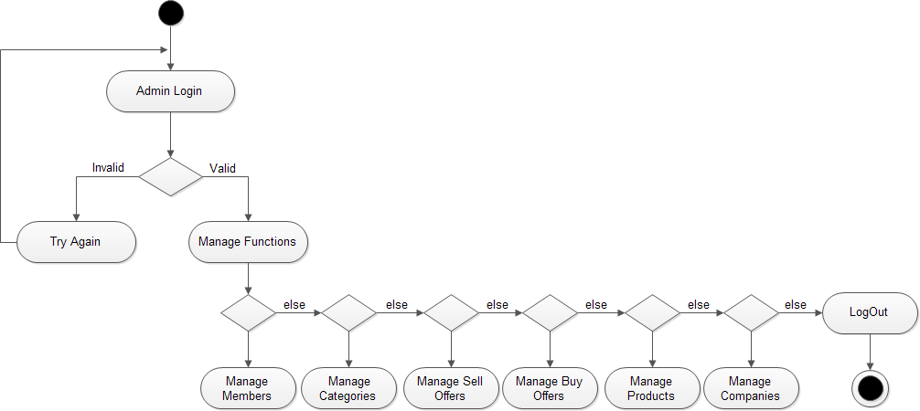

* 1. **ACTIVITY DIAGRAM**

Fig. 9.2.1 : ACTIVITY DIAGRAM FOR ADMIN

Fig. 9.2.2 : ACTIVITY DIAGRAM FOR USER

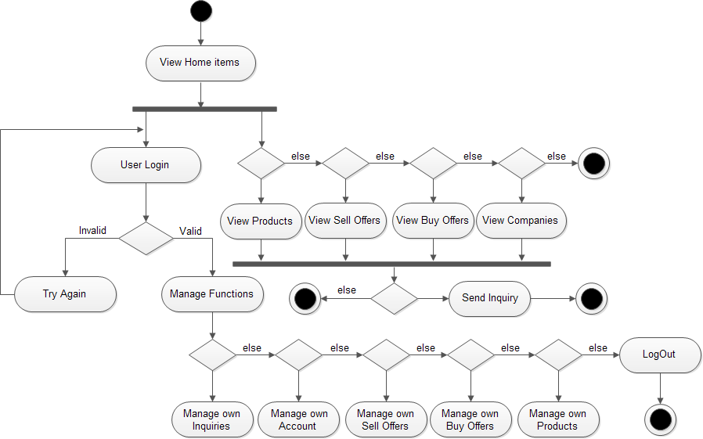

Fig. 9.2.3 : ACTIVITY DIAGRAM FOR USER REGISTRATION

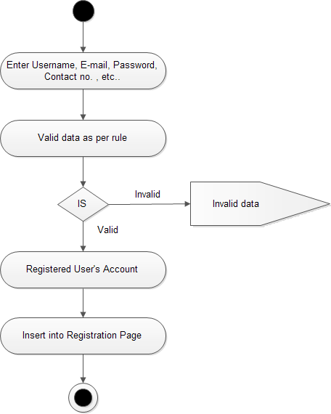

Fig. 9.2.4 : ACTIVITY DIAGRAM FOR USER LOGIN

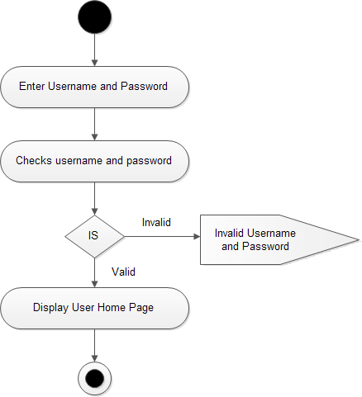

Fig. 9.2.5 : ACTIVITY DIAGRAM FOR USER FORGET PASSWORD

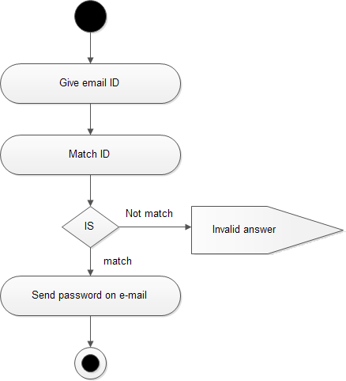

Fig. 9.2.6 : ACTIVITY DIAGRAM FOR USER CHANGE PASSWORD

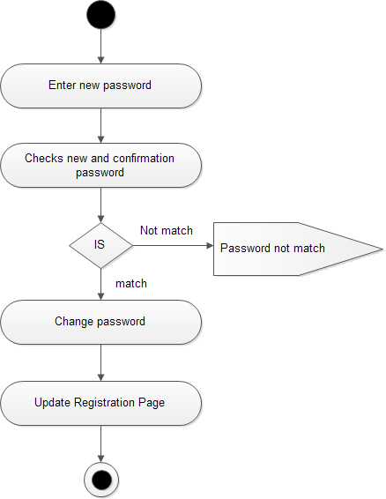

Fig. 9.2.7 : ACTIVITY DIAGRAM FOR ANY EDIT PAGE

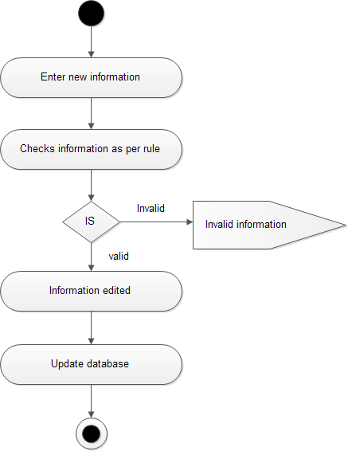

## CLASS DIAGRAM

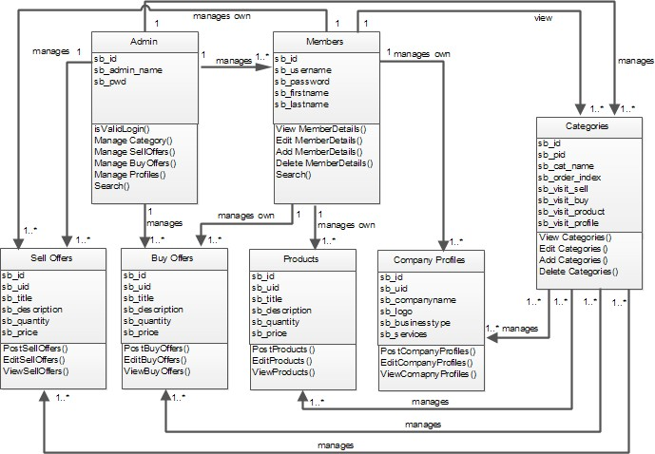

* 1. **SEQUENCE DIAGRAM**

Fig. 9.4.1 : SEQUENCE DIAGRAM FOR USER

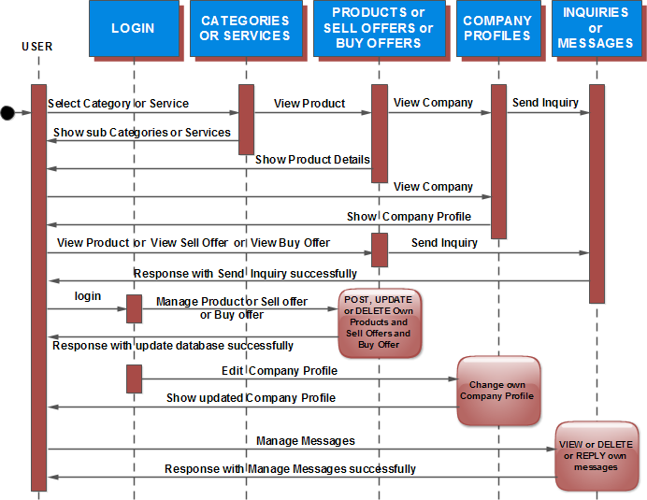

Fig. 9.4.2 : SEQUENCE DIAGRAM FOR ADMIN

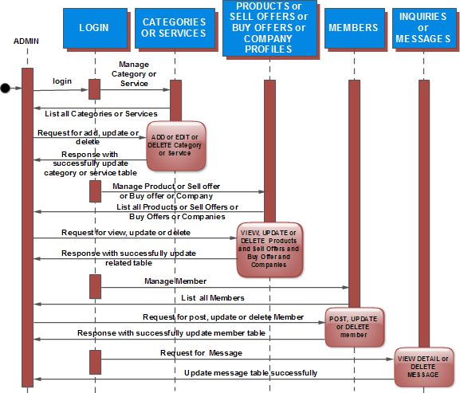



**SYSTEM IMPLEMENTATION**

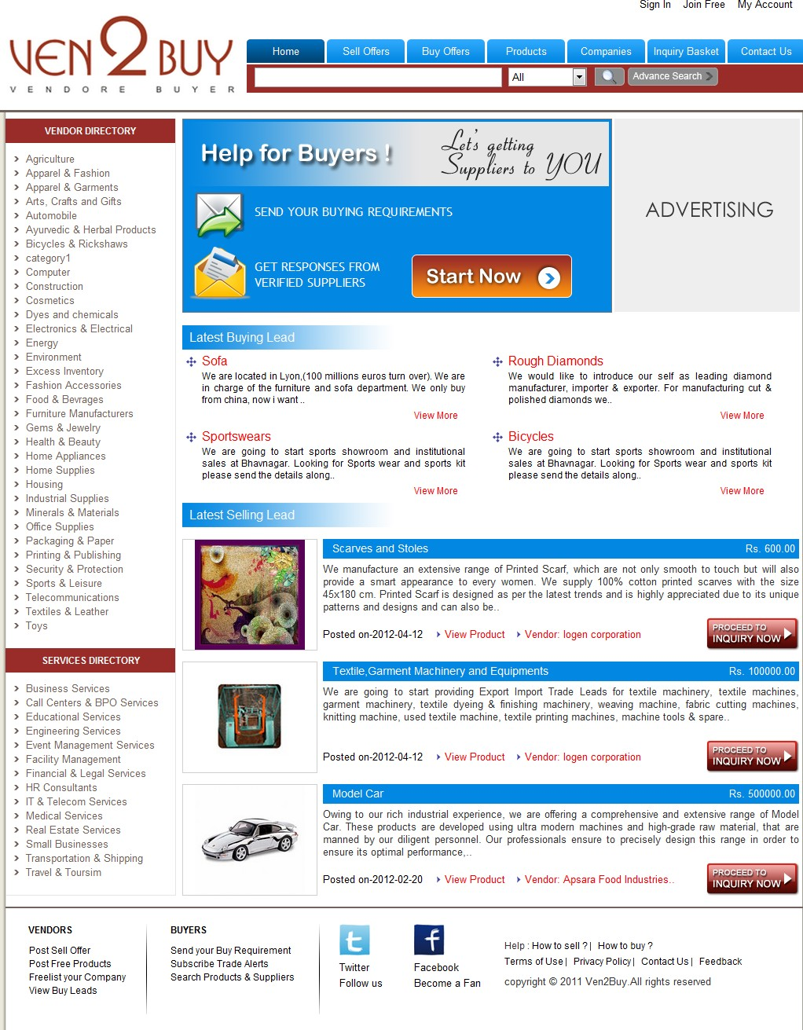

# SYSTEM IMPLEMENTATION

## SCREEN SHOTS

* + 1. HOME PAGE / INDEX PAGE

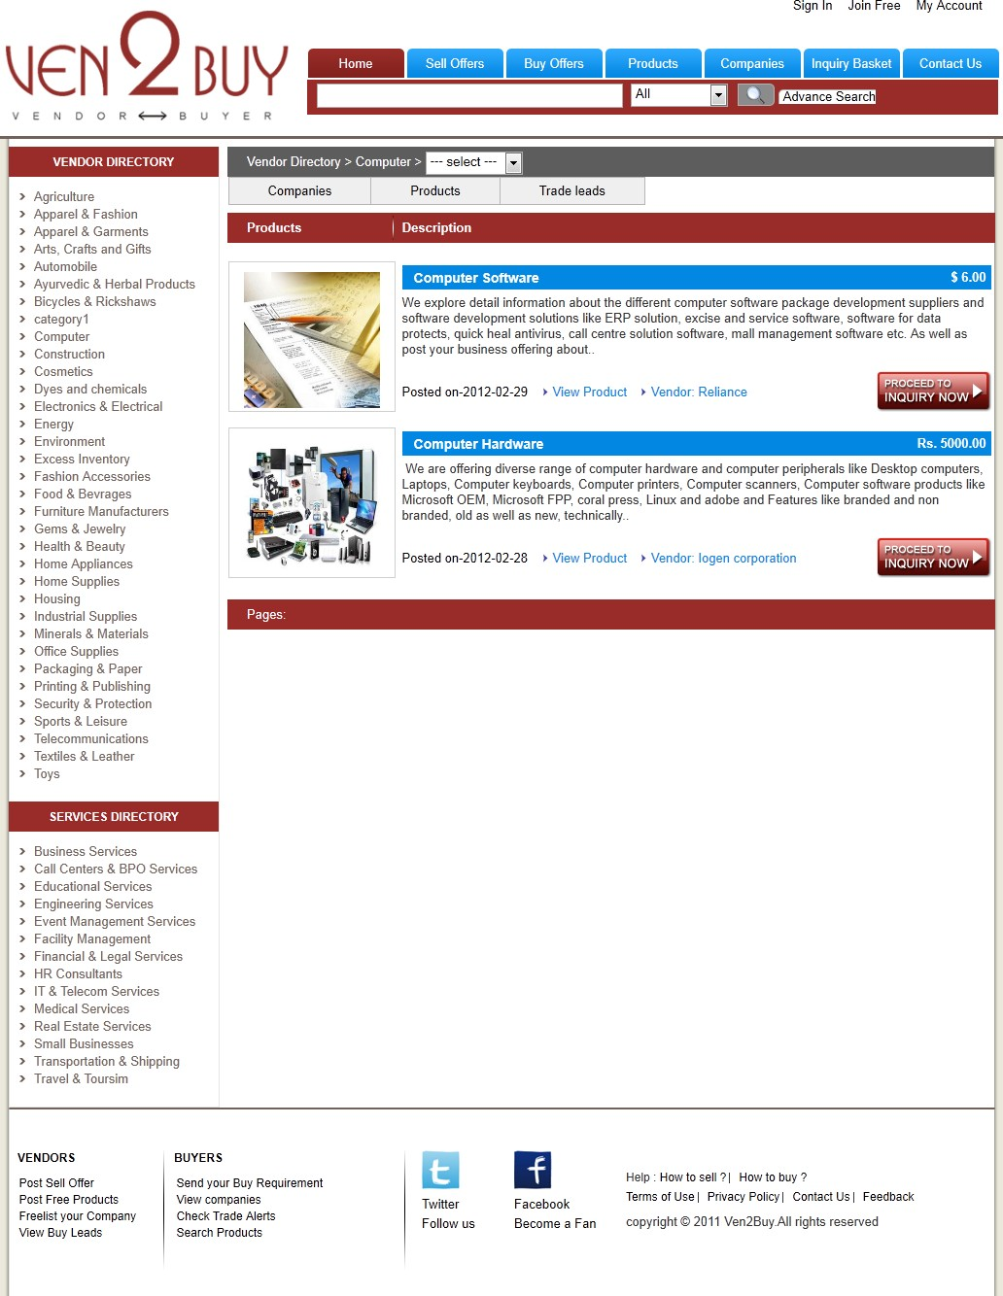

* + 1. CATEGORIES WISE LISTING PAGE

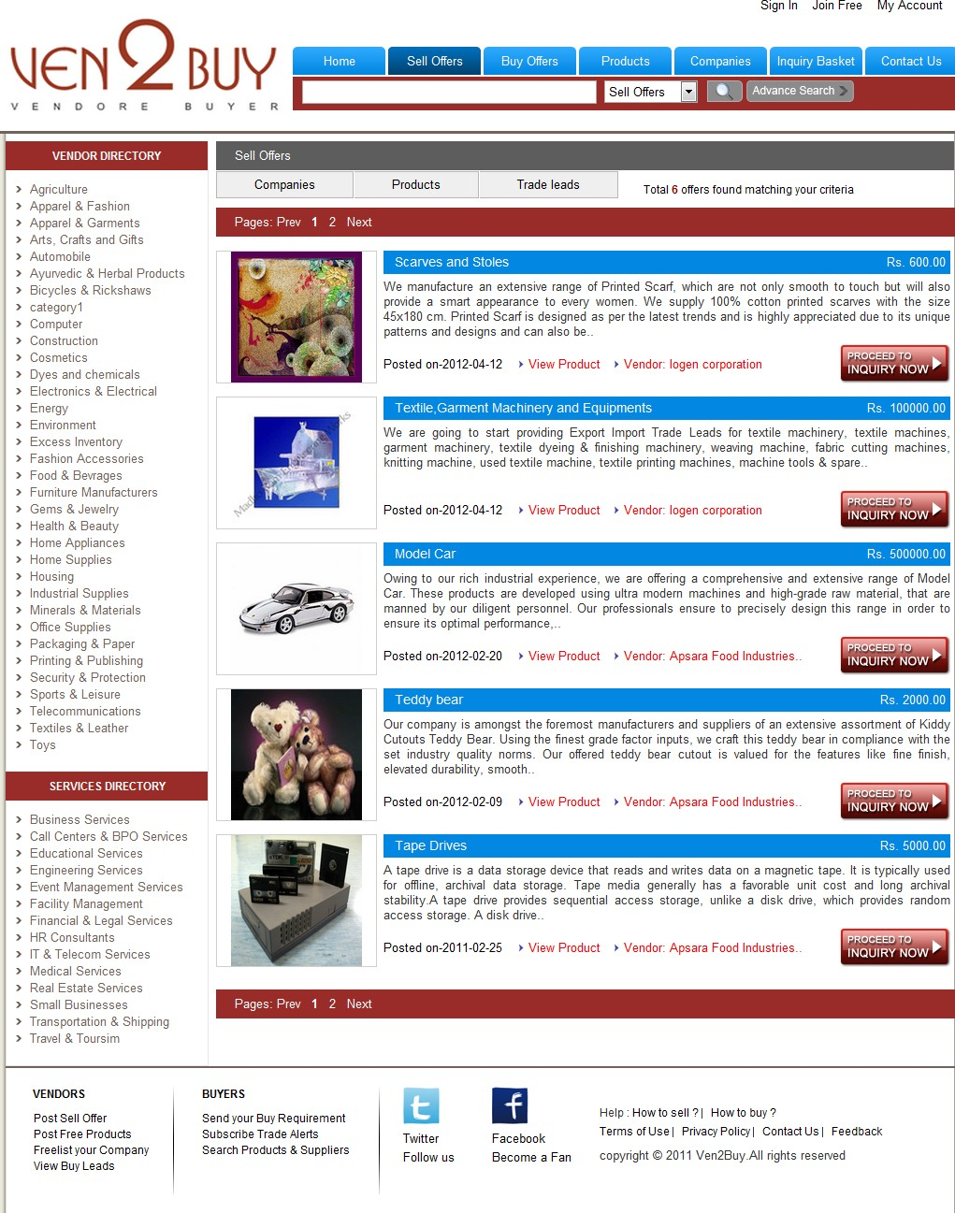

* + 1. SELL OFFERS PAGE



* + 1. SELL OFFER DETAILS PAGE

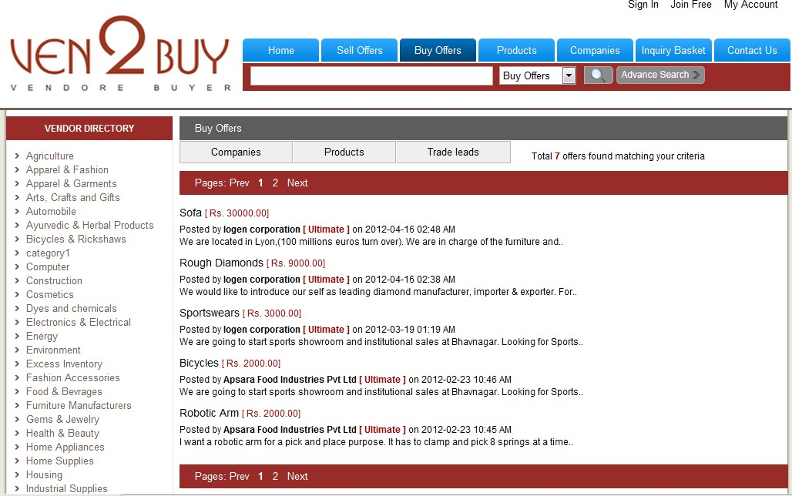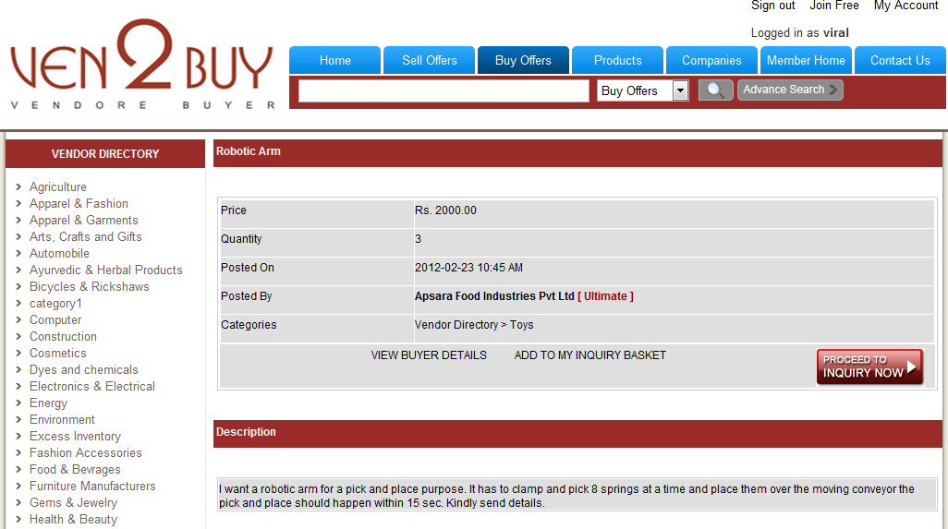

* + 1. BUY OFFERS PAGE
    2. BUY OFFER DETAILS PAGE

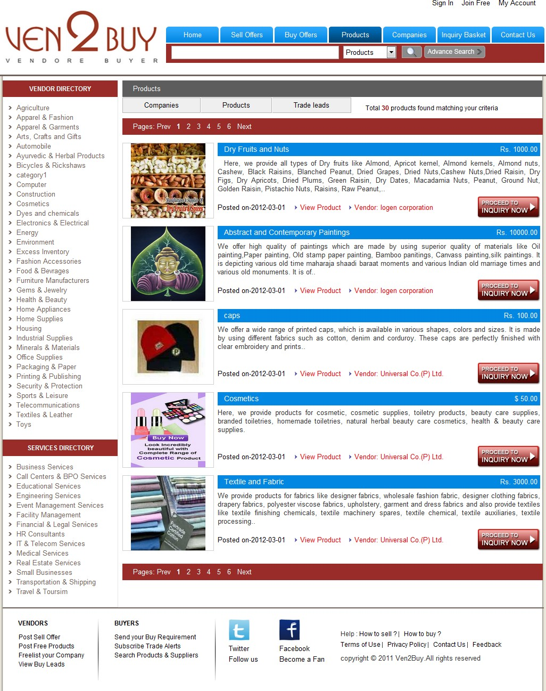

* + 1. PRODUCTS PAGE

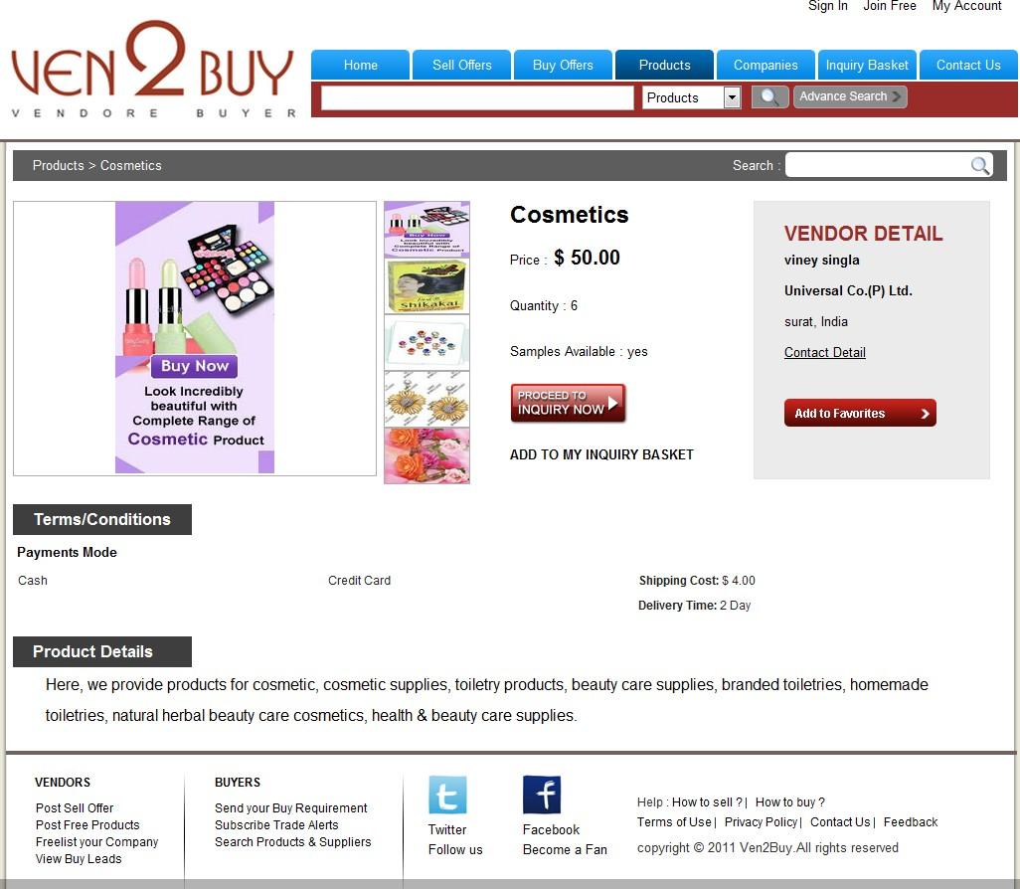

* + 1. PRODUCT DETAILS PAGE

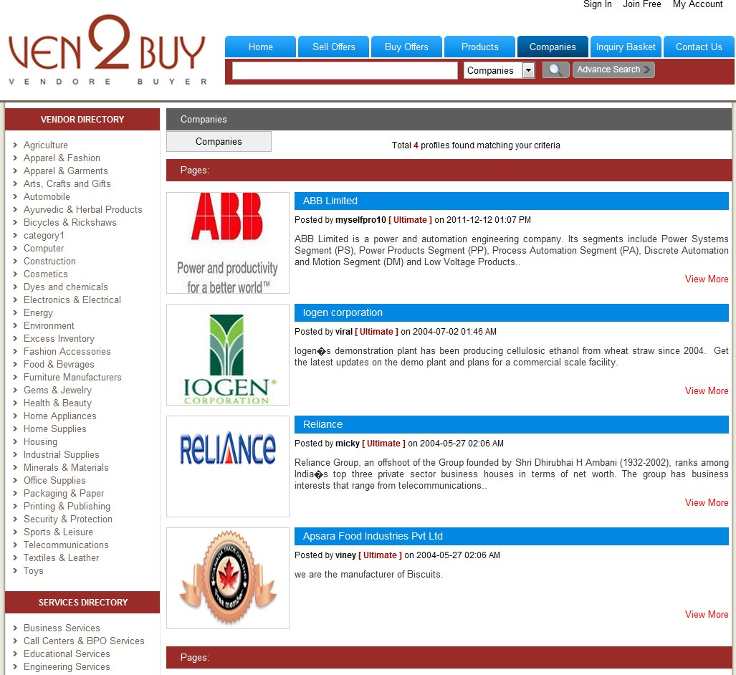

* + 1. COMPANIES PAGE

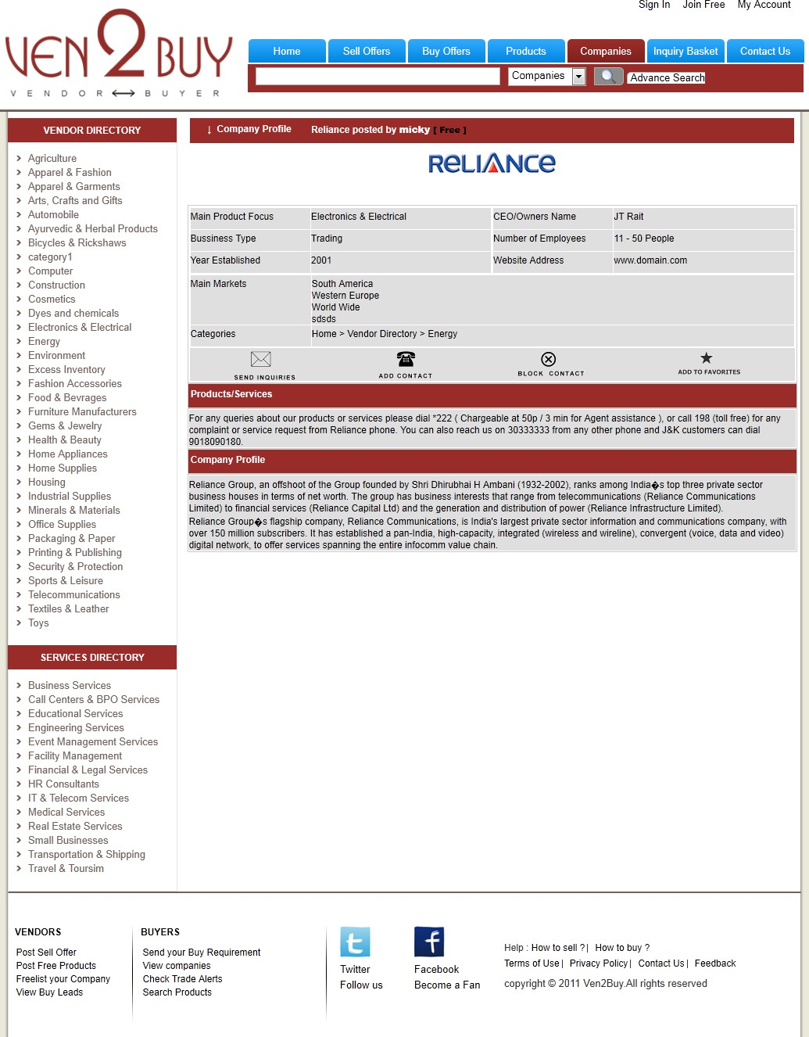

* + 1. COMPANY DETAILS PAGE

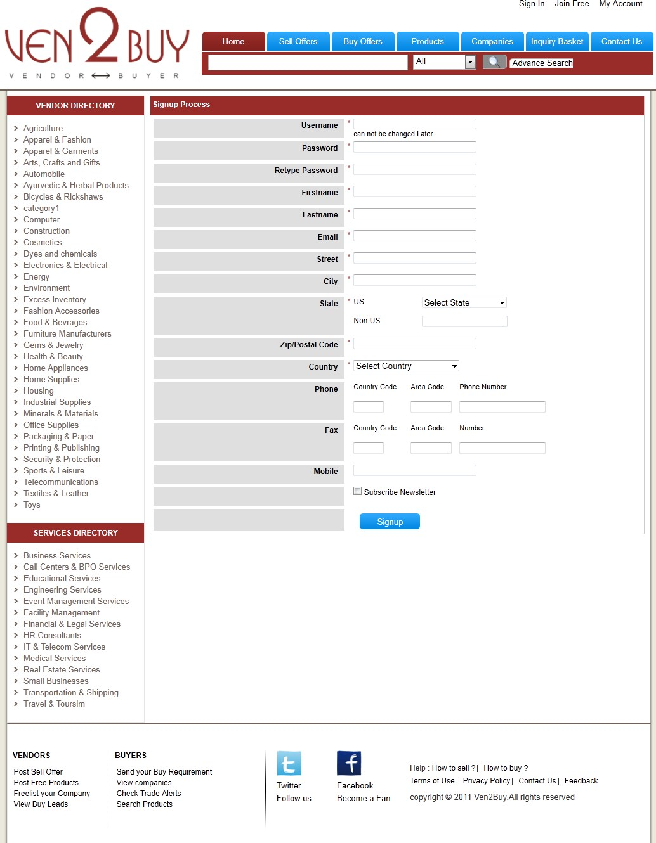

* + 1. USER REGISTRATION PAGE

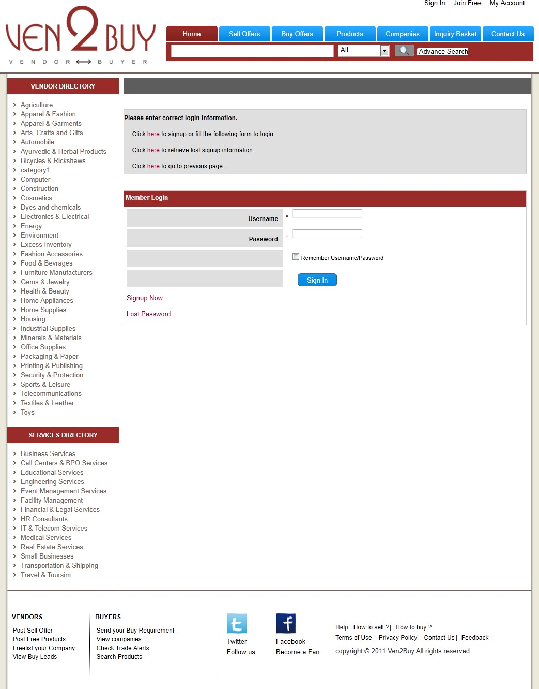

* + 1. LOGIN PAGE

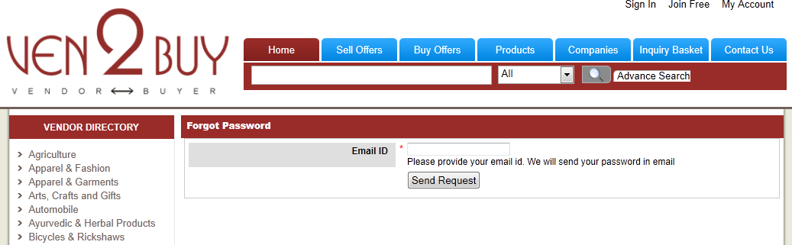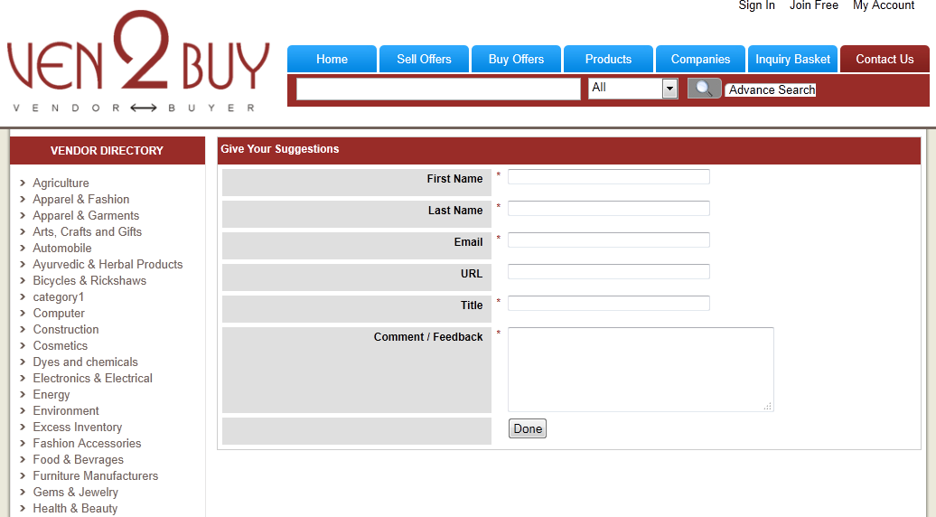

* + 1. FORGET PASSWORD PAGE
    2. CONTACT US PAGE

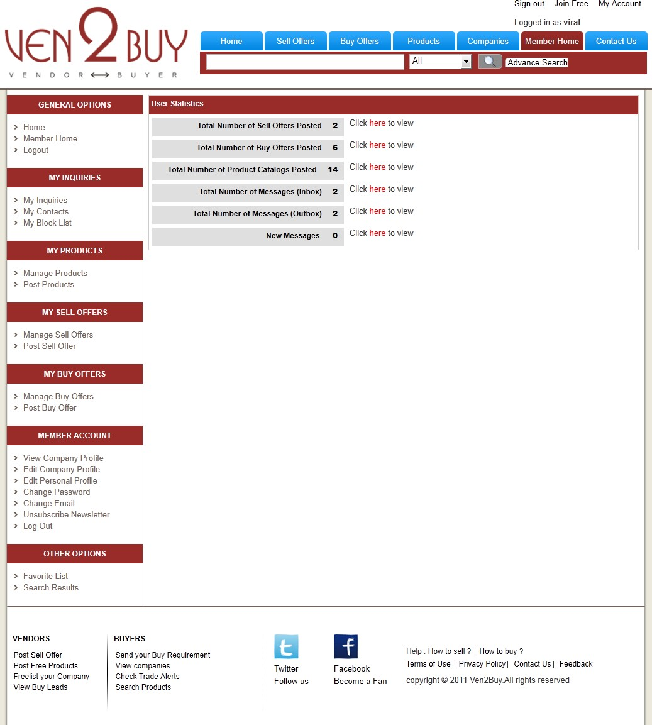

* + 1. MEMBER HOME PAGE

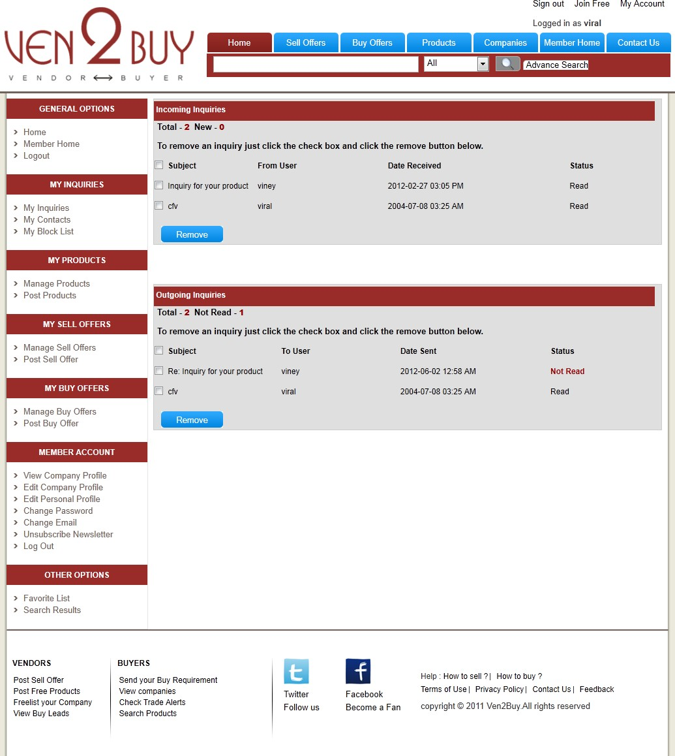

* + 1. MY INQUIRIES PAGE

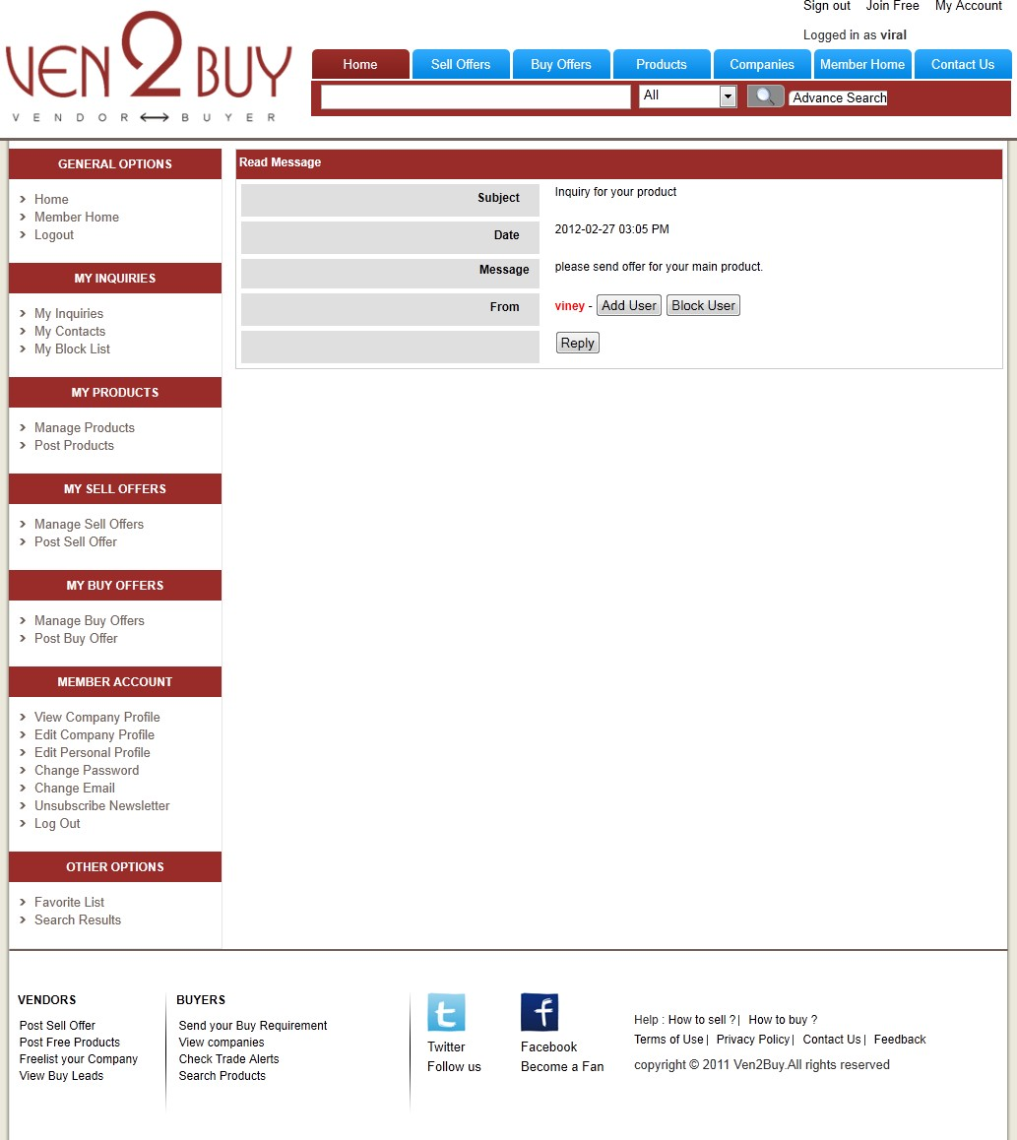

* + 1. READ MESSAGE PAGE

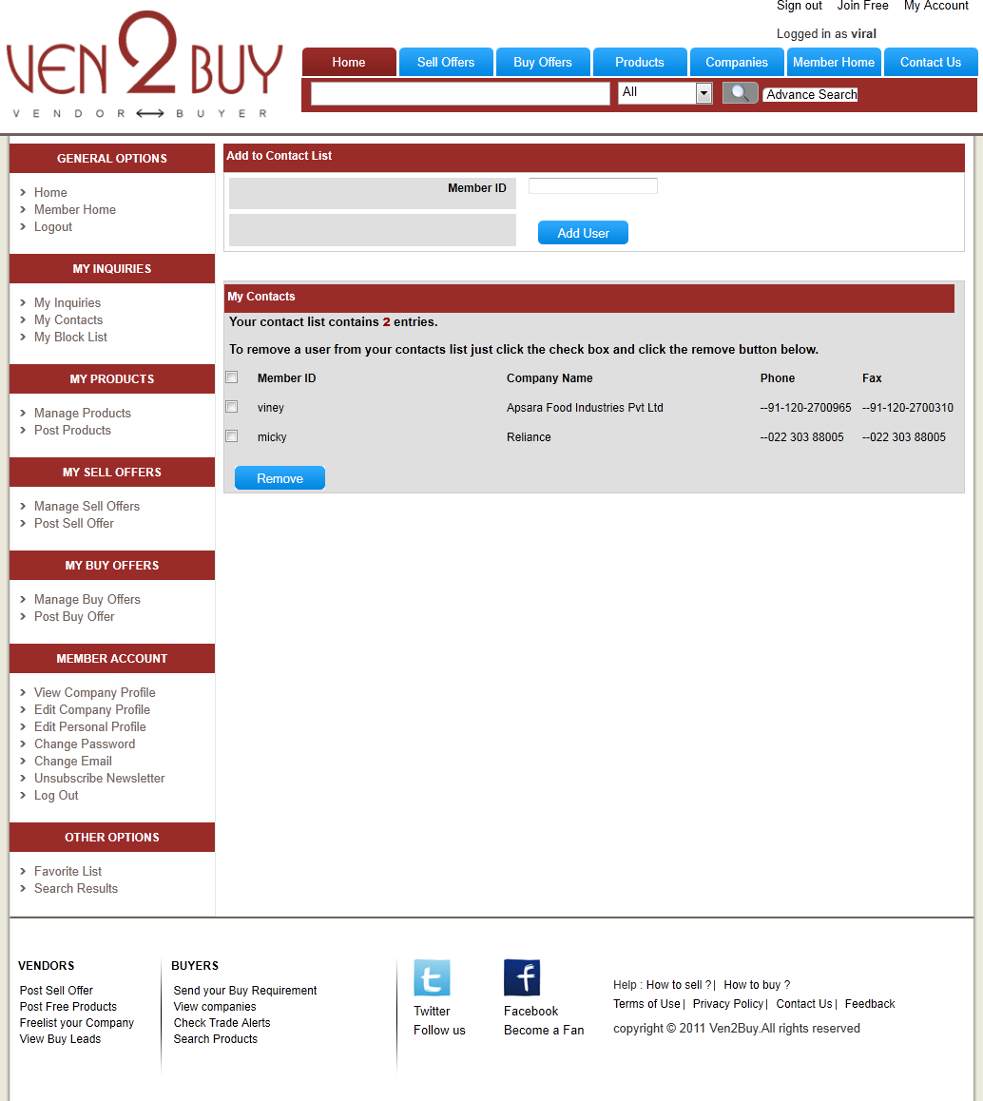

* + 1. MY CONTACTS PAGE

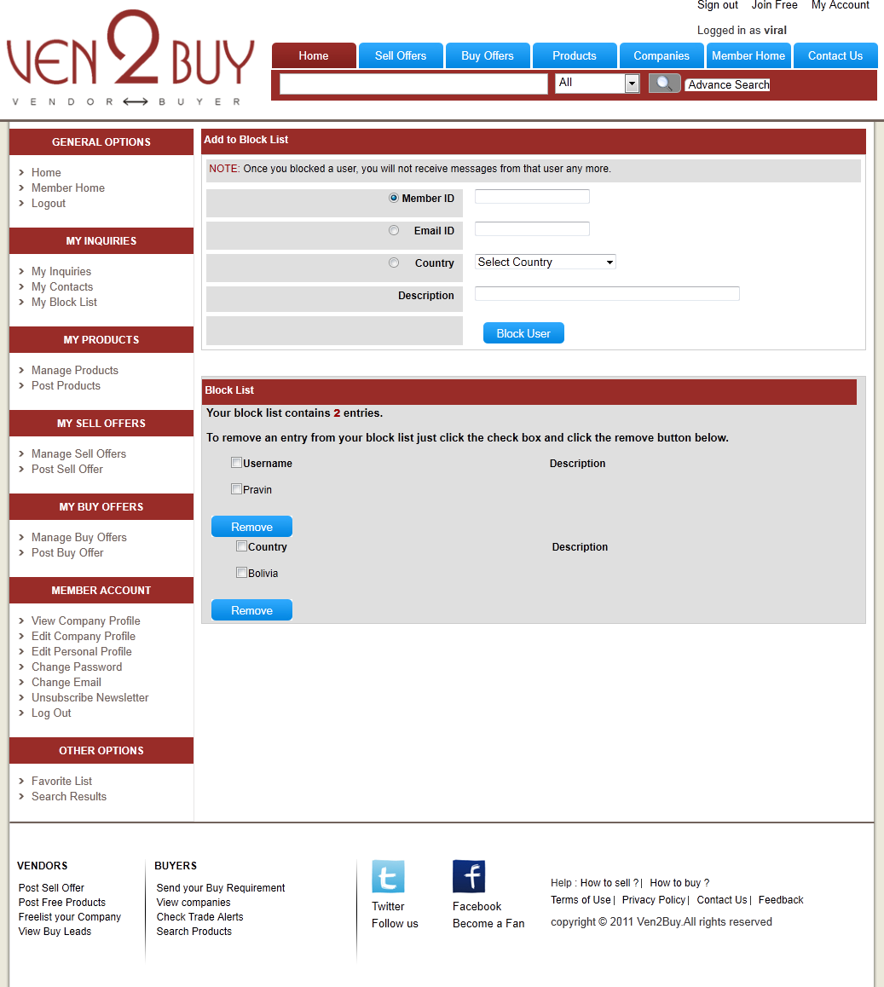

* + 1. MY BLOCK LIST PAGE

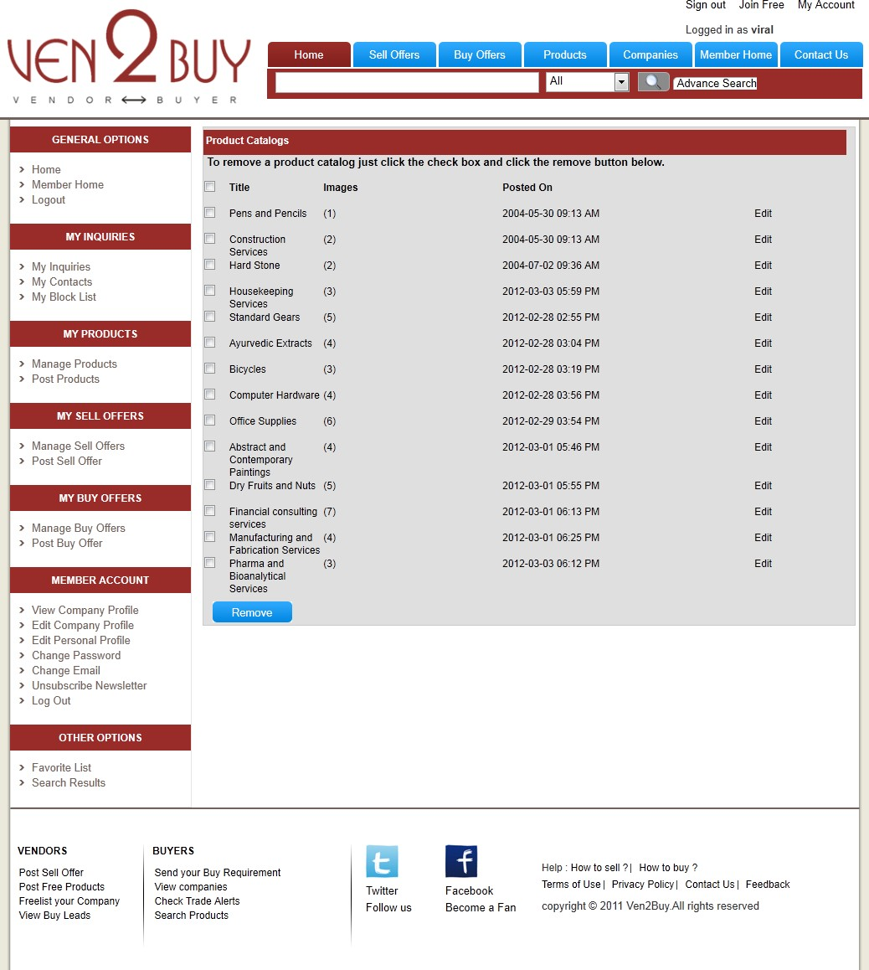

* + 1. MANAGE PROUCTS PAGE
    2. UPLOAD IMAGES FOR PRODUCT

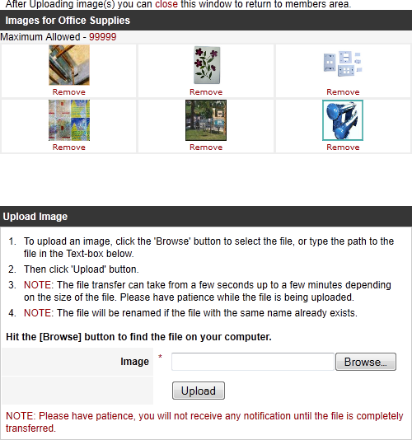

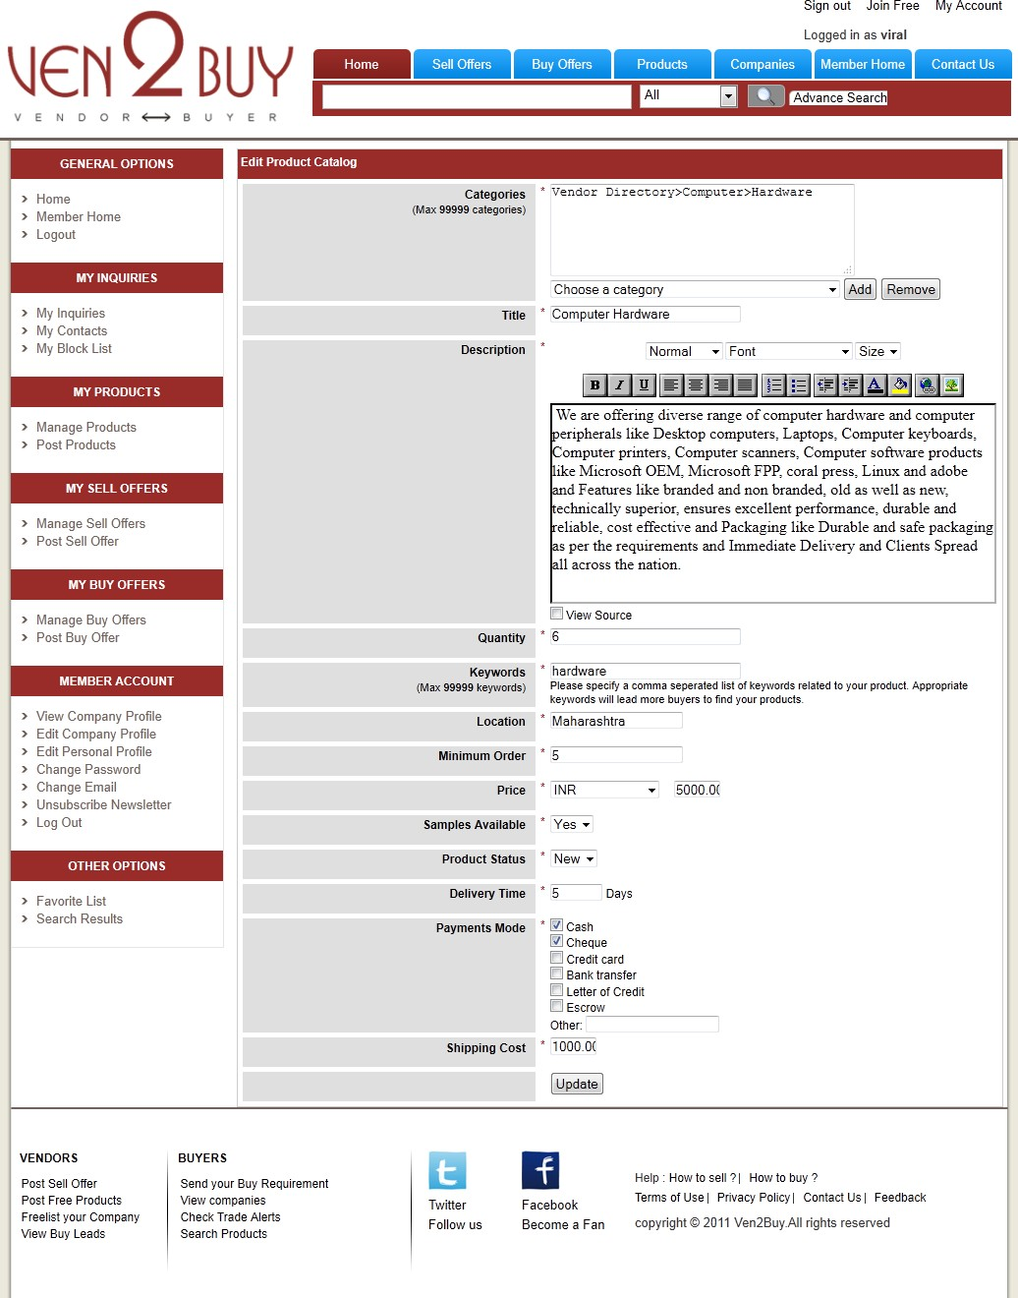

* + 1. EDIT PRODUCT PAGE

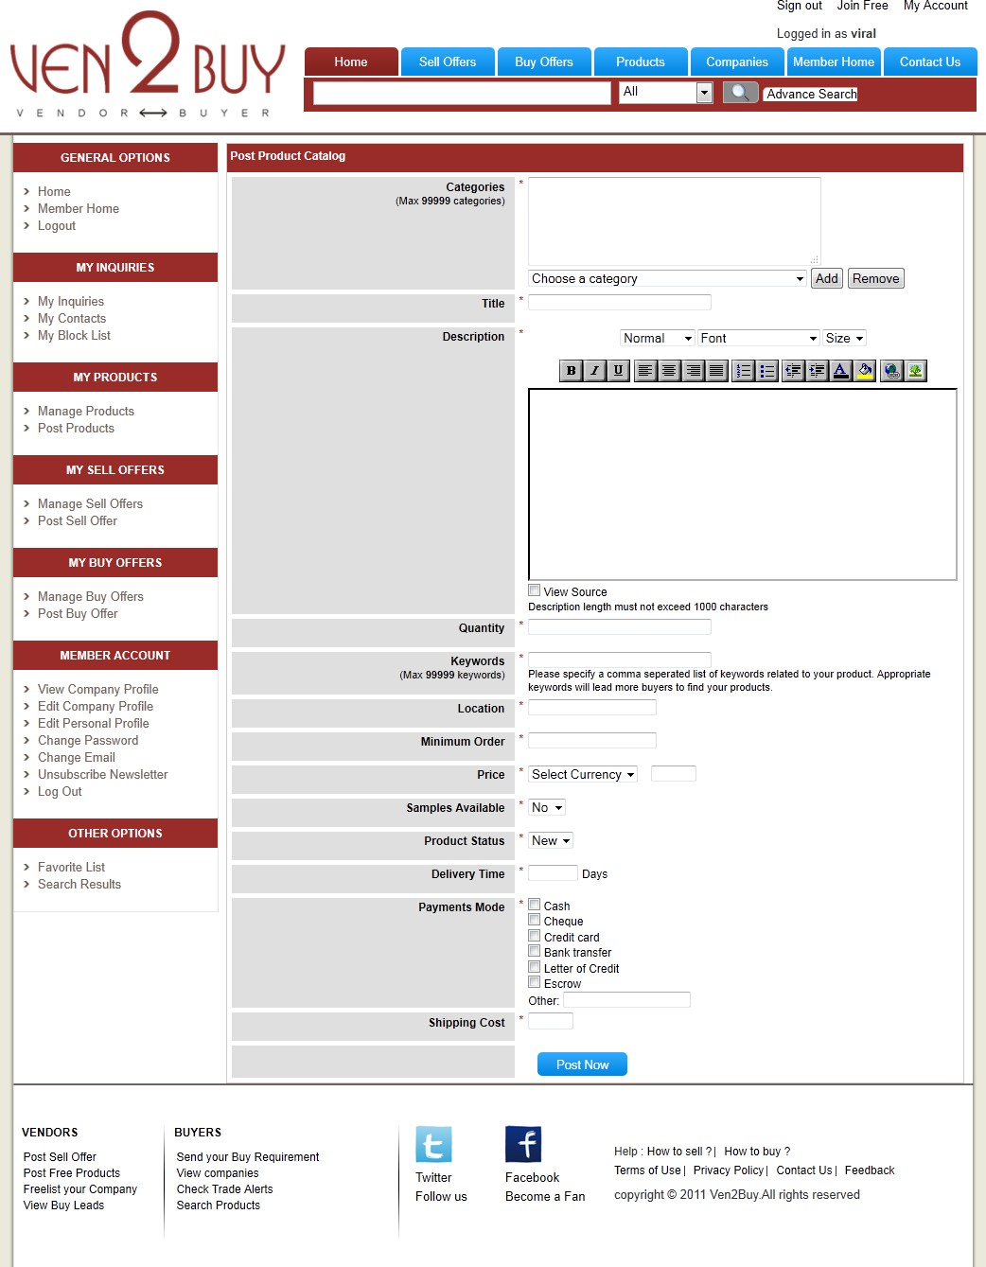

* + 1. POST PRODUCT PAGE

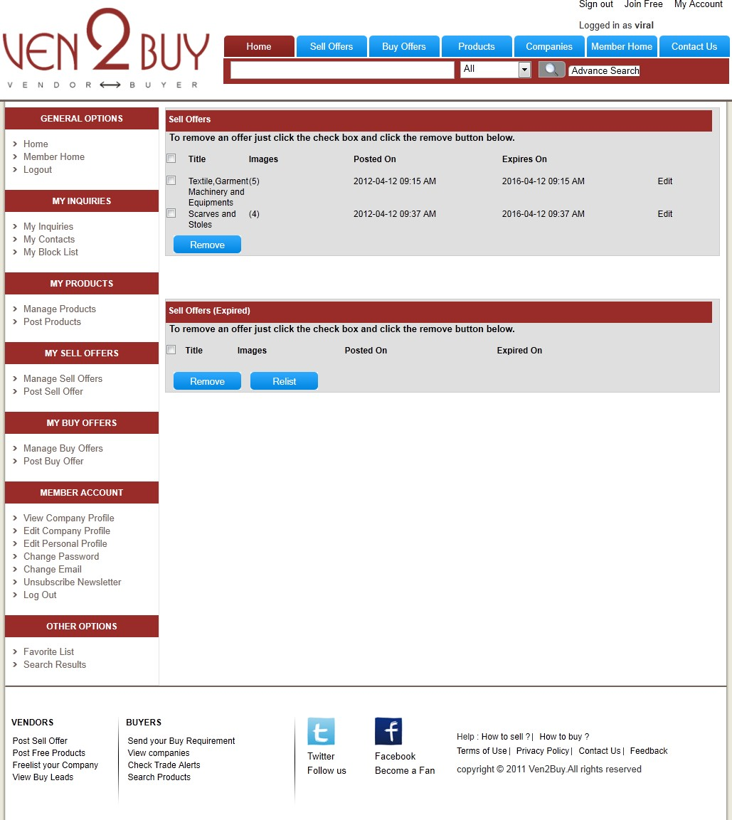

* + 1. MANAGE SELL OFFER PAGE

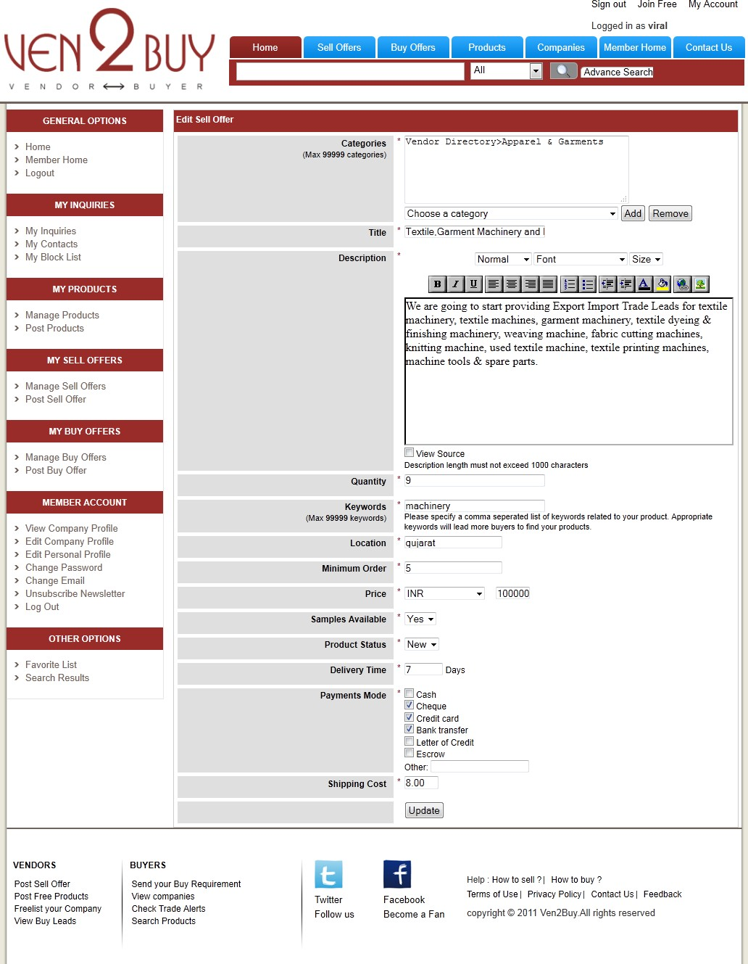

* + 1. EDIT SELL OFFER PAGE

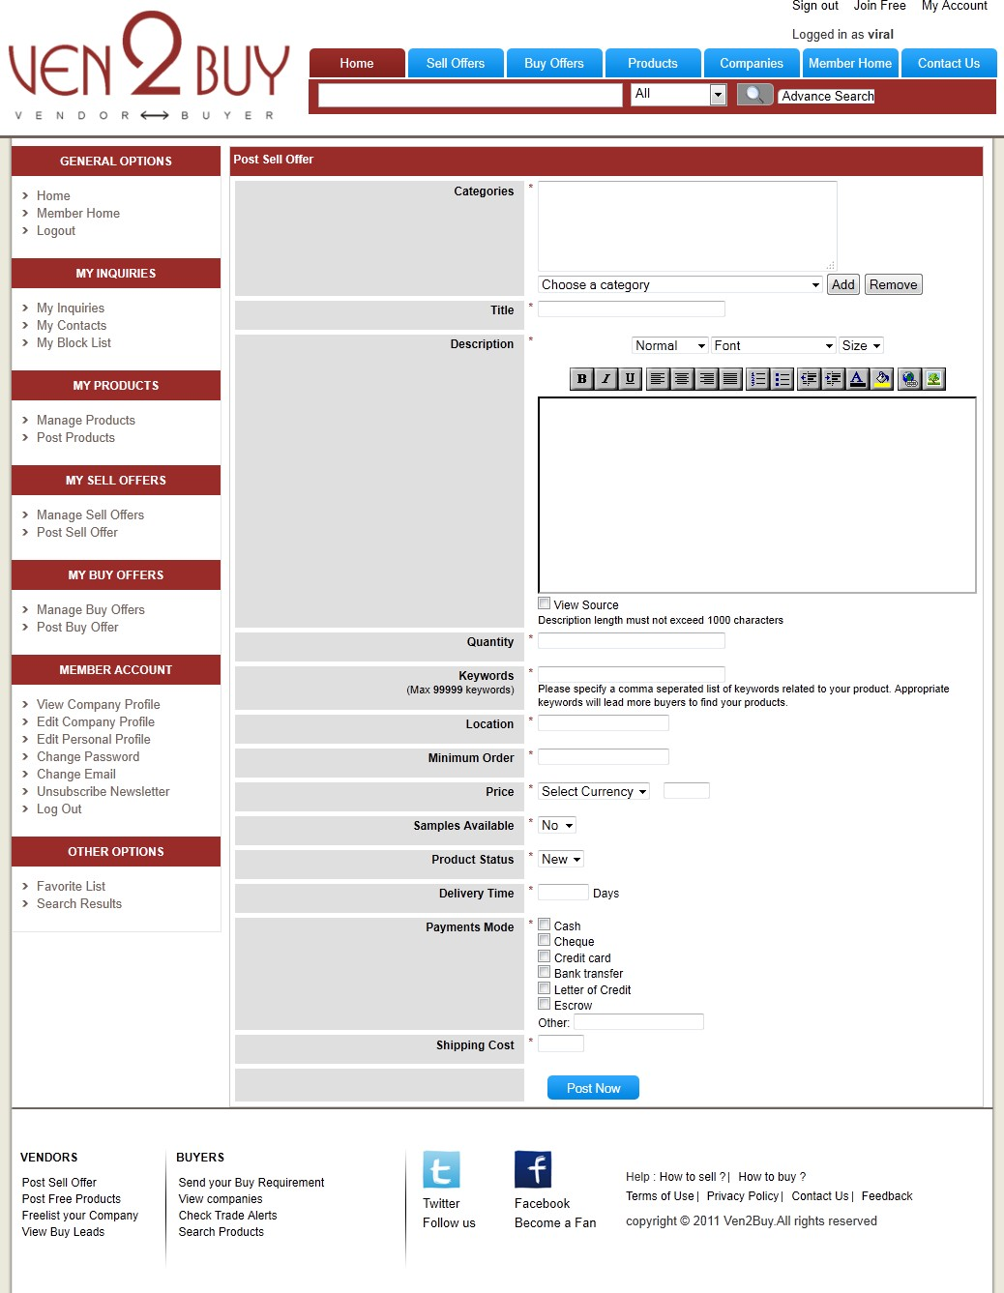

* + 1. POST SELL OFFER PAGE

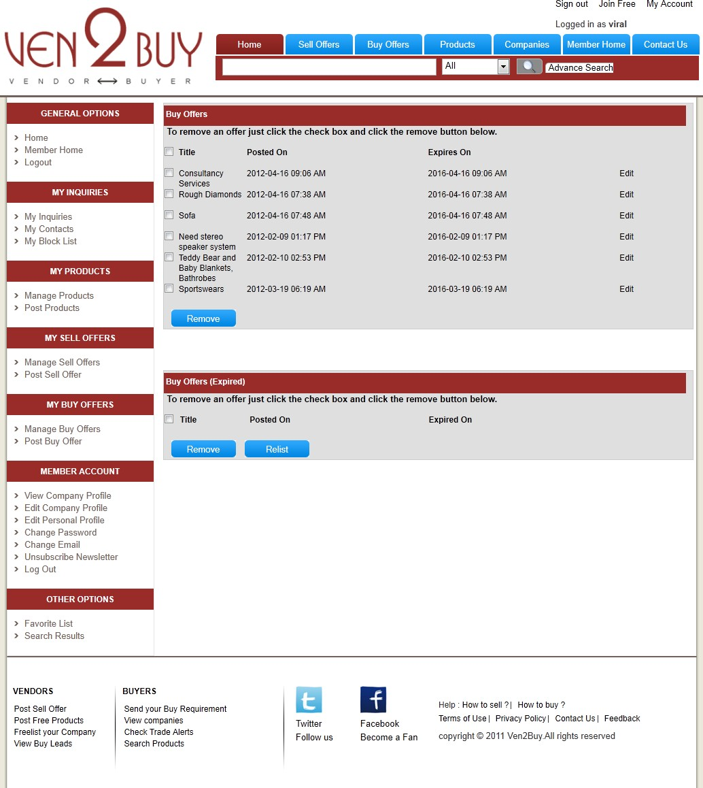

* + 1. MANAGE BUY OFFER PAGE

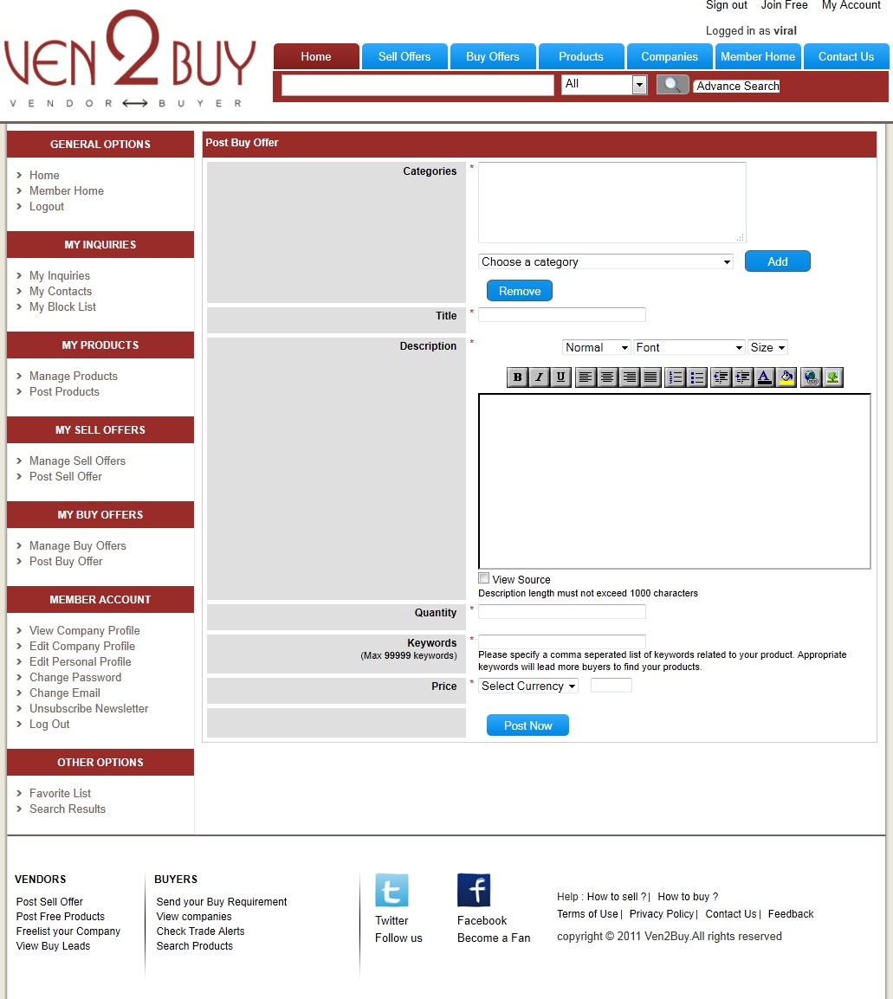

* + 1. POST BUY OFFER PAGE

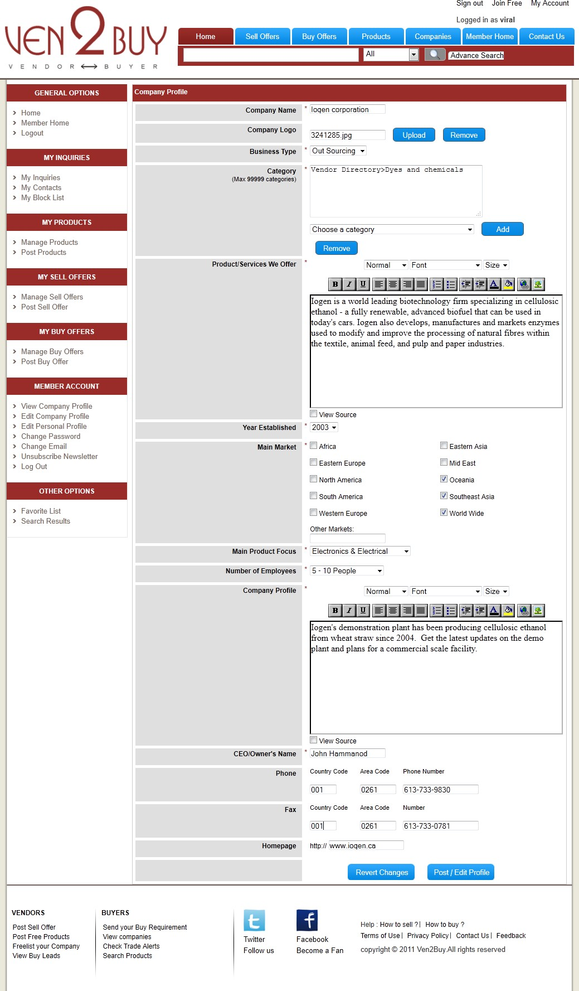

* + 1. EDIT COMPANY PROFILE PAGE

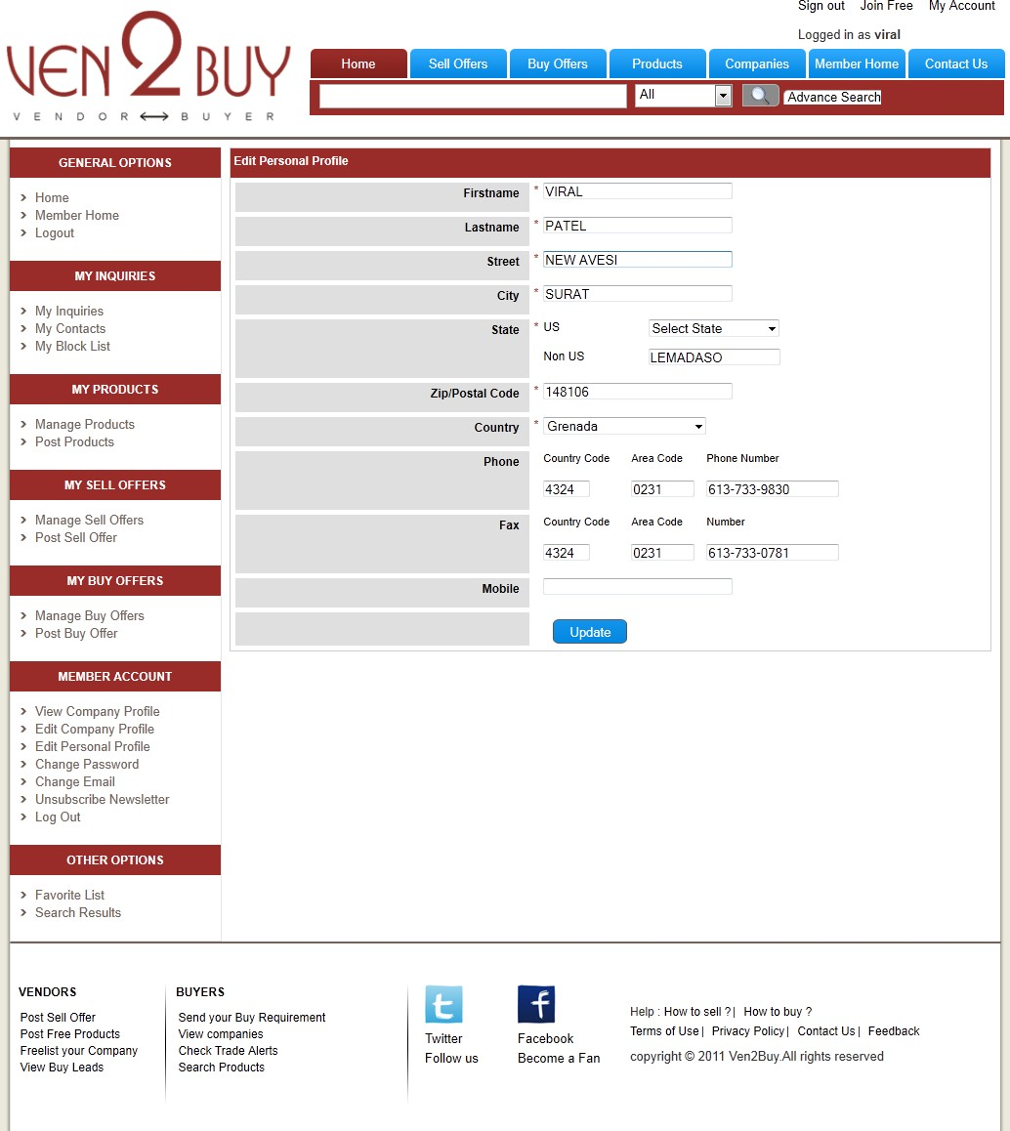

* + 1. EDIT PERSONAL PROFILE PAGE

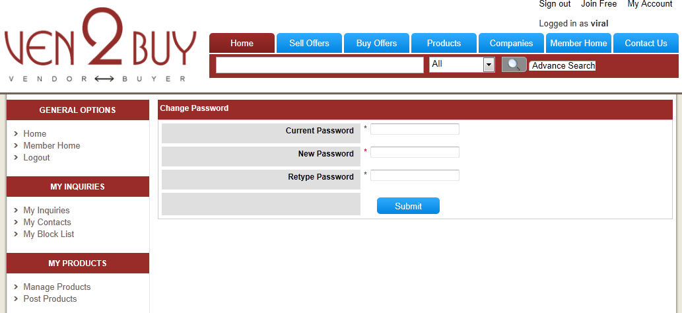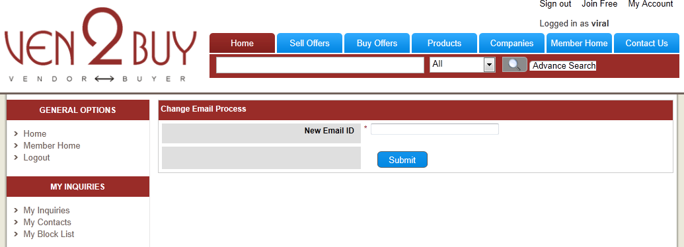

* + 1. CHANGE PASSWORD PAGE
    2. CHANGE EMAIL ID PAGE

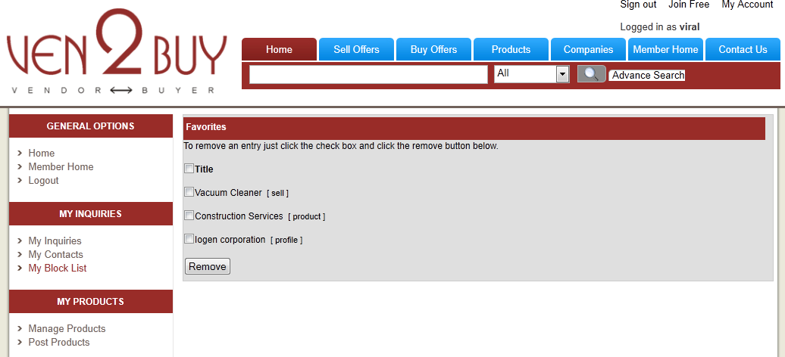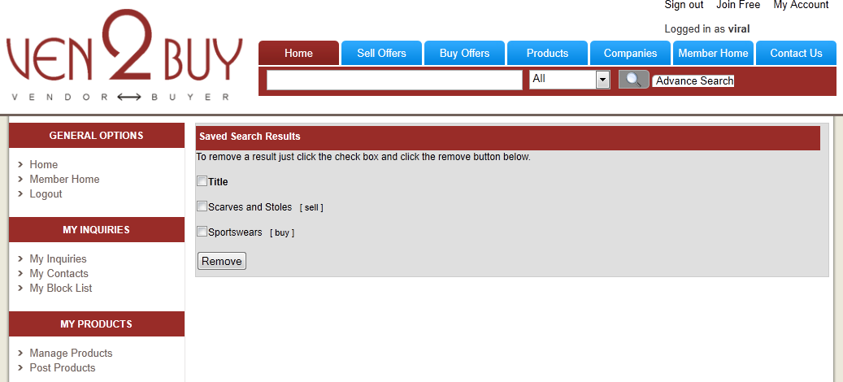

* + 1. FAVORITE LIST PAGE
    2. SAVED SEARCH RESULTS PAGE

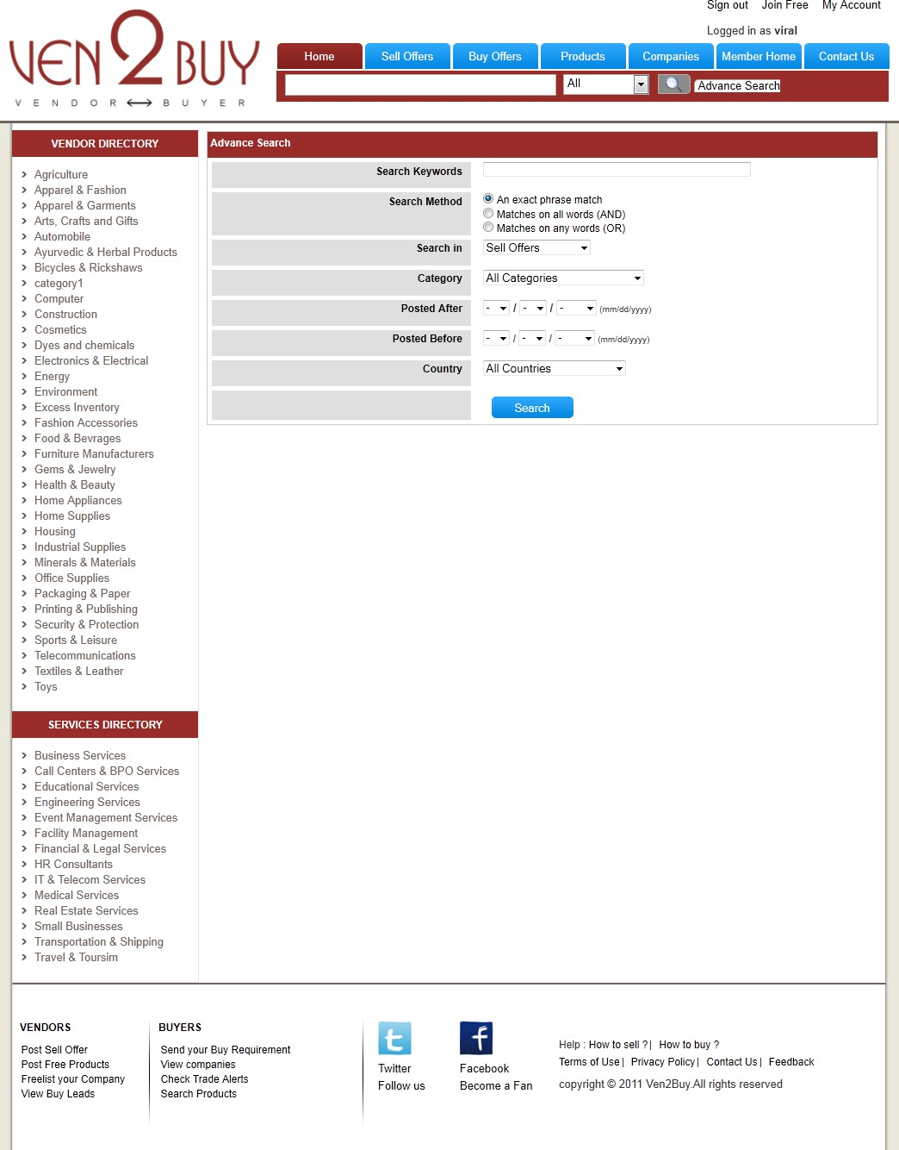

* + 1. ADVANCE SEARCH PAGE
    2. HELP PAGE

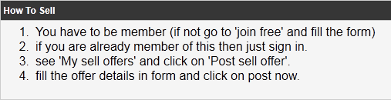

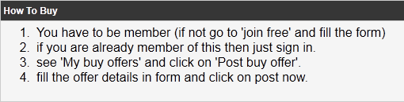

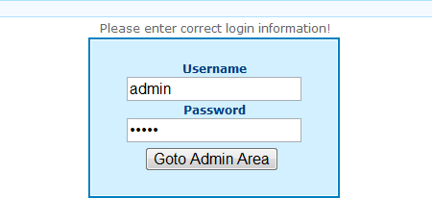

* + 1. ADMIN LOGIN PAGE

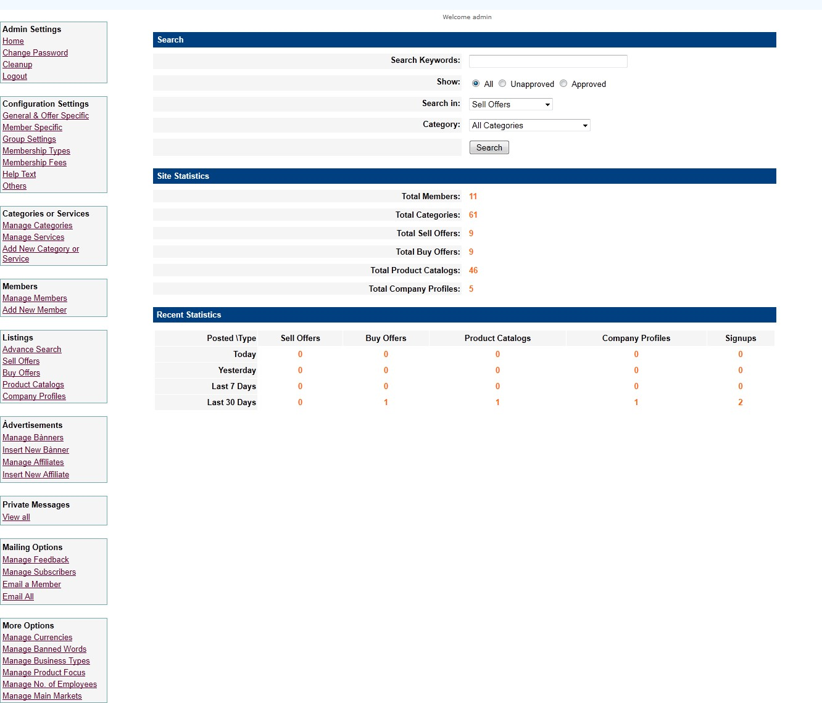

* + 1. ADMIN HOME PAGE
    2. ADMIN CHANGE PASSWORD PAGE

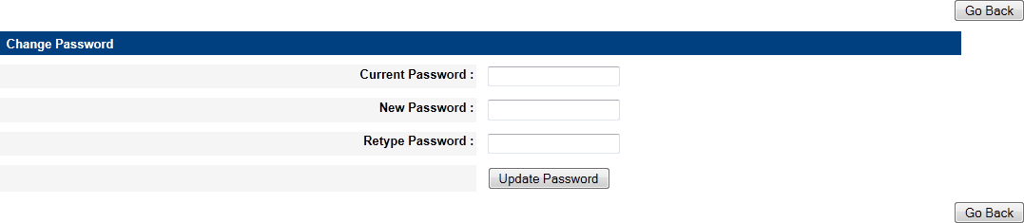

* + 1. ADMIN CLEAN UP PAGE

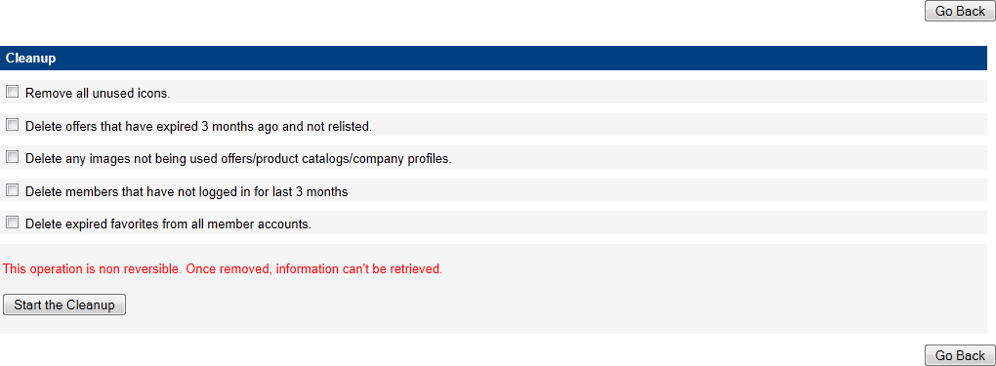

* + 1. ADMIN OFFER SPECIFIC PARAMETERS PAGE

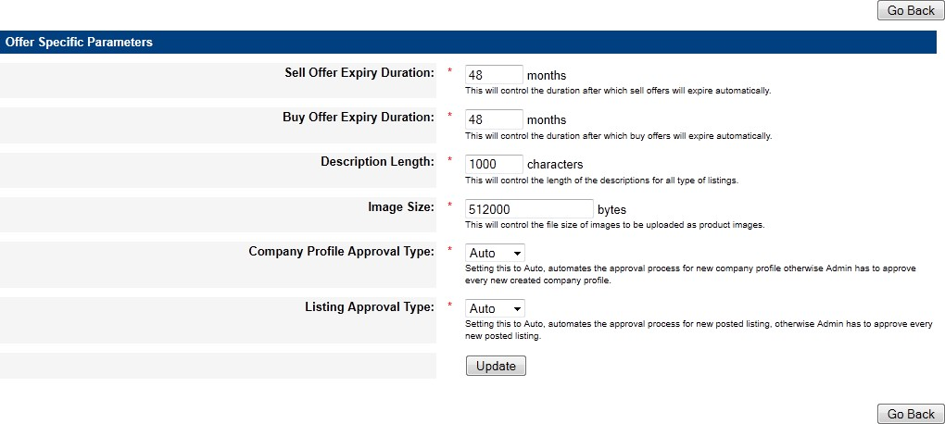

* + 1. ADMIN MEMBER SPECIFIC PARAMETERS PAGE

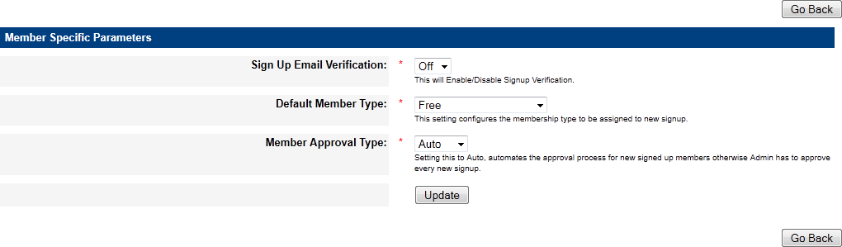

* + 1. ADMIN CONFIGURE MEMBER OPTIONS PAGE

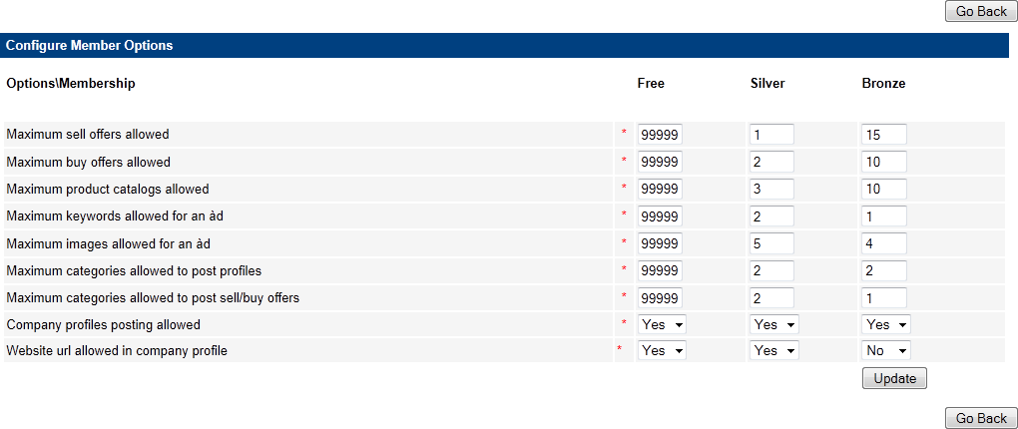

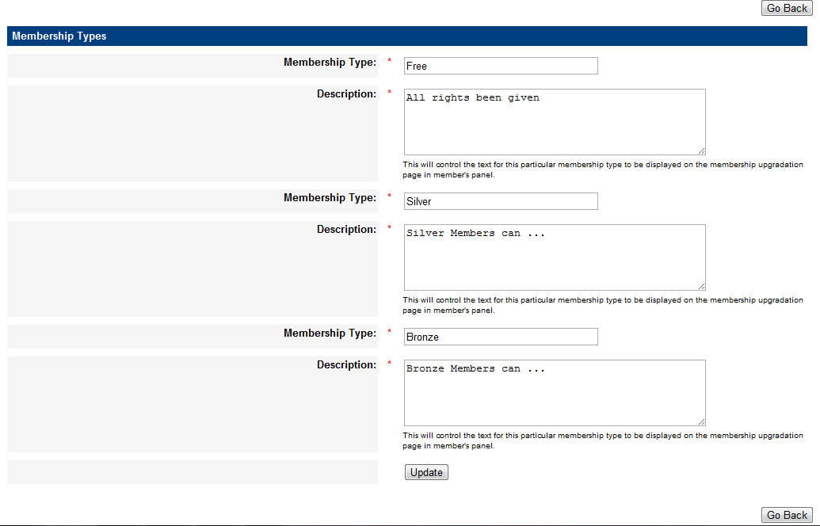

* + 1. MEMBERSHIP TYPES PAGE
    2. MEMBERSHIP FEES PAGE

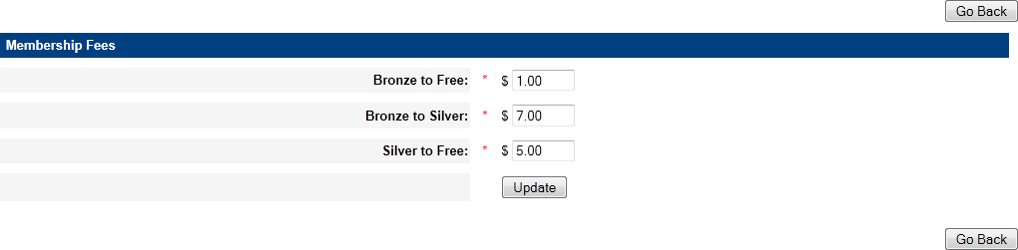

* + 1. 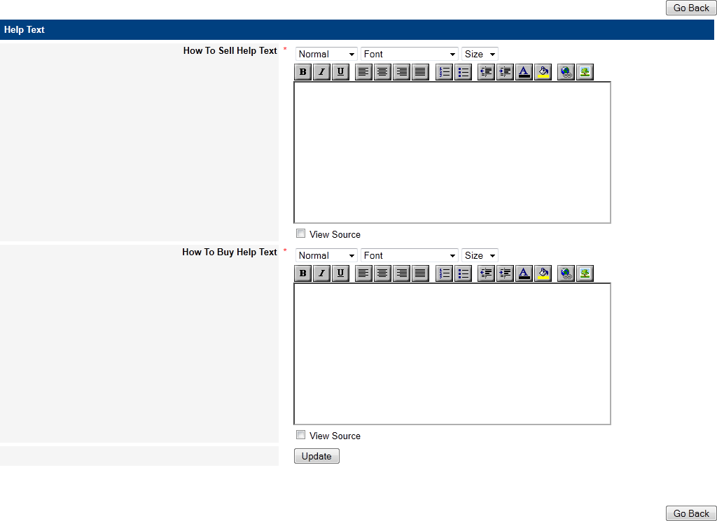HELP TEXT PAGE
    2. 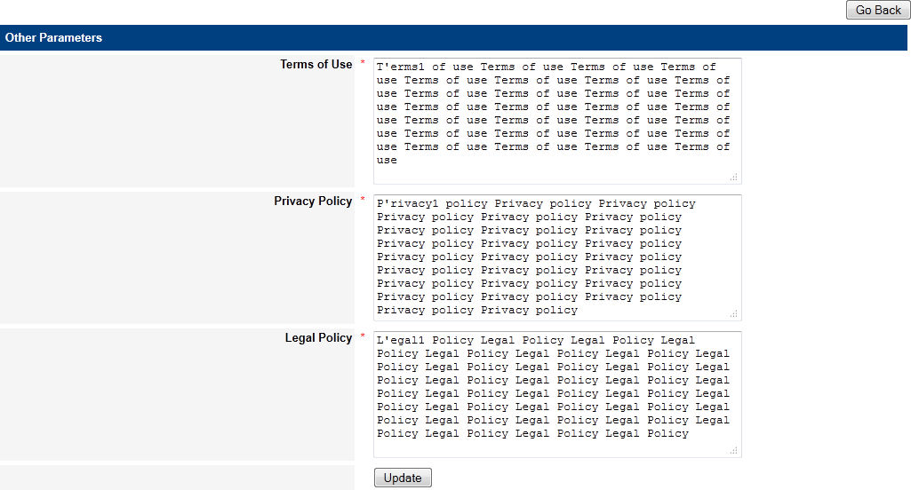OTHER PARAMETERS PAGE
    3. MANAGE CATEGORIES PAGE

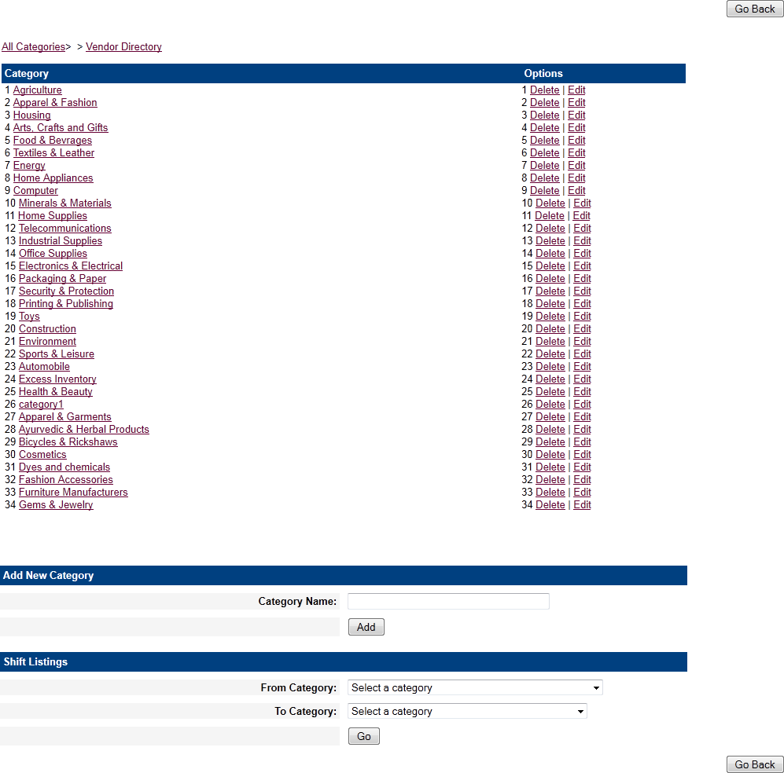

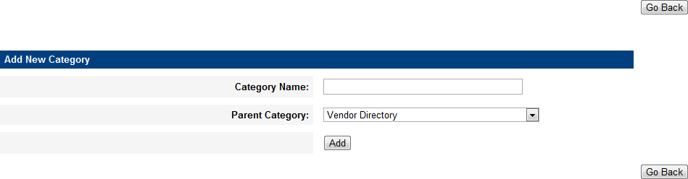

* + 1. MANAGE SERVICES PAGE

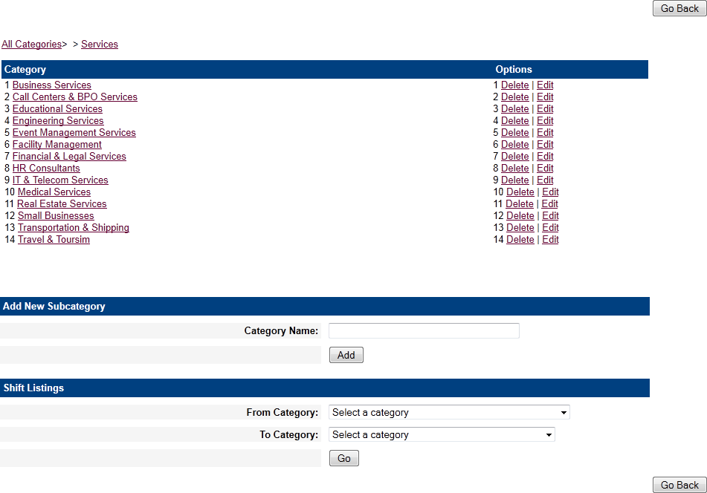

* + 1. ADD NEW CATEGORY PAGE
    2. MANAGE MEMBER PAGE

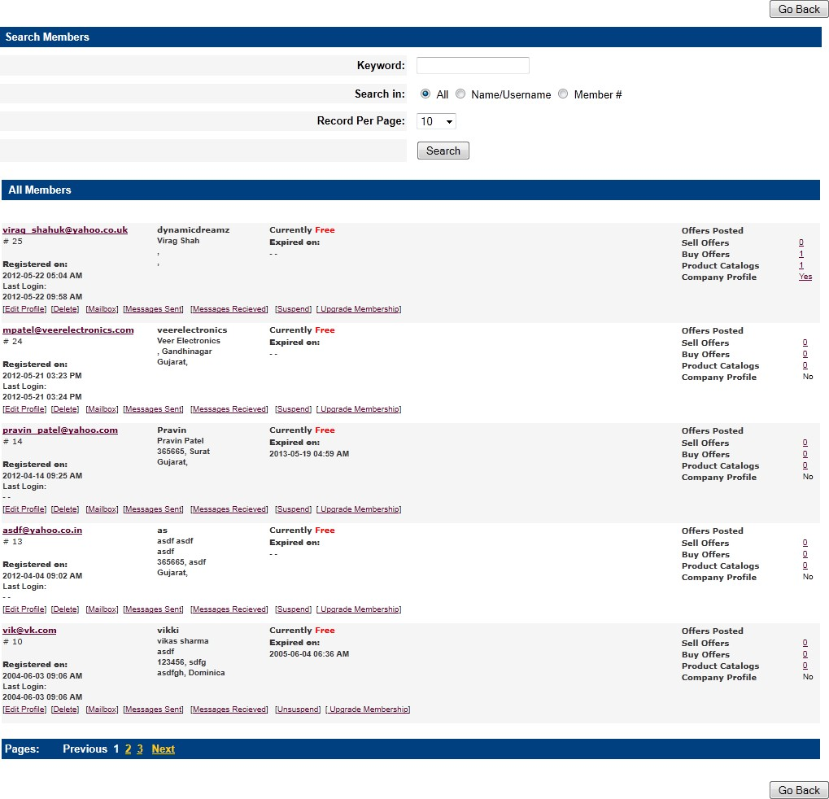

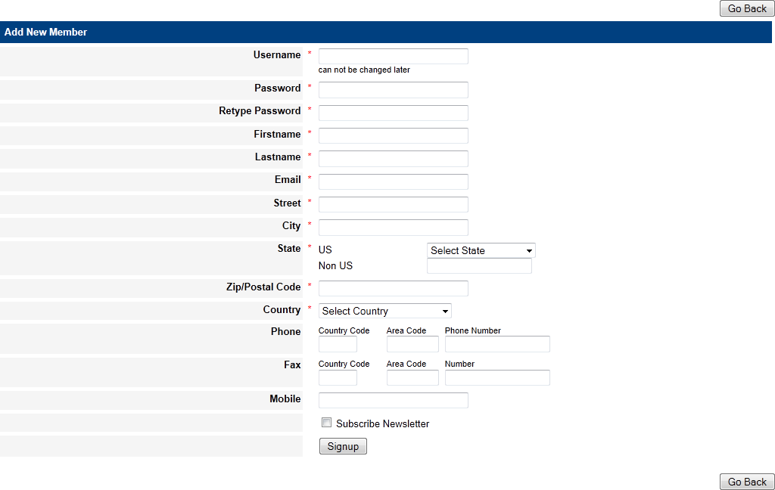

* + 1. 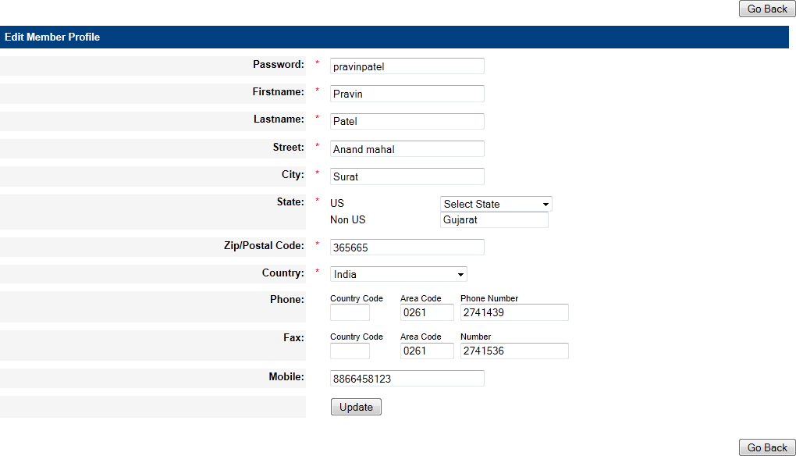EDIT MEMBER PROFILE PAGE
    2. ADD NEW MEMBER PAGE
    3. ADVANCE SEARCH PAGE

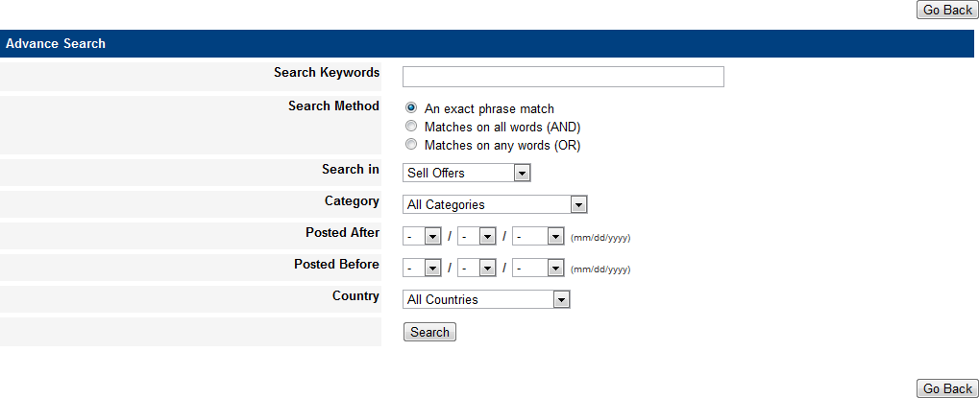

* + 1. MANAGE SELL OFFERS PAGE

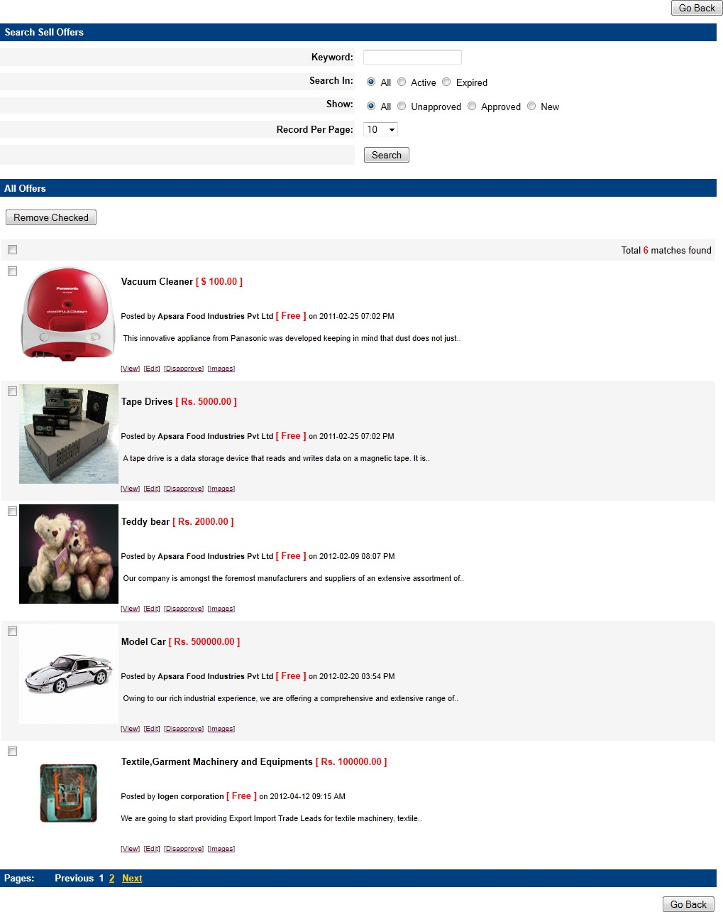

* + 1. VIEW SELL OFFER DETAILS PAGE

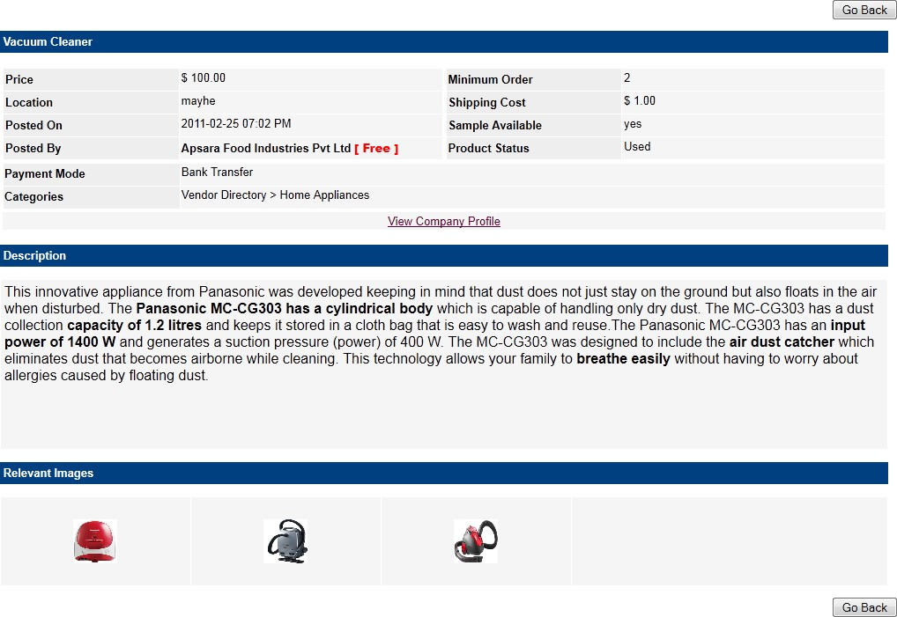

* + 1. EDIT SELL OFFER PAGE

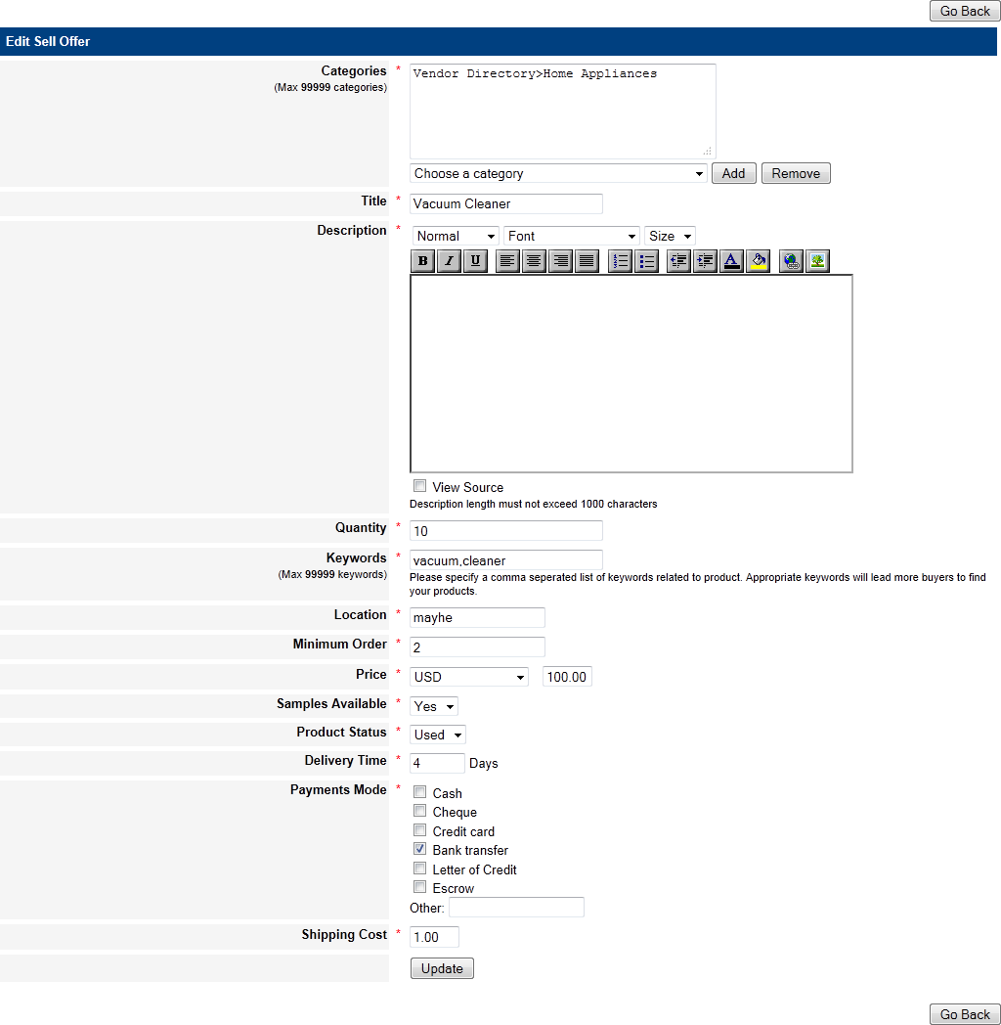

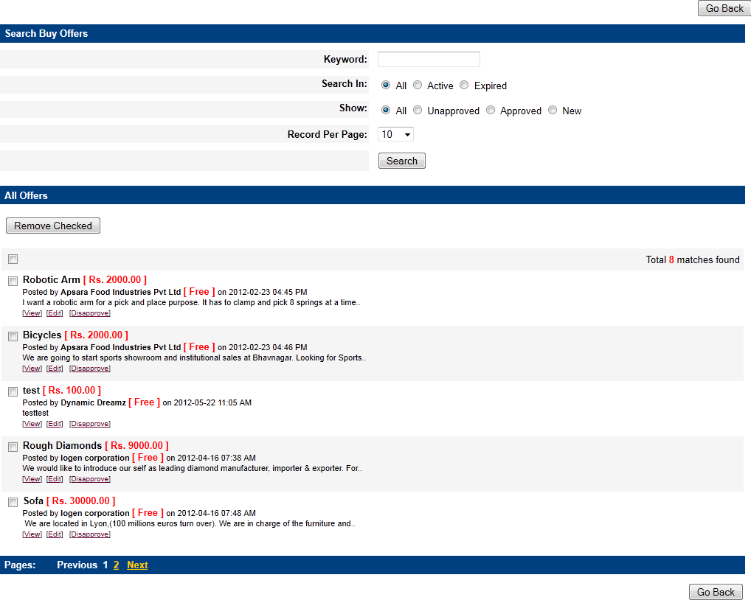

* + 1. MANAGE BUY OFFERS PAGE
    2. VIEW BUY OFFER DETAILS PAGE

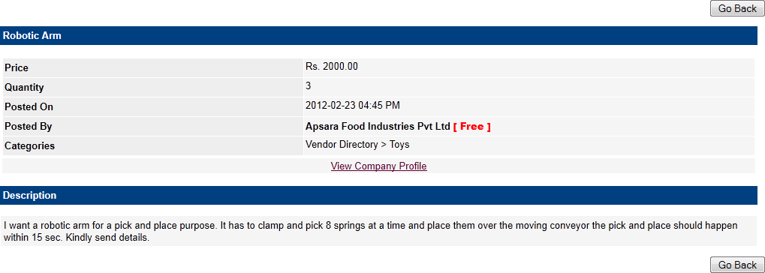

* + 1. EDIT BUY OFFER PAGE

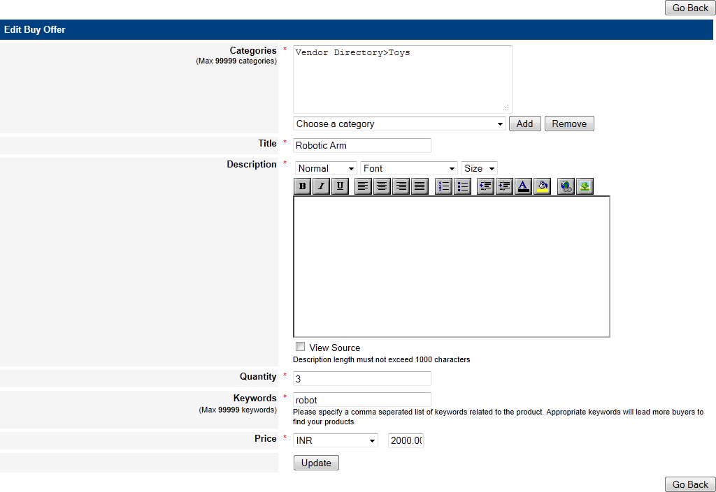

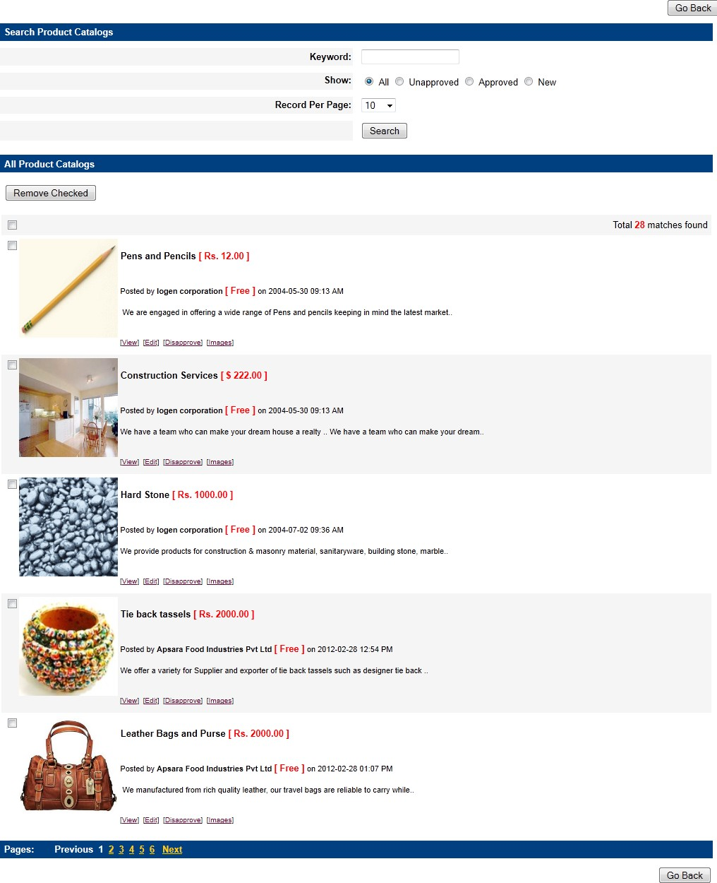

* + 1. MANAGE PRODUCTS PAGE
    2. VIEW PRODUCT DETIALS PAGE

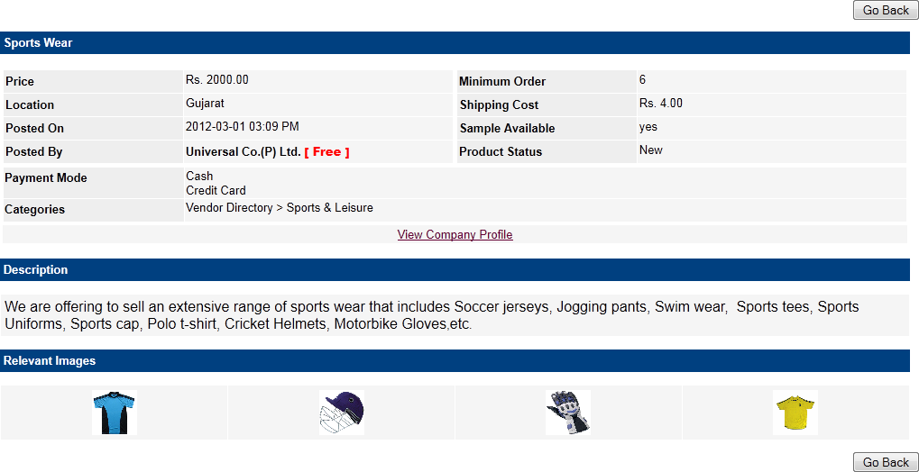

* + 1. EDIT PRODUCT PAGE

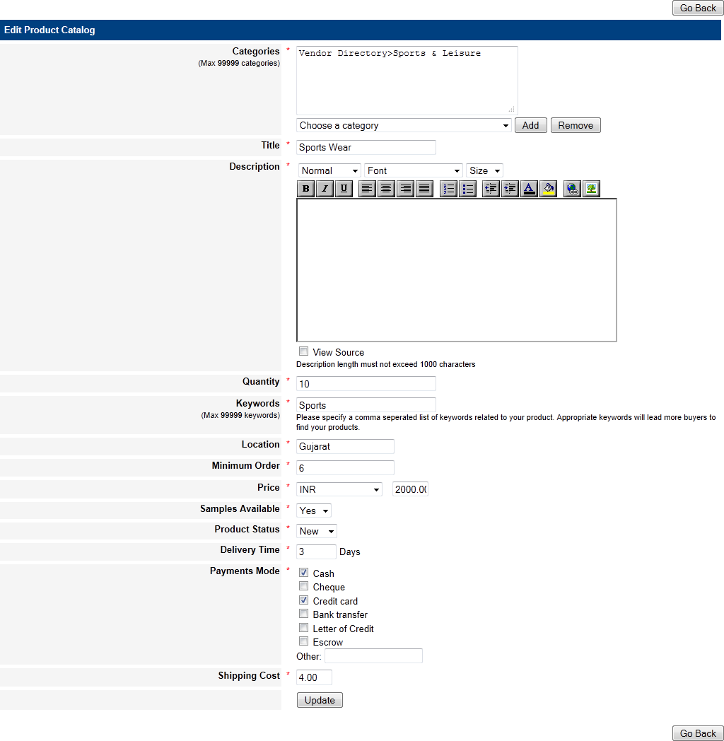

* + 1. MANAGE COMPANY PROFILES PAGE

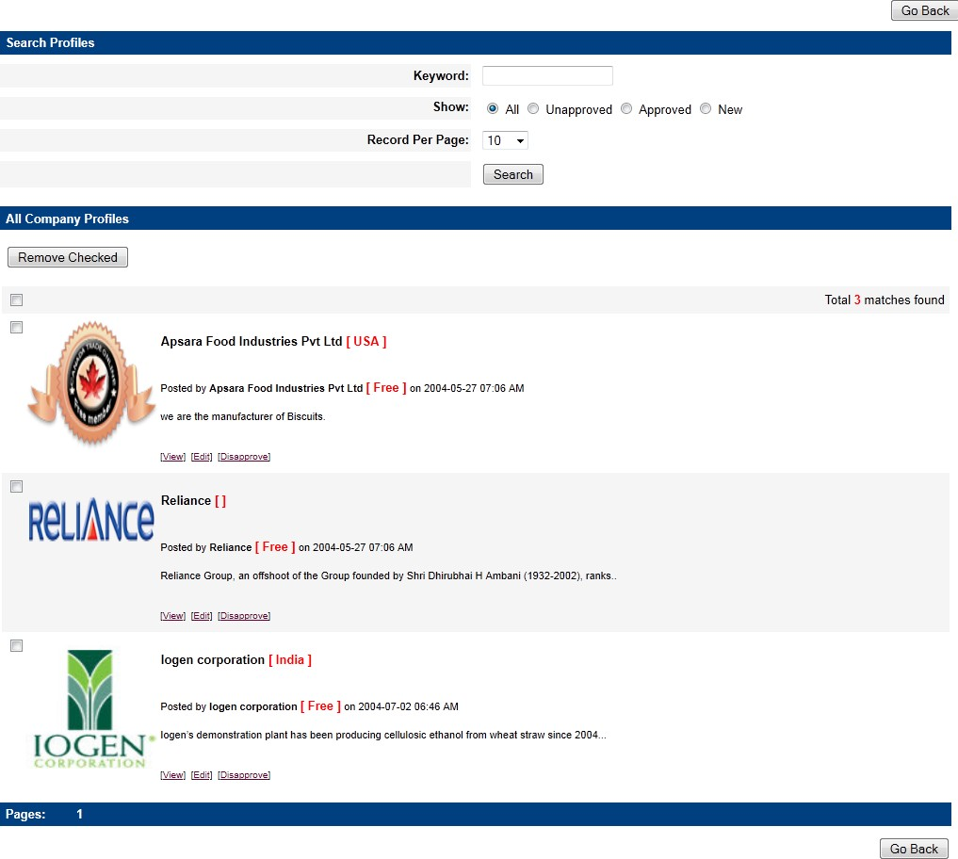

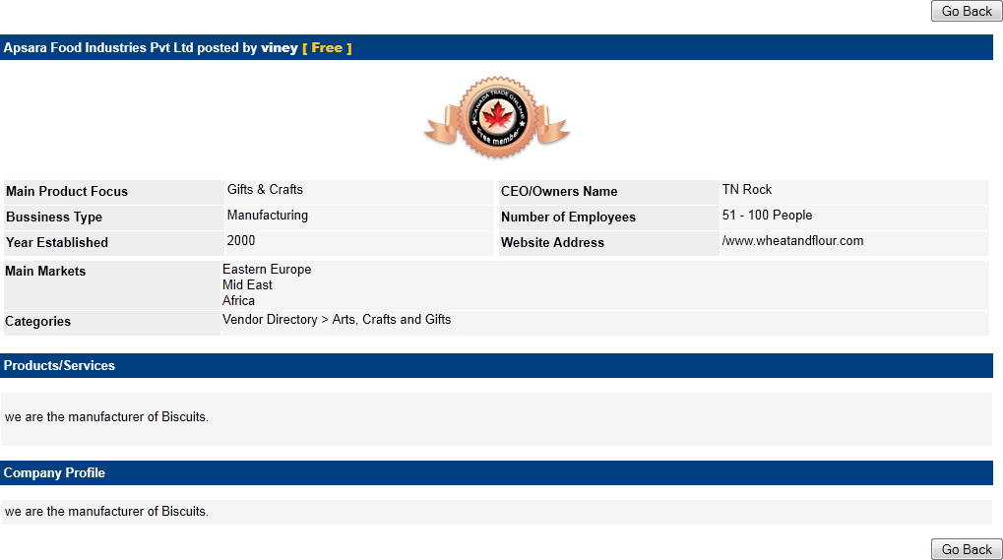

* + 1. VIEW COMPANY PROFILE PAGE
    2. EDIT COMPANY PROFILE PAGE

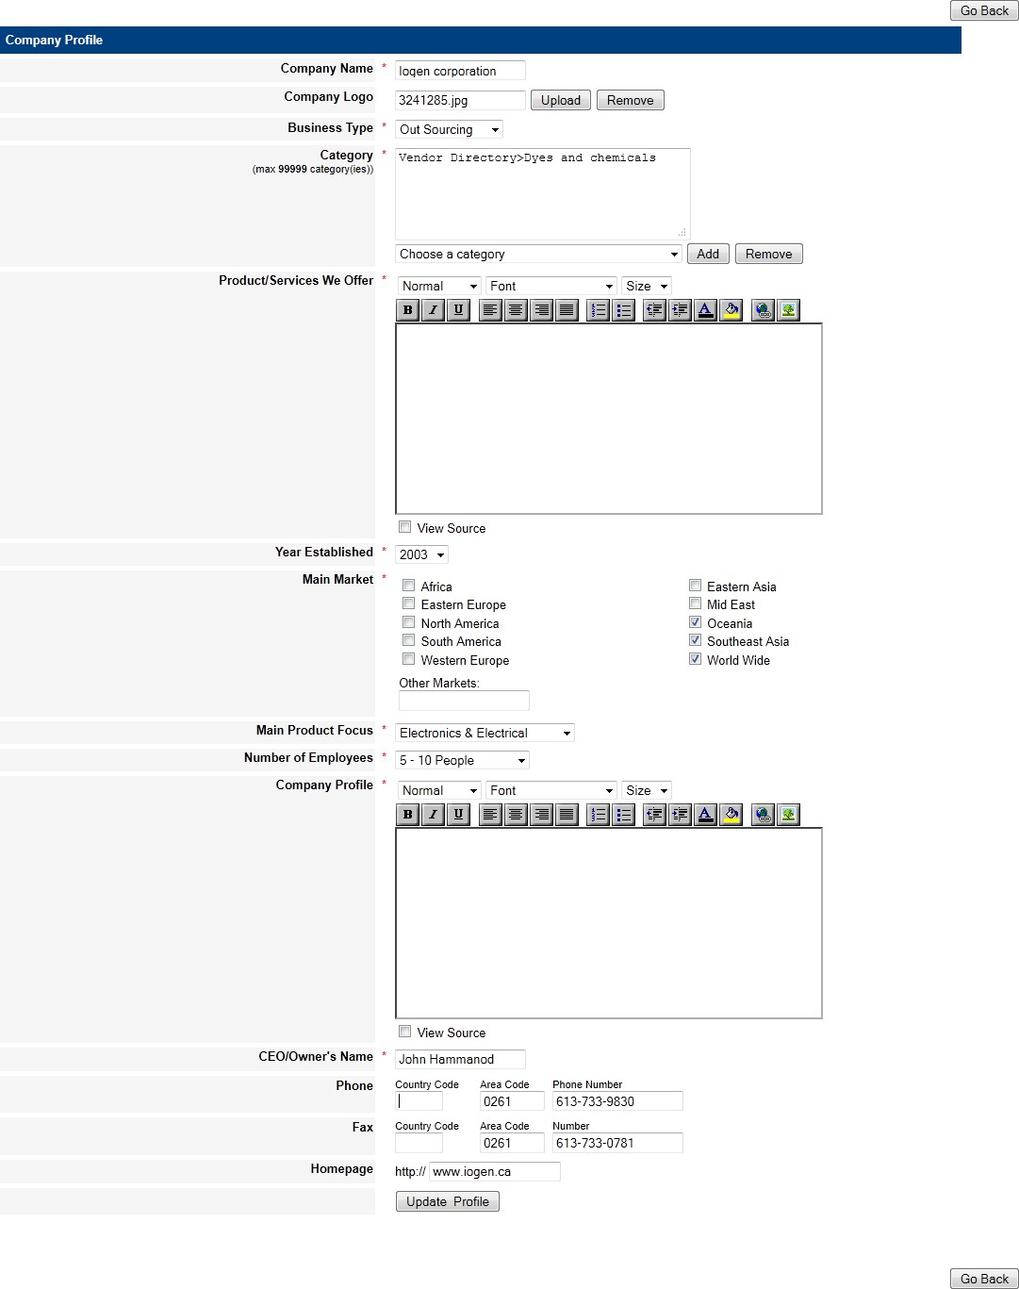

* + 1. VIEW MESSAGES PAGE

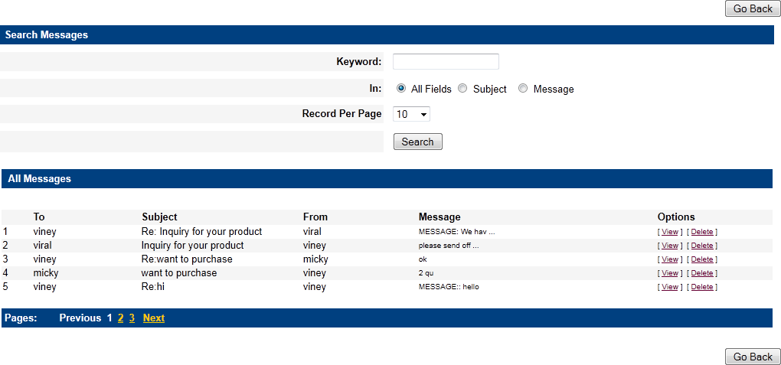

* + 1. VIEW MESSAGE DETAILS PAGE

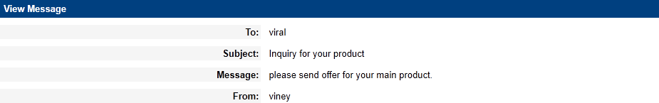

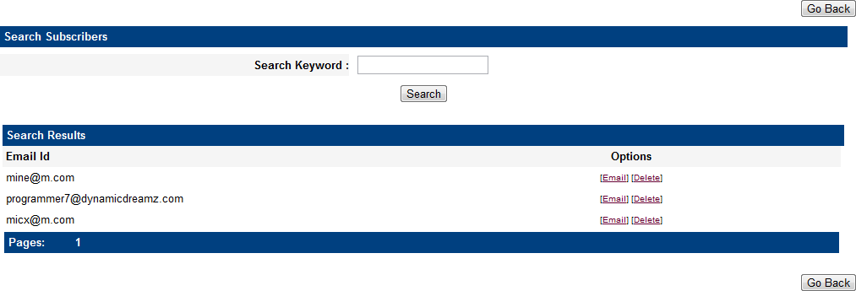

* + 1. MANAGE SUBSCRIBERS PAGE
    2. EMAIL PAGE

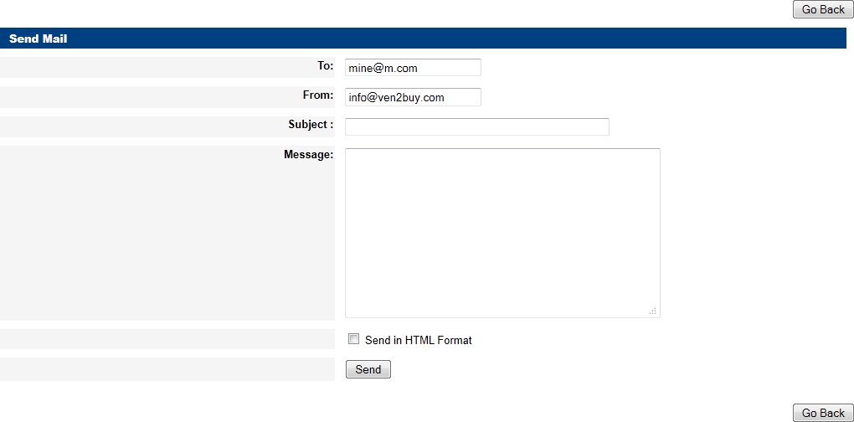

* + 1. MAIL TO ALL PAGE

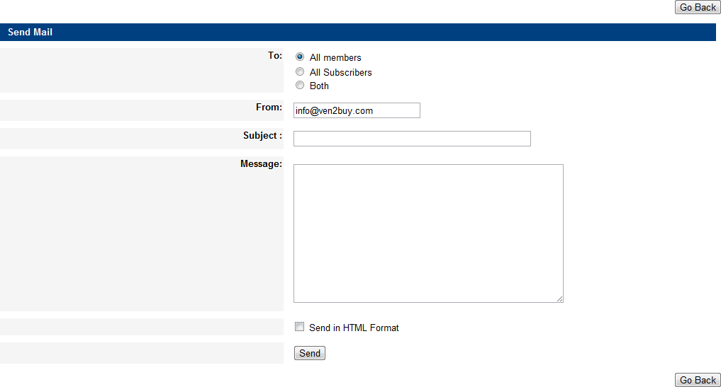

* + 1. MANAGE CURRENCIES PAGE

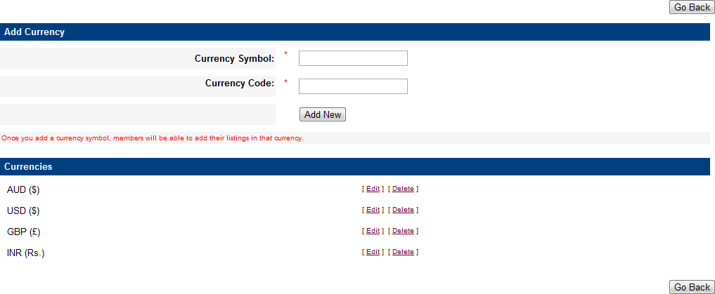

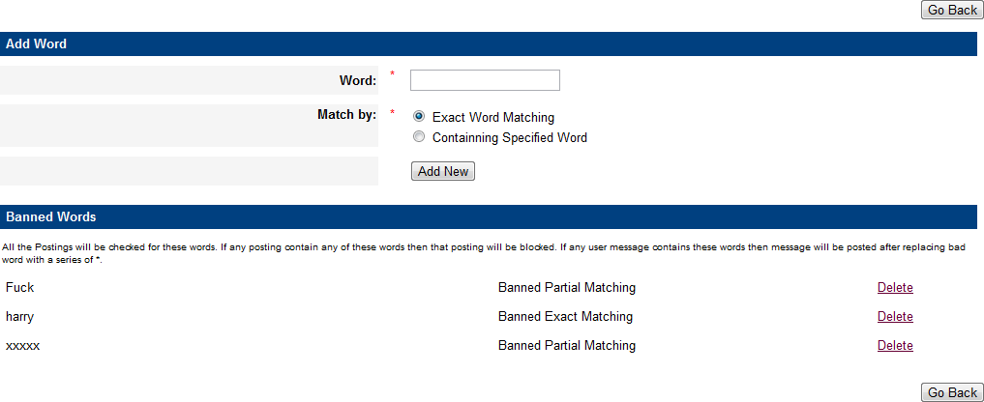

* + 1. MANAGE BANNED WORDS PAGE
    2. MANAGE BUSINESS TYPES PAGE

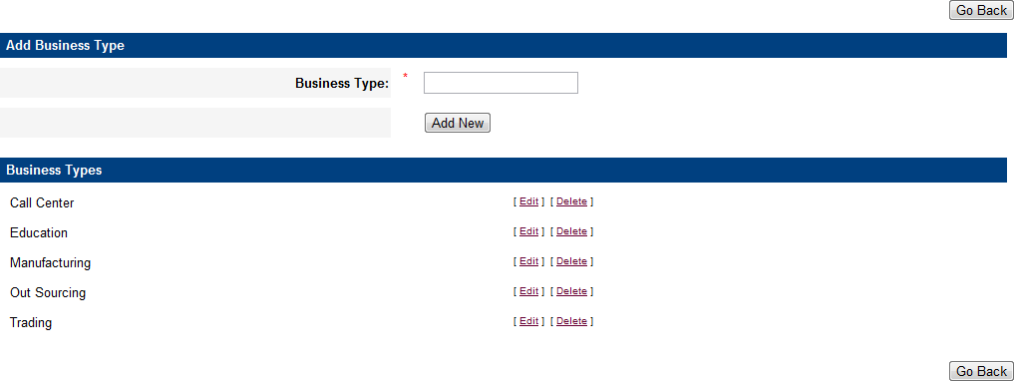

* + 1. MANAGE PRODUCT FOCUS PAGE

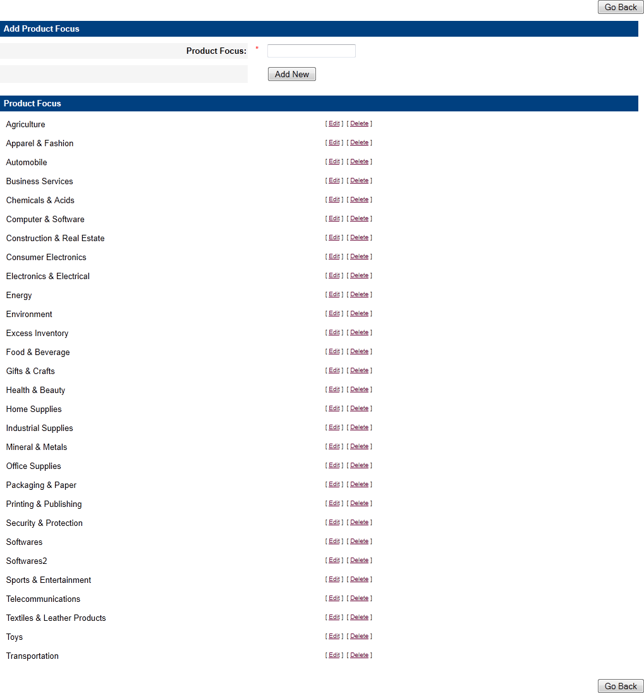

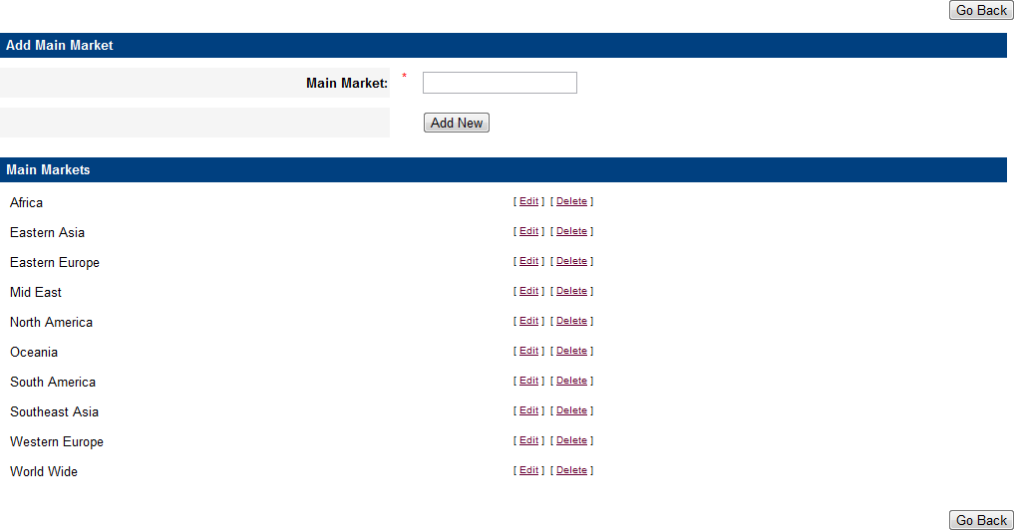

* + 1. MANAGE MAIN MARKETS PAGE



**SPECIAL CASES**

# SPECIAL CASES

After completed this project we have started new project on same topic - b2b portal to show that how can we improve this system by using following things.

* **Java Script** : Used for better validation, Ordering of products, Paging and **Pop Up Window**
* **Ajax** : Used for flexibility and fast **Searching**, Ordering and Paging
* **JQuery** : Used for make better and all time **Advertise** display.
* **LightBox** : Used for smooth and full screen **Images**.
* **Classes** : Used for security of our data in **Database**.

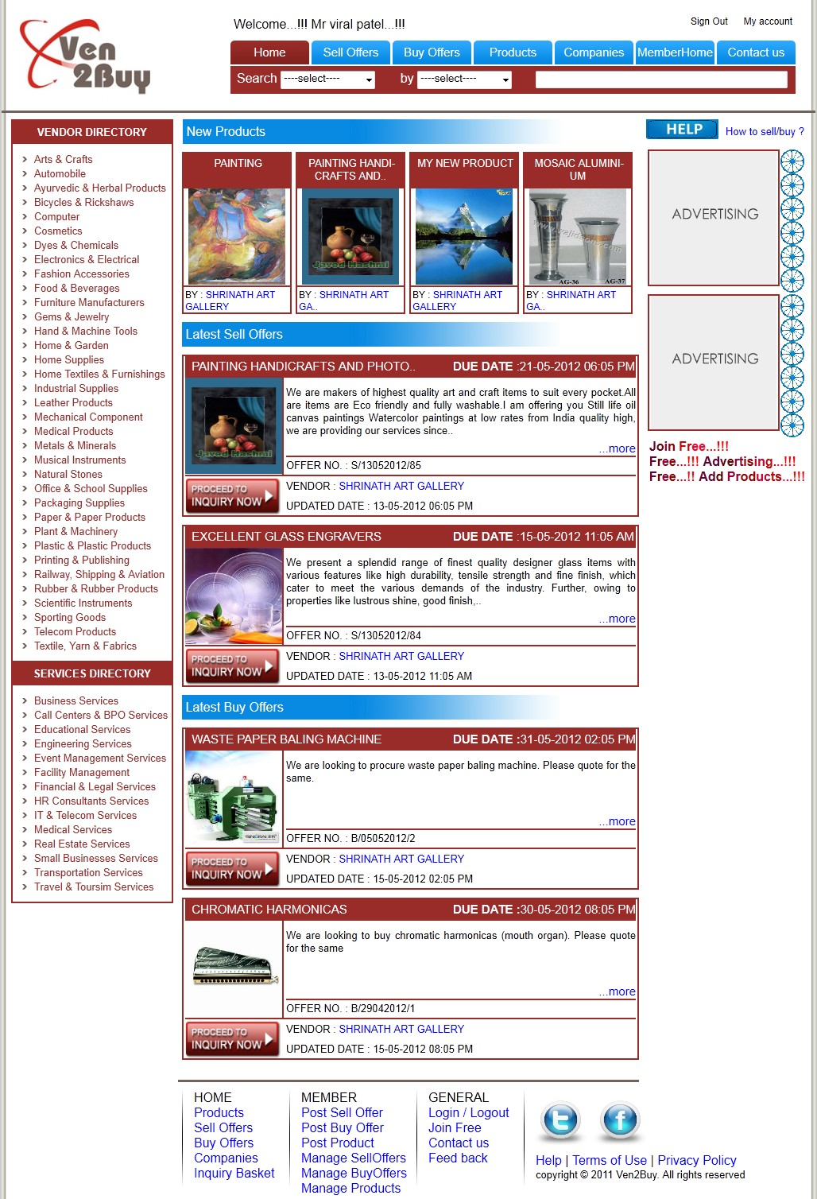

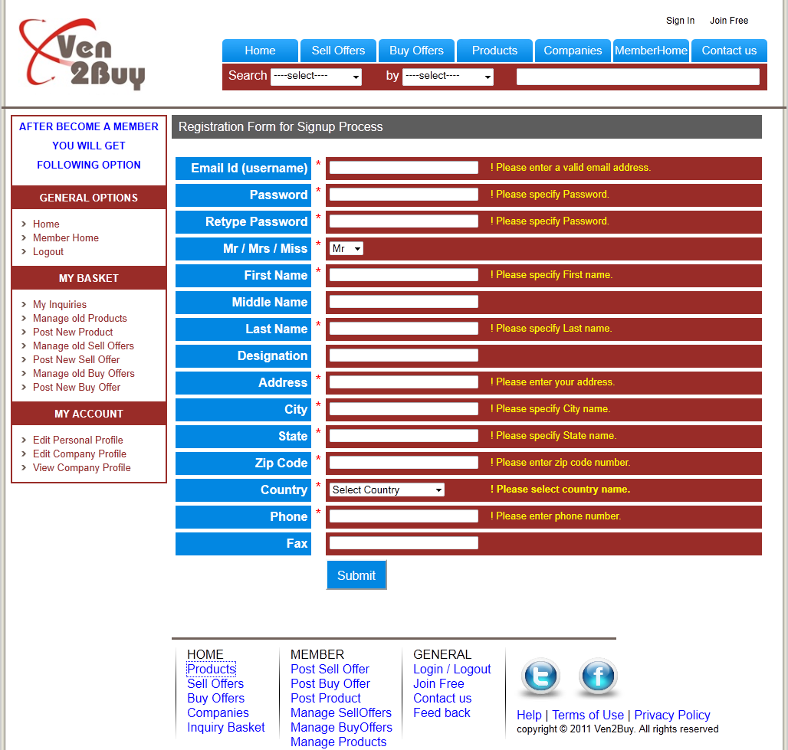

## REGISTRATION PAGE VALIDATION USING JAVASCRIPT

When we leave the any text box validation done instantly because of onblur javascript run. If any error in textbox data that error will show in yellow font when leave the textbox as shown in fig above.

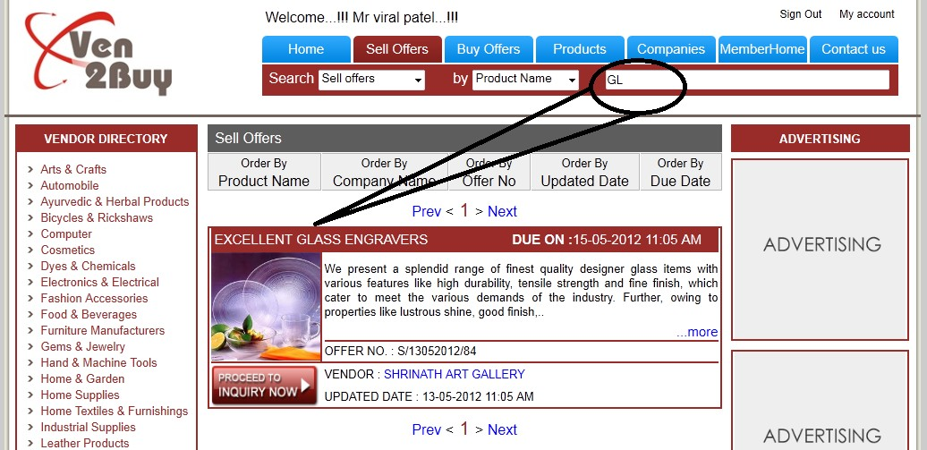

## SELL OFFERS PAGE DISPLAY ALL OFFERS BEFORE SEARCH

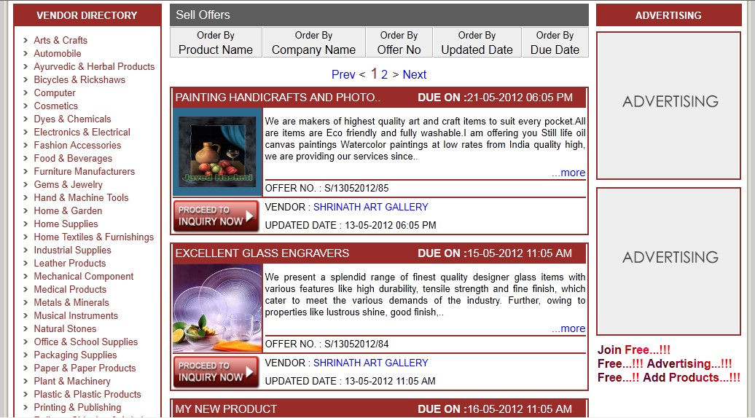

**SELL OFFERS SEARCH USING AJAX**

## Like google search

Here search is worked as google search. On type characters in search box that characters match items are displaying below instantly as shown in fig. This is done by using Ajax.

|  |  |
| --- | --- |
| **JQUERY USED FOR DISPLAY ADVERTISING ON TOP**  **Before Scrolling** |  |
| **As Scrolling below** |
| JQuery is used for fixed the position of Advertise on top of the site at scrolling time as shown in fig. | |

## PRODUCT IMAGES USING LIGHTBOX

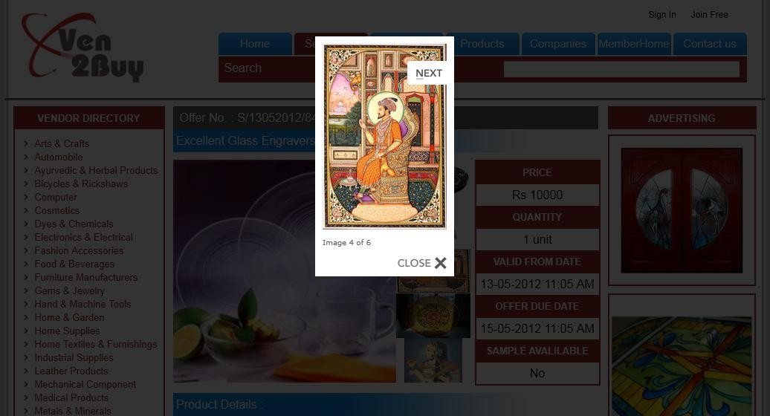

**VENDOR DIRECTORY SEARCH USING AJAX**

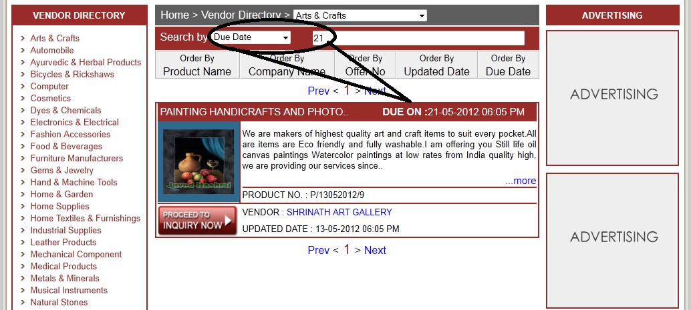

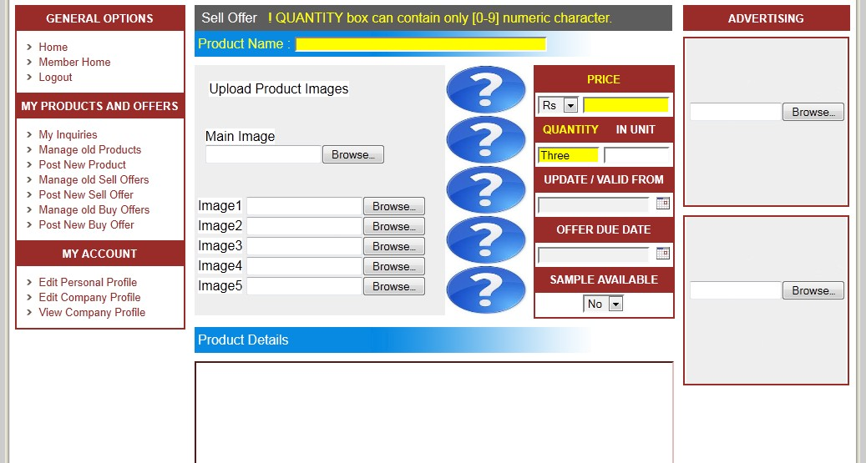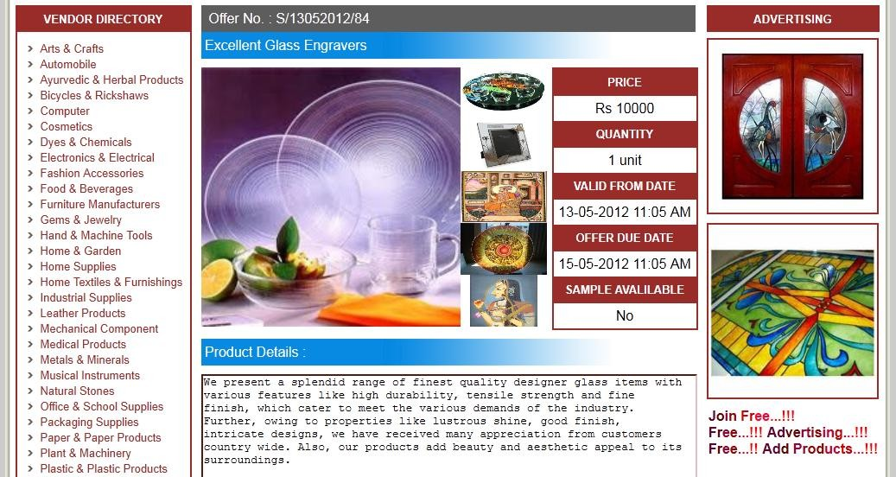

## POP UP WINDOW USING JAVASCRIPT

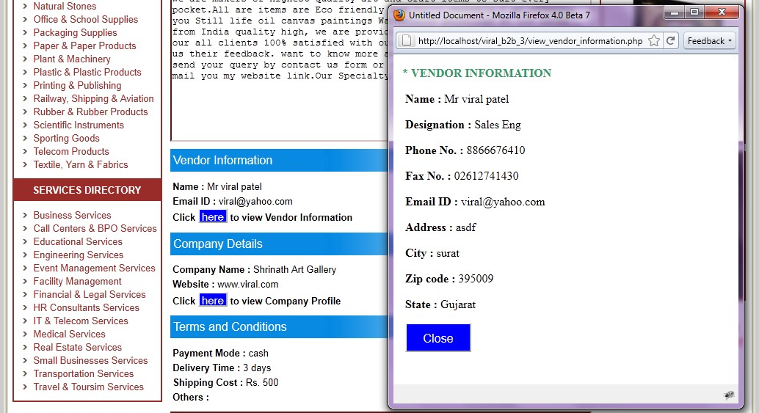

**POST PAGE DESIGN SAME AS VIEW PAGE**

Post page design is same as view page so user can image and know the actual display of his/her offer at the time of fill details of offer. This can help the user to know one step before that how his offer will look and display when some client visit his/her offer on site.

Fig. show the post page and view page structure which is same.

## CLASSES

### class Manage

{

private $my_tablename; private $num_of_records; private $id;

private $field_name; function construct()

{

$servername='localhost' ; // Replace this 'localhost' with your server name

$database_username='root'; // Replace this with your username

$database_password=''; // Replace this with your password

$database_name='my_b2b_db'; // Replace this 'db' with your database name mysql_connect($servername,$database_username,$database_password); mysql_select_db($database_name);

}

private function getTableName()

{

$tablename = $this->my_tablename; return $tablename;

}

public function setTableName($tablename)

{

$this->my_tablename = $tablename;

}

public function setId($id)

{

$this->id = $id;

}

public function getId()

{

return $this->id;

}

public function setFieldName($field_name)

{

$this->field_name = $field_name;

}

public function select_all()

{

$sql="select * from ".$this->my_tablename;

$rs = mysql_query($sql) or die(mysql_error()); return $rs;

}

public function delete_where($field_value,$field_name = "")

{

if($field_value == "")

{

return ;

}

if($field_name == "cmp_user")

{

$field_name = "c_m_id";

}

if($field_name == "user")

{

$field_name = "m_id";

}

if($field_name == "sell_user")

{

$field_name = "s_m_id";

}

if($field_name == "")

{

$field_name = $this->field_name;

}

$sql="delete from ".$this->my_tablename." where ".$field_name." = ".$field_value;

$rs = mysql_query($sql) or die(mysql_error());

}

public function select_where($field_value,$field_name = "")

{

if($field_name == "cmp_user")

{

$field_name = "c_m_id";

}

if($field_name == "user")

{

$field_name = "m_id";

}

if($field_name == "sell_user")

{

$field_name = "s_m_id";

}

if($field_name == "type")

{

$field_name = "cat_type";

}

if($field_name == "")

{

$field_name = $this->field_name;

}

$sql="select * from ".$this->my_tablename." where ".$field_name." = ".$field_value;

$rs = mysql_query($sql) or die(mysql_error()); return $rs;

}

public function select_order($order_by,$order_type="desc")

{

if($order_by == "")

{

$order_by = $this->field_name;

}

$sql="select * from ".$this->my_tablename." order by ".$order_by." ".$order_type;

$rs = mysql_query($sql) or die(mysql_error()); return $rs;

}

public function select_order_limit($order_by="",$order_type="desc",$sl="0",$el="5")

{

if($order_by == "")

{

$order_by = $this->field_name;

}

if($order_by == "sell_pro_name")

{

$order_by = "s_title";;

}

$sql="select * from ".$this->my_tablename." order by ".$order_by." ".$order_type." limit ".$sl.",".$el."";

$rs = mysql_query($sql) or die(mysql_error()); return $rs;

}

public function select_where_order_limit ($field_name, $field_value, $order_by,

$order_type="desc", $sl="0", $el="5")

{

if($field_name=="msg")

{

$field_name="mg_to_m_id";

}

if($order_by == "")

{

$order_by = $this->field_name;

}

if($order_type == "")

{

$order_type = "desc";

}

$sql="select * from ".$this->my_tablename." where ".$field_name." = ".$field_value." order by ".$order_by." ".$order_type." limit ".$sl.",".$el."";

$rs = mysql_query($sql) or die(mysql_error()); return $rs;

}

public function mylogin($login,$password)

{

$msg = $this->valid_login($login,$password); return $msg;

}

private function valid_login($login,$password)

{

$login=mysql_real_escape_string($login);

$password=mysql_real_escape_string($password);

$sql="select * from b2b_members where m_email='".$login."' and m_userpass='".$password."'";

$rs=mysql_query($sql) or die(mysql_error());

$rec=mysql_fetch_row($rs); if(mysql_num_rows($rs)>0)

{

}

else

{

$_SESSION["user"] = $rec[0];

$msg = "Hi ".$rec[2]." ".$rec[3]."..!"; return $msg;

$msg = "Invalid Email ID or Password";

return $msg;

}

}

}

### class Message_cl extends Manage

{

private $my_tablename; private $id;

function construct()

{

parent:: construct(); parent::setTableName("b2b_messages"); parent::setFieldName("mg_id");

}

public function setId($id)

{

$this->id = $id;

}

public function getId()

{

return $this->id;

}

public function myinsert($type,$type_no,$to_mem,$ref_no,$ref_title,$sub,$content)

{

if($this->verify_insert($type,$type_no,$to_mem,$ref_no,$ref_title,$sub,$content))

{

echo "<span style='color:#0F0'>&nbsp;&nbsp;&nbsp;Message is send Successfully...!!!</span>";

}

}

private function verify_insert($type,$type_no,$to_mem,$ref_no,$ref_title,$sub,$content)

{

$strsql = "INSERT INTO b2b_messages (mg_type, mg_type_id, mg_to_m_id, mg_reference_no, mg_title, mg_subject, mg_content) VALUES ('".$type."','".$type_no."','".$to_mem."','".$ref_no."','".$ref_title."','".$sub."','".$content."')";

mysql_query($strsql) or die(mysql_error()); return TRUE;

}

}

### class Country_cl extends Manage

{

private $my_tablename; function construct()

{

parent:: construct(); parent::setTableName("b2b_country");

}

}

### class Member_cl extends Manage

{

private $my_tablename; private $id;

function construct()

{

parent:: construct(); parent::setTableName("b2b_members"); parent::setFieldName("m_id");

}

public function setId($id)

{

$this->id = $id;

}

public function getId()

{

return $this->id;

}

public function myupdate ($mrormrs, $fname, $mname, $lname, $city, $zipcode, $state,

$country, $phone, $fax, $address, $designation)

{

if($this->verify_update ($mrormrs, $fname, $mname, $lname, $city, $zipcode, $state,

$country, $phone, $fax, $address, $designation))

{

echo "Data are Updated Success Fully...!!!";

}

}

private function verify_update ($mrormrs, $fname, $mname, $lname, $city, $zipcode, $state,

$country, $phone, $fax, $address, $designation)

{

$strsql = "UPDATE b2b_members set m_mrormrs='".$mrormrs."', m_fname='".$fname."', m_mname='".$mname."', m_lname='".$lname."', m_city='".$city."',

m_zipcode='".$zipcode."', m_state='".$state."', m_country='".$country."', m_phone='".$phone."', m_fax='".$fax."' , m_address='".$address."', m_designation='".$designation."' WHERE m_id = '".$this->id."'";

mysql_query($strsql) or die(mysql_error());

}

public function myinsert ($email, $password, $mrormrs, $fname, $mname, $lname, $city,

$zipcode, $state, $country, $phone, $fax, $address, $designation)

{

if($this->verify_insert ($email, $password, $mrormrs, $fname, $mname, $lname, $city,

$zipcode, $state,$country,$phone,$fax,$address,$designation))

{

echo "Data are inserted Success Fully...!!!";

}

}

private function verify_insert ($email, $password, $mrormrs, $fname, $mname, $lname, $city,

$zipcode, $state, $country,$phone,$fax,$address,$designation)

{

$strsql = "INSERT INTO b2b_members (m_email, m_userpass, m_mrormrs, m_fname, m_mname,m_lname,m_city,m_zipcode,m_state,m_country,m_phone,m_fax,m_address,m_designat ion) VALUES ('".$email."', '".$password."', '".$mrormrs."', '".$fname."', '".$mname."', '".$lname."',

'".$city."', ".$zipcode.", '".$state."', '".$country."', '".$phone."', '".$fax."', '".$address."', '".$designation."')";

mysql_query($strsql) or die(mysql_error()); return TRUE;

}

}

### class selloffer_cl extends Manage

{

private $my_tablename; private $id;

private $user_id; function construct()

{

parent:: construct(); parent::setTableName("b2b_selloffers"); parent::setFieldName("s_id");

}

public function setId($id)

{

$this->id = $id;

}

public function getId()

{

return $this->id;

}

public function set_user_Id($id)

{

$this->user_id = $id;

}

public function get_user_Id()

{

return $this->user_id;

}

public function myupdate($title,$crncy,$price,$qty,$unit,$desc,$updated,$due,$available,$paymode,$deltime,$shp cost,$other,$mimg,$img1,$img2,$img3,$img4,$img5,$advimg1,$advimg2,$nam_f,$des_f,$pho_f,$ fax_f,$ema_f,$add_f,$cit_f,$zip_f,$sta_f,$offer_categories)

{

if($this-

>verify_update($title,$crncy,$price,$qty,$unit,$desc,$updated,$due,$available,$paymode,$deltime,

$shpcost,$other,$mimg,$img1,$img2,$img3,$img4,$img5,$advimg1,$advimg2,$nam_f,$des_f,$ph o_f,$fax_f,$ema_f,$add_f,$cit_f,$zip_f,$sta_f,$offer_categories))

{

echo "Data are Updated Success Fully...!!!";

}

}

private function verify_update($title,$crncy,$price,$qty,$unit,$desc,$updated,$due,$available,$paymode,$deltime,$ shpcost,$other,$mimg,$img1,$img2,$img3,$img4,$img5,$advimg1,$advimg2,$nam_f,$des_f,$pho

_f,$fax_f,$ema_f,$add_f,$cit_f,$zip_f,$sta_f,$offer_categories)

{

$rimg = $this->select_where($this->getId());

$recimg = mysql_fetch_row($rimg);

if($mimg=="" || $mimg=="null")

{

$mimg = $recimg[17];

}

if($img1=="" || $img1=="null")

{

$img1 = $recimg[18];

}

if($img2=="" || $img2=="null")

{

$img2 = $recimg[19];

}

if($img3=="" || $img3=="null")

{

$img3 = $recimg[20];

}

if($img4=="" || $img4=="null")

{

$img4 = $recimg[21];

}

if($img5=="" || $img5=="null")

{

$img5 = $recimg[22];

}

if($advimg1=="" || $advimg1=="null")

{

$advimg1 = $recimg[23];

}

if($advimg2=="" || $advimg2=="null")

{

$advimg2 = $recimg[24];

}

$strsql = "UPDATE b2b_selloffers set s_title='".$title."', s_curency='".$crncy."', s_price='".$price."',s_quantity='".$qty."',s_unit='".$unit."',s_description='".$desc."',s_updatedon='".

$updated."',s_dueon='".$due."',s_available='".$available."',s_payment_mode='".$paymode."',s_deli very_time='".$deltime."',s_shipping_cost='".$shpcost."',s_other_conditions='".$other."',s_main_img

='".$mimg."',s_img1='".$img1."',s_img2='".$img2."',s_img3='".$img3."',s_img4='".$img4."',s_img

5='".$img5."',s_advimg1='".$advimg1."',s_advimg2='".$advimg2."',s_m_name_f='".$nam_f."',s_m

_desig_f='".$des_f."',s_m_ph_f='".$pho_f."',s_m_fax_f='".$fax_f."',s_m_email_f='".$ema_f."',s_m

_add_f='".$add_f."',s_m_city_f='".$cit_f."',s_m_zip_f ='".$zip_f."', s_m_state_f='".$sta_f."', s_categories='".$offer_categories."' WHERE s_id = '".$this->id."'";

mysql_query($strsql) or die(mysql_error()); if($mimg!="")

{

move_uploaded_file($_FILES['mimg']['tmp_name'],"admin/upload_images/selloffer_images/".$mi mg);

}

if($img1!="")

{

move_uploaded_file($_FILES['img1']['tmp_name'],"admin/upload_images/selloffer_images/".$img 1);

}

if($img2!="")

{

move_uploaded_file($_FILES['img2']['tmp_name'],"admin/upload_images/selloffer_images/".$img 2);

}

if($img3!="")

{

move_uploaded_file($_FILES['img3']['tmp_name'],"admin/upload_images/selloffer_images/".$img 3);

}

if($img4!="")

{

move_uploaded_file($_FILES['img4']['tmp_name'],"admin/upload_images/selloffer_images/".$img 4);

}

if($img5!="")

{

move_uploaded_file($_FILES['img5']['tmp_name'],"admin/upload_images/selloffer_images/".$img 5);

}

if($advimg1!="")

{

move_uploaded_file($_FILES['advimg1']['tmp_name'],"admin/upload_images/advertise_images/".

$advimg1);

}

if($advimg2!="")

{

move_uploaded_file($_FILES['advimg2']['tmp_name'],"admin/upload_images/advertise_images/".

$advimg2);

}

$re23 = parent::select_where($this->getId());

$rs23 = mysql_fetch_array($re23);

$temp1 = $rs23['s_updatedon'];

$temp11 = $rs23['s_dueon'];

$temp2 = substr(strip_tags($temp1),0,2).substr(strip_tags($temp1),3,2).substr(strip_tags($temp1),6,4);

$temp22 = substr(strip_tags($temp11),0,2).substr(strip_tags($temp11),3,2).substr(strip_tags($temp11),6,4);

$strsql_15 = "UPDATE b2b_selloffers set s_updatedon_order = '".$temp2."',s_dueon_order = '".$temp22."' WHERE s_id='".$this->getId()."'";

mysql_query($strsql_15) or die(mysql_error());

}

public function myinsert($user_id,$title,$crncy,$price,$qty,$unit,$desc,$updated,$due,$available,$paymode,$delti me,$shpcost,$other,$mimg,$img1,$img2,$img3,$img4,$img5,$advimg1,$advimg2,$nam_f,$des_f,

$pho_f,$fax_f,$ema_f,$add_f,$cit_f,$zip_f,$sta_f,$offer_categories)

{

if($this->verify_insert ($user_id, $title, $crncy, $price, $qty, $unit, $desc, $updated, $due,

$available,$paymode,$deltime,$shpcost,$other,$mimg,$img1,$img2,$img3,$img4,$img5,$advimg 1,$advimg2,$nam_f,$des_f,$pho_f,$fax_f,$ema_f,$add_f,$cit_f,$zip_f,$sta_f,$offer_categories))

{

echo "Data are inserted Success Fully...!!!";

}

}

private function verify_insert($user_id,$title,$crncy,$price,$qty,$unit,$desc,$updated,$due,$available,$paymode,$d eltime,$shpcost,$other,$mimg,$img1,$img2,$img3,$img4,$img5,$advimg1,$advimg2,$nam_f,$des

_f,$pho_f,$fax_f,$ema_f,$add_f,$cit_f,$zip_f,$sta_f,$offer_categories)

{

$strsql = "INSERT INTO b2b_selloffers (s_m_id, s_title, s_curency, s_price, s_quantity,s_unit,s_description,s_updatedon,s_dueon,s_available,s_payment_mode,s_delivery_time

,s_shipping_cost,s_other_conditions,s_main_img,s_img1,s_img2,s_img3,s_img4,s_img5,s_advimg 1,s_advimg2,s_m_name_f,s_m_desig_f,s_m_ph_f,s_m_fax_f,s_m_email_f,s_m_add_f,s_m_city_f, s_m_zip_f,s_m_state_f,s_categories) VALUES ('".$user_id."', '".$title."', '".$crncy."', '".$price."', '".$qty."','".$unit."','".$desc."','".$updated."','".$due."','".$available."','".$paymode."','".$deltime."','".

$shpcost."','".$other."','".$mimg."','".$img1."','".$img2."','".$img3."','".$img4."','".$img5."','".$advim

g1."','".$advimg2."','".$nam_f."','".$des_f."','".$pho_f."','".$fax_f."','".$ema_f."','".$add_f."','".$cit_f. "','".$zip_f."','".$sta_f."','".$offer_categories."')";

mysql_query($strsql) or die(mysql_error());

$this->set_user_Id($user_id);

$id = mysql_insert_id();

$this->setId($id); parent::setId($id);

$strsql2 = "UPDATE b2b_selloffers set s_offer_no = '"."S/".date('dmY',mktime(0,0,0,date('m'),date('d'),date('Y'))). "/".$id."' WHERE s_id = '".$id."'"; mysql_query($strsql2) or die(mysql_error());

if($mimg!="") move_uploaded_file($_FILES['mimg']['tmp_name'],"admin/upload_images/selloffer_images/".$mi mg);

if($img1!="") move_uploaded_file($_FILES['img1']['tmp_name'],"admin/upload_images/selloffer_images/".$img 1);

if($img2!="") move_uploaded_file($_FILES['img2']['tmp_name'],"admin/upload_images/selloffer_images/".$img 2);

if($img3!="") move_uploaded_file($_FILES['img3']['tmp_name'],"admin/upload_images/selloffer_images/".$img 3);

if($img4!="") move_uploaded_file($_FILES['img4']['tmp_name'],"admin/upload_images/selloffer_images/".$img 4);

if($img5!="") move_uploaded_file($_FILES['img5']['tmp_name'],"admin/upload_images/selloffer_images/".$img 5);

if($advimg1!="") move_uploaded_file($_FILES['advimg1']['tmp_name'],"admin/upload_images/advertise_images/".

$advimg1); if($advimg2!="")

move_uploaded_file($_FILES['advimg2']['tmp_name'],"admin/upload_images/advertise_images/".

$advimg2); if($mimg!="")

move_uploaded_file($_FILES['mimg']['tmp_name'],"admin/upload_images/product_images/".$mi mg);

if($img1!="") move_uploaded_file($_FILES['img1']['tmp_name'],"admin/upload_images/product_images/".$img 1);

if($img2!="") move_uploaded_file($_FILES['img2']['tmp_name'],"admin/upload_images/product_images/".$img 2);

if($img3!="") move_uploaded_file($_FILES['img3']['tmp_name'],"admin/upload_images/product_images/".$img 3);

if($img4!="") move_uploaded_file($_FILES['img4']['tmp_name'],"admin/upload_images/product_images/".$img 4);

if($img5!="") move_uploaded_file($_FILES['img5']['tmp_name'],"admin/upload_images/product_images/".$img 5);

parent::setTableName("b2b_companies");

$r14 = parent::select_where($this->get_user_Id(),"c_m_id");

$rec14 = mysql_fetch_row($r14); parent:: construct();

$strsql_14 = "UPDATE b2b_selloffers set s_c_id='".$rec14[0]."' WHERE s_id='".$id."'"; mysql_query($strsql_14) or die(mysql_error());

parent::setTableName("b2b_selloffers");

$re23 = parent::select_where($this->getId());

$rs23 = mysql_fetch_array($re23);

$temp1 = $rs23['s_updatedon'];

$temp11 = $rs23['s_dueon'];

$temp2 = substr(strip_tags($temp1),0,2).substr(strip_tags($temp1),3,2).substr(strip_tags($temp1),6,4);

$temp22 = substr(strip_tags($temp11),0,2).substr(strip_tags($temp11),3,2).substr(strip_tags($temp11),6,4);

$strsql_15 = "UPDATE b2b_selloffers set s_updatedon_order = '".$temp2."',s_dueon_order = '".$temp22."' WHERE s_id='".$this->getId()."'";

mysql_query($strsql_15) or die(mysql_error()); return TRUE;

}

}

### class buyoffer_cl extends Manage

{

private $my_tablename; private $id;

private $user_id; function construct()

{

parent:: construct(); parent::setTableName("b2b_buyoffers"); parent::setFieldName("b_id");

}

public function setId($id)

{

$this->id = $id;

}

public function getId()

{

return $this->id;

}

public function set_user_Id($id)

{

$this->user_id = $id;

}

public function get_user_Id()

{

return $this->user_id;

}

public function myupdate ($title, $crncy, $price, $qty, $unit, $desc, $updated, $due, $other,

$mimg,$advimg1,$advimg2,$nam_f,$des_f,$pho_f,$fax_f,$ema_f,$add_f,$cit_f,$zip_f,$sta_f)

{

if($this->verify_update ($title, $crncy, $price, $qty, $unit, $desc, $updated, $due, $other,

$mimg,$advimg1,$advimg2,$nam_f,$des_f,$pho_f,$fax_f,$ema_f,$add_f,$cit_f,$zip_f,$sta_f))

{

echo "Data are Updated Success Fully...!!!";

}

}

private function verify_update ($title, $crncy, $price, $qty, $unit, $desc, $updated, $due, $other,

$mimg,$advimg1,$advimg2,$nam_f,$des_f,$pho_f,$fax_f,$ema_f,$add_f,$cit_f,$zip_f,$sta_f)

{

$rimg = $this->select_where($this->getId());

$recimg = mysql_fetch_row($rimg);

if($mimg=="" || $mimg=="null")

{

$mimg = $recimg[13];

}

if($advimg1=="" || $advimg1=="null")

{

$advimg1 = $recimg[14];

}

if($advimg2=="" || $advimg2=="null")

{

$advimg2 = $recimg[15];

}

$strsql = "UPDATE b2b_buyoffers set b_title='".$title."',b_curency='".$crncy."',b_price='".$price."',b_quantity='".$qty."',b_unit='".$unit."', b_description='".$desc."',b_updatedon='".$updated."',b_dueon='".$due."',b_other_conditions='".$ot her."',b_main_img='".$mimg."',b_advimg1='".$advimg1."',b_advimg2='".$advimg2."',b_m_name_f

='".$nam_f."',b_m_desig_f='".$des_f."',b_m_ph_f='".$pho_f."',b_m_fax_f='".$fax_f."',b_m_email_ f='".$ema_f."',b_m_add_f='".$add_f."',b_m_city_f='".$cit_f."',b_m_zip_f

='".$zip_f."',b_m_state_f='".$sta_f."' WHERE b_id = '".$this->id."'"; mysql_query($strsql) or die(mysql_error());

if($mimg!="")

{

move_uploaded_file($_FILES['mimg']['tmp_name'],"admin/upload_images/buyoffer_images/".$mi mg);

}

if($advimg1!="")

{

move_uploaded_file($_FILES['advimg1']['tmp_name'],"admin/upload_images/advertise_images/".

$advimg1);

}

if($advimg2!="")

{

move_uploaded_file($_FILES['advimg2']['tmp_name'],"admin/upload_images/advertise_images/".

$advimg2);

}

$re23 = parent::select_where($this->getId());

$rs23 = mysql_fetch_array($re23);

$temp1 = $rs23['b_updatedon'];

$temp11 = $rs23['b_dueon'];

$temp2 = substr(strip_tags($temp1),0,2).substr(strip_tags($temp1),3,2).substr(strip_tags($temp1),6,4);

$temp22 = substr(strip_tags($temp11),0,2).substr(strip_tags($temp11),3,2).substr(strip_tags($temp11),6,4);

$strsql_15 = "UPDATE b2b_buyoffers set b_updatedon_order = '".$temp2."',b_dueon_order = '".$temp22."' WHERE b_id='".$this->getId()."'";

mysql_query($strsql_15) or die(mysql_error());

}

public function myinsert ($user_id, $title, $crncy, $price, $qty, $unit,$desc, $updated, $due, $other,

$mimg,$advimg1,$advimg2,$nam_f,$des_f,$pho_f,$fax_f,$ema_f,$add_f,$cit_f,$zip_f,$sta_f)

{

if($this->verify_insert($user_id,$title,$crncy,$price,$qty,$unit,$desc, $updated,$due, $other,

$mimg,$advimg1,$advimg2,$nam_f,$des_f,$pho_f,$fax_f,$ema_f,$add_f,$cit_f,$zip_f,$sta_f))

{

echo "Data are inserted Success Fully...!!!";

}

}

private function verify_insert($user_id,$title,$crncy,$price,$qty,$unit,$desc,$updated, $due, $other,

$mimg,$advimg1,$advimg2,$nam_f,$des_f,$pho_f,$fax_f,$ema_f,$add_f,$cit_f,$zip_f,$sta_f)

{

$strsql = "INSERT INTO b2b_buyoffers (b_m_id,b_title,b_curency,b_price,b_quantity, b_unit,b_description,b_updatedon,b_dueon,b_other_conditions,b_main_img,b_advimg1,b_advimg 2,b_m_name_f,b_m_desig_f,b_m_ph_f,b_m_fax_f,b_m_email_f,b_m_add_f,b_m_city_f,b_m_zip_ f,b_m_state_f) VALUES ('".$user_id."','".$title."','".$crncy."','".$price."','".$qty."','".$unit."',

'".$desc."','".$updated."','".$due."','".$other."','".$mimg."','".$advimg1."','".$advimg2."','".$nam_f."','

".$des_f."','".$pho_f."','".$fax_f."','".$ema_f."','".$add_f."','".$cit_f."','".$zip_f."','".$sta_f."')"; mysql_query($strsql) or die(mysql_error());

$this->set_user_Id($user_id);

$id = mysql_insert_id();

$this->setId($id); parent::setId($id);

$strsql2 = "UPDATE b2b_buyoffers set b_offer_no = '"."B/".date('dmY',mktime(0,0,0,date('m'),date('d'),date('Y'))). "/".$id."' WHERE b_id = '".$id."'"; mysql_query($strsql2) or die(mysql_error());

if($mimg!="") move_uploaded_file($_FILES['mimg']['tmp_name'],"admin/upload_images/buyoffer_images/".$mi mg);

if($advimg1!="") move_uploaded_file($_FILES['advimg1']['tmp_name'],"admin/upload_images/advertise_images/".

$advimg1); if($advimg2!="")

move_uploaded_file($_FILES['advimg2']['tmp_name'],"admin/upload_images/advertise_images/".

$advimg2); parent::setTableName("b2b_companies");

$r14 = parent::select_where($this->get_user_Id(),"c_m_id");

$rec14 = mysql_fetch_row($r14); parent:: construct();

$strsql_14 = "UPDATE b2b_buyoffers set b_c_id='".$rec14[0]."' WHERE b_id='".$id."'"; mysql_query($strsql_14) or die(mysql_error());

parent::setTableName("b2b_buyoffers");

$re23 = parent::select_where($this->getId());

$rs23 = mysql_fetch_array($re23);

$temp1 = $rs23['b_updatedon'];

$temp11 = $rs23['b_dueon'];

$temp2 = substr(strip_tags($temp1),0,2).substr(strip_tags($temp1),3,2).substr(strip_tags($temp1),6,4);

$temp22 = substr(strip_tags($temp11),0,2).substr(strip_tags($temp11),3,2).substr(strip_tags($temp11),6,4);

$strsql_15 = "UPDATE b2b_buyoffers set b_updatedon_order = '".$temp2."',b_dueon_order = '".$temp22."' WHERE b_id='".$this->getId()."'";

mysql_query($strsql_15) or die(mysql_error()); return TRUE;

}

}

### class product_cl extends Manage

{

private $my_tablename; private $id;

private $user_id; function construct()

{

parent:: construct(); parent::setTableName("b2b_products"); parent::setFieldName("p_id");

}

public function setId($id)

{

$this->id = $id;

}

public function getId()

{

return $this->id;

}

public function set_user_Id($id)

{

$this->user_id = $id;

}

public function get_user_Id()

{

return $this->user_id;

}

public function myupdate($title,$crncy,$price,$qty,$unit,$desc,$updated,$due,$mimg,

$img1,$img2,$img3,$img4,$img5,$advimg1,$advimg2,$nam_f,$des_f,$pho_f,$fax_f,$ema_f,$add

_f,$cit_f,$zip_f,$sta_f,$offer_categories)

{

if($this->verify_update($title,$crncy,$price,$qty,$unit,$desc,$updated, $due,$mimg,

$img1,$img2,$img3,$img4,$img5,$advimg1,$advimg2,$nam_f,$des_f,$pho_f,$fax_f,$ema_f,$add

_f,$cit_f,$zip_f,$sta_f,$offer_categories))

{

echo "Data are Updated Success Fully...!!!";

}

}

private function verify_update($title,$crncy,$price,$qty,$unit,$desc,$updated,$due,$mimg,$img1,$img2,$img3,$im g4,$img5,$advimg1,$advimg2,$nam_f,$des_f,$pho_f,$fax_f,$ema_f,$add_f,$cit_f,$zip_f,$sta_f,$o ffer_categories)

{

$rimg = $this->select_where($this->getId());

$recimg = mysql_fetch_row($rimg);

if($mimg=="" || $mimg=="null")

{

$mimg = $recimg[12];

}

if($img1=="" || $img1=="null")

{

$img1 = $recimg[13];

}

if($img2=="" || $img2=="null")

{

$img2 = $recimg[14];

}

if($img3=="" || $img3=="null")

{

$img3 = $recimg[15];

}

if($img4=="" || $img4=="null")

{

$img4 = $recimg[16];

}

if($img5=="" || $img5=="null")

{

$img5 = $recimg[17];

}

if($advimg1=="" || $advimg1=="null")

{

$advimg1 = $recimg[18];

}

if($advimg2=="" || $advimg2=="null")

{

$advimg2 = $recimg[19];

}

$strsql = "UPDATE b2b_products set p_title='".$title."',p_curency='".$crncy."', p_price='".$price."',p_quantity='".$qty."',p_unit='".$unit."',p_description='".$desc."',p_updatedon=' ".$updated."',p_dueon='".$due."',p_main_img='".$mimg."',p_img1='".$img1."',p_img2='".$img2."',

p_img3='".$img3."',p_img4='".$img4."',p_img5='".$img5."',p_advimg1='".$advimg1."',p_advimg2

='".$advimg2."',p_m_name_f='".$nam_f."',p_m_desig_f='".$des_f."',p_m_ph_f='".$pho_f."',p_m_f ax_f='".$fax_f."',p_m_email_f='".$ema_f."',p_m_add_f='".$add_f."',p_m_city_f='".$cit_f."',p_m_zi p_f ='".$zip_f."',p_m_state_f='".$sta_f."',p_categories='".$offer_categories."' WHERE p_id = '".$this->id."'";

mysql_query($strsql) or die(mysql_error()); if($mimg!="")

{

move_uploaded_file($_FILES['mimg']['tmp_name'],"admin/upload_images/product_images/".$mi mg);

}

if($img1!="")

{

move_uploaded_file($_FILES['img1']['tmp_name'],"admin/upload_images/product_images/".$img 1);

}

if($img2!="")

{

move_uploaded_file($_FILES['img2']['tmp_name'],"admin/upload_images/product_images/".$img 2);

}

if($img3!="")

{

move_uploaded_file($_FILES['img3']['tmp_name'],"admin/upload_images/product_images/".$img 3);

}

if($img4!="")

{

move_uploaded_file($_FILES['img4']['tmp_name'],"admin/upload_images/product_images/".$img 4);

}

if($img5!="")

{

move_uploaded_file($_FILES['img5']['tmp_name'],"admin/upload_images/product_images/".$img 5);

}

if($advimg1!="")

{

move_uploaded_file($_FILES['advimg1']['tmp_name'],"admin/upload_images/advertise_images/".

$advimg1);

}

if($advimg2!="")

{

move_uploaded_file($_FILES['advimg2']['tmp_name'],"admin/upload_images/advertise_images/".

$advimg2);

}

$re23 = parent::select_where($this->getId());

$rs23 = mysql_fetch_array($re23);

$temp1 = $rs23['p_updatedon'];

$temp11 = $rs23['p_dueon'];

$temp2 = substr(strip_tags($temp1),0,2).substr(strip_tags($temp1),3,2).substr(strip_tags($temp1),6,4);

$temp22 = substr(strip_tags($temp11),0,2).substr(strip_tags($temp11),3,2).substr(strip_tags($temp11),6,4);

$strsql_15 = "UPDATE b2b_products set p_updatedon_order = '".$temp2."',p_dueon_order = '".$temp22."' WHERE p_id='".$this->getId()."'";

mysql_query($strsql_15) or die(mysql_error());

}

public function myinsert($user_id,$title,$crncy,$price,$qty,$unit,$desc, $updated,$due,

$mimg,$img1,$img2,$img3,$img4,$img5,$advimg1,$advimg2,$nam_f,$des_f,$pho_f,$fax_f,$ema

_f,$add_f,$cit_f,$zip_f,$sta_f,$offer_categories)

{

if($this->verify_insert($user_id,$title,$crncy,$price,$qty,$unit,$desc, $updated,$due,

$mimg,$img1,$img2,$img3,$img4,$img5,$advimg1,$advimg2,$nam_f,$des_f,$pho_f,$fax_f,$ema

_f,$add_f,$cit_f,$zip_f,$sta_f,$offer_categories))

{

echo "Data are inserted Success Fully...!!!";

}

}

private function verify_insert($user_id,$title,$crncy,$price,$qty,$unit,$desc,$updated,$due,$mimg,$img1,$img2,$i mg3,$img4,$img5,$advimg1,$advimg2,$nam_f,$des_f,$pho_f,$fax_f,$ema_f,$add_f,$cit_f,$zip_f,

$sta_f,$offer_categories)

{

$strsql = "INSERT INTO b2b_products (p_m_id,p_title,p_curency,p_price,p_quantity,p_unit,p_description,p_updatedon,p_dueon,p_main_i mg,p_img1,p_img2,p_img3,p_img4,p_img5,p_advimg1,p_advimg2,p_m_name_f,p_m_desig_f,p_ m_ph_f,p_m_fax_f,p_m_email_f,p_m_add_f,p_m_city_f,p_m_zip_f,p_m_state_f,p_categories) VALUES

('".$user_id."','".$title."','".$crncy."','".$price."','".$qty."','".$unit."','".$desc."','".$updated."','".$due."',

'".$mimg."','".$img1."','".$img2."','".$img3."','".$img4."','".$img5."','".$advimg1."','".$advimg2."','".

$nam_f."','".$des_f."','".$pho_f."','".$fax_f."','".$ema_f."','".$add_f."','".$cit_f."','".$zip_f."','".$sta_f. "','".$offer_categories."')";

mysql_query($strsql) or die(mysql_error());

$this->set_user_Id($user_id);

$id = mysql_insert_id();

$this->setId($id); parent::setId($id);

$strsql2 = "UPDATE b2b_products set p_offer_no = '"."P/".date('dmY',mktime(0,0,0,date('m'),date('d'),date('Y'))). "/".$id."' WHERE p_id = '".$id."'"; mysql_query($strsql2) or die(mysql_error());

if($mimg!="") move_uploaded_file($_FILES['mimg']['tmp_name'],"admin/upload_images/product_images/".$mi mg);

if($img1!="") move_uploaded_file($_FILES['img1']['tmp_name'],"admin/upload_images/product_images/".$img 1);

if($img2!="") move_uploaded_file($_FILES['img2']['tmp_name'],"admin/upload_images/product_images/".$img 2);

if($img3!="") move_uploaded_file($_FILES['img3']['tmp_name'],"admin/upload_images/product_images/".$img 3);

if($img4!="") move_uploaded_file($_FILES['img4']['tmp_name'],"admin/upload_images/product_images/".$img 4);

if($img5!="") move_uploaded_file($_FILES['img5']['tmp_name'],"admin/upload_images/product_images/".$img 5);

if($advimg1!="") move_uploaded_file($_FILES['advimg1']['tmp_name'],"admin/upload_images/advertise_images/".

$advimg1); if($advimg2!="")

move_uploaded_file($_FILES['advimg2']['tmp_name'],"admin/upload_images/advertise_images/".

$advimg2); parent::setTableName("b2b_companies");

$r14 = parent::select_where($this->get_user_Id(),"c_m_id");

$rec14 = mysql_fetch_row($r14); parent:: construct();

$strsql_14 = "UPDATE b2b_products set p_c_id='".$rec14[0]."' WHERE p_id='".$id."'"; mysql_query($strsql_14) or die(mysql_error());

parent::setTableName("b2b_products");

$re23 = parent::select_where($this->getId());

$rs23 = mysql_fetch_array($re23);

$temp1 = $rs23['p_updatedon'];

$temp11 = $rs23['p_dueon'];

$temp2 = substr(strip_tags($temp1),0,2).substr(strip_tags($temp1),3,2).substr(strip_tags($temp1),6,4);

$temp22 = substr(strip_tags($temp11),0,2).substr(strip_tags($temp11),3,2).substr(strip_tags($temp11),6,4);

$strsql_15 = "UPDATE b2b_products set p_updatedon_order = '".$temp2."',p_dueon_order = '".$temp22."' WHERE p_id='".$this->getId()."'";

mysql_query($strsql_15) or die(mysql_error()); return TRUE;

}

}

### class categories_cl extends Manage

{

private $my_tablename; private $id;

function construct()

{

parent:: construct(); parent::setTableName("b2b_categories"); parent::setFieldName("cat_id");

}

public function setId($id)

{

$this->id = $id;

}

public function getId()

{

return $this->id;

}

public function get_cagetories($st)

{

$val = explode(';',$st); for($i=0;$i<(count($val)-1);$i++)

{

$rc = $this->select_where($val[$i]);

$rd = mysql_fetch_row($rc);

$strsql .= $rd[1].";";

if($i<(count($val)-2))

{

$strsql .= "\n";

}

}

return $strsql;

}

}

### class company_cl extends Manage

{

private $my_tablename; private $id;

private $user_id; function construct()

{

parent:: construct(); parent::setTableName("b2b_companies"); parent::setFieldName("c_id");

}

public function setId($id)

{

$this->id = $id;

}

public function getId()

{

return $this->id;

}

public function set_user_Id($id)

{

$this->user_id = $id;

}

public function get_user_Id()

{

return $this->user_id;

}

public function myupdate($cmp_m,$cmp_name,$cmp_logo,$cmp_owner, $cmp_bus_type,

$cmp_establish,$cmp_main_pro,$cmp_email,$cmp_website,$cmp_ph,$cmp_fax,$cmp_add,$cmp_ city,$cmp_zip,$cmp_state,$cmp_country,$cmp_categories,$cmp_pro_ser,$cmp_pro,$advimg1,$ad vimg2)

{

if($this->verify_update($cmp_m,$cmp_name,$cmp_logo,$cmp_owner,

$cmp_bus_type,$cmp_establish,$cmp_main_pro,$cmp_email,$cmp_website,$cmp_ph,$cmp_fax,$ cmp_add,$cmp_city,$cmp_zip,$cmp_state,$cmp_country,$cmp_categories,$cmp_pro_ser,$cmp_pr o,$advimg1,$advimg2))

{

echo "Data are Updated Success Fully...!!!";

}

}

private function verify_update($cmp_m,$cmp_name,$cmp_logo,$cmp_owner,

$cmp_bus_type,$cmp_establish,$cmp_main_pro,$cmp_email,$cmp_website,$cmp_ph,$cmp_fax,$ cmp_add,$cmp_city,$cmp_zip,$cmp_state,$cmp_country,$cmp_categories,$cmp_pro_ser,$cmp_pr o,$advimg1,$advimg2)

{

$rimg = $this->select_where($this->getId());

$recimg = mysql_fetch_row($rimg);

if($cmp_logo=="" || $cmp_logo=="null")

{

$cmp_logo = $recimg[4];

}

if($advimg1=="" || $advimg1=="null")

{

$advimg1 = $recimg[21];

}

if($advimg2=="" || $advimg2=="null")

{

$advimg2 = $recimg[22];

}

$strsql = "UPDATE b2b_companies set c_m_id='".$cmp_m."', c_name='".$cmp_name."', c_logo='".$cmp_logo."',c_owner='".$cmp_owner."',c_business_type='".$cmp_bus_type."',c_establi sh='".$cmp_establish."',c_main_product='".$cmp_main_pro."',c_email='".$cmp_email."',c_website

='".$cmp_website."',c_phone='".$cmp_ph."',c_fax='".$cmp_fax."',c_address='".$cmp_add."',c_city

='".$cmp_city."',c_zip='".$cmp_zip."',c_state='".$cmp_state."',c_country='".$cmp_country."',c_cate gories='".$cmp_categories."',c_product_service='".$cmp_pro_ser."',c_profile='".$cmp_pro."',c_advi mg1='".$advimg1."',c_advimg2='".$advimg2."' WHERE c_id = '".$this->id."'"; mysql_query($strsql) or die(mysql_error());

if($cmp_logo!="") move_uploaded_file($_FILES['logoimg']['tmp_name'],"admin/upload_images/company_logo/".$c mp_logo);

if($advimg1!="") move_uploaded_file($_FILES['advimg1']['tmp_name'],"admin/upload_images/advertise_images/".

$advimg1); if($advimg2!="")

move_uploaded_file($_FILES['advimg2']['tmp_name'],"admin/upload_images/advertise_images/".

$advimg2);

}

public function myinsert($cmp_m,$cmp_name,$cmp_logo,$cmp_owner, $cmp_bus_type,

$cmp_establish,$cmp_main_pro,$cmp_email,$cmp_website,$cmp_ph,$cmp_fax,$cmp_add,$cmp_ city,$cmp_zip,$cmp_state,$cmp_country,$cmp_categories,$cmp_pro_ser,$cmp_pro,$advimg1,$ad vimg2)

{

if($this->verify_insert($cmp_m,$cmp_name,$cmp_logo, $cmp_owner, $cmp_bus_type,

$cmp_establish,$cmp_main_pro,$cmp_email,$cmp_website,$cmp_ph,$cmp_fax,$cmp_add,$cmp_ city,$cmp_zip,$cmp_state,$cmp_country,$cmp_categories,$cmp_pro_ser,$cmp_pro,$advimg1,$ad vimg2))

{

echo "Data are inserted Success Fully...!!!";

}

}

private function verify_insert($cmp_m,$cmp_name,$cmp_logo, $cmp_owner,$cmp_bus_type,

$cmp_establish,$cmp_main_pro,$cmp_email,$cmp_website,$cmp_ph,$cmp_fax,$cmp_add,$cmp_ city,$cmp_zip,$cmp_state,$cmp_country,$cmp_categories,$cmp_pro_ser,$cmp_pro,$advimg1,$ad vimg2)

{

$strsql = "INSERT INTO b2b_companies (c_m_id,c_name,c_logo,c_owner, c_business_type,c_establish,c_main_product,c_email,c_website,c_phone,c_fax,c_address,c_city,c_ zip,c_state,c_country,c_categories,c_product_service,c_profile,c_advimg1,c_advimg2) VALUES ('".$cmp_m."','".$cmp_name."','".$cmp_logo."','".$cmp_owner."','".$cmp_bus_type."','".$cmp_estab

lish."','".$cmp_main_pro."','".$cmp_email."','".$cmp_website."','".$cmp_ph."','".$cmp_fax."','".$cm

p_add."','".$cmp_city."','".$cmp_zip."','".$cmp_state."','".$cmp_country."','".$cmp_categories."','".$ cmp_pro_ser."','".$cmp_pro."','".$advimg1."','".$advimg2."')";

mysql_query($strsql) or die(mysql_error());

$this->set_user_Id($cmp_m);

$id = mysql_insert_id();

$this->setId($id); parent::setId($id);

$strsql2 = "UPDATE b2b_companies set c_profile_no = '"."C/".date('dmY',mktime(0,0,0,date('m'),date('d'),date('Y'))). "/".$id."' WHERE c_id = '".$id."'"; mysql_query($strsql2) or die(mysql_error());

if($cmp_logo!="") move_uploaded_file($_FILES['logoimg']['tmp_name'],"admin/upload_images/company_logo/".$c mp_logo);

if($advimg1!="") move_uploaded_file($_FILES['advimg1']['tmp_name'],"admin/upload_images/advertise_images/".

$advimg1); if($advimg2!="")

move_uploaded_file($_FILES['advimg2']['tmp_name'],"admin/upload_images/advertise_images/".

$advimg2);

return TRUE;

}

}

### class search_cl extends Manage

{

function construct()

{

parent:: construct();

}

public function select_where_like($tablename,$field_name,$field_value,$order_by,$order_type,$sl,$el)

{

if($tablename=="b2b_selloffers")

{

if($order_by == 1)

{

$order_by = "s_title";

}

else if($order_by == 2)

{

$order_by = "s_c_id";

}

else if($order_by == 3)

{

$order_by = "s_offer_no";

}

else if($order_by == 4)

{

$order_by = "s_updatedon_order";

}

else if($order_by == 5)

{

}

else

{

}

}

$order_by = "s_dueon_order";

$order_by = "s_id";

if($tablename=="b2b_buyoffers")

{

if($order_by == 1)

{

$order_by = "b_title";

}

else if($order_by == 2)

{

$order_by = "b_c_id";

}

else if($order_by == 3)

{

$order_by = "b_offer_no";

}

else if($order_by == 4)

{

$order_by = "b_updatedon_order";

}

else if($order_by == 5)

{

}

else

{

}

}

$order_by = "b_dueon_order";

$order_by = "b_id";

if($tablename=="b2b_products")

{

if($order_by == 1)

{

$order_by = "p_title";

}

else if($order_by == 2)

{

$order_by = "p_c_id";

}

else if($order_by == 3)

{

$order_by = "p_offer_no";

}

else if($order_by == 4)

{

$order_by = "p_updatedon_order";

}

else if($order_by == 5)

{

$order_by = "p_dueon_order";

}

else

{

}

}

$order_by = "p_id";

if($tablename=="b2b_companies")

{

if($order_by == 1)

{

$order_by = "c_name";

}

else if($order_by == 2)

{

}

else

{

}

}

$order_by = "c_profile_no";

$order_by = "c_id";

if($order_type == 0)

{

}

else

{

}

$order_type = "desc";

$order_type = "asc";

if($field_name=="s_c_id")

{

$sql1= "select * from b2b_companies where c_name like ".$field_value."";

$rs1 = mysql_query($sql1) or die(mysql_error());

$sql="select * from ".$tablename." where"; while($rec1 = mysql_fetch_row($rs1))

{

$sql=$sql." ".$field_name."=".$rec1[0]." or ";

}

$sql=$sql.$field_name."=0 order by ".$order_by." ".$order_type." limit ".$sl.",".$el."";

}

else if($field_name=="b_c_id")

{

$sql1= "select * from b2b_companies where c_name like ".$field_value."";

$rs1 = mysql_query($sql1) or die(mysql_error());

".$sl.",".$el."";

}

$sql="select * from ".$tablename." where"; while($rec1 = mysql_fetch_row($rs1))

{

$sql=$sql." ".$field_name."=".$rec1[0]." or ";

}

$sql=$sql.$field_name."=0 order by ".$order_by." ".$order_type." limit

else if($field_name=="p_c_id")

{

".$sl.",".$el."";

}

else

{

$sql1= "select * from b2b_companies where c_name like ".$field_value."";

$rs1 = mysql_query($sql1) or die(mysql_error());

$sql="select * from ".$tablename." where"; while($rec1 = mysql_fetch_row($rs1))

{

$sql=$sql." ".$field_name."=".$rec1[0]." or ";

}

$sql=$sql.$field_name."=0 order by ".$order_by." ".$order_type." limit

$sql="select * from ".$tablename." where ".$field_name." like ".$field_value." order by ".$order_by." ".$order_type." limit ".$sl.",".$el."";

}

$rs = mysql_query($sql) or die(mysql_error()); return $rs;

}

public function mysearch($item,$searchby,$str,$order_by,$order_type,$sl="0",$el="5")

{

if($item==1)

{

$tablename="b2b_selloffers";

if($searchby==1)

{

$field_name="s_title";

}

if($searchby==2)

{

$field_name="s_offer_no";

}

if($searchby==3)

}

if($item==2)

{

{

$field_name="s_dueon";

}

if($searchby==4)

{

$field_name="s_updatedon";

}

if($searchby==5)

{

$field_name="s_c_id";

}

$tablename="b2b_buyoffers";

if($searchby==1)

{

$field_name="b_title";

}

if($searchby==2)

{

$field_name="b_offer_no";

}

if($searchby==3)

{

$field_name="b_dueon";

}

if($searchby==4)

{

$field_name="b_updatedon";

}

if($searchby==5)

{

$field_name="b_c_id";

}

}

if($item==3)

{

$tablename="b2b_products";

if($searchby==1)

{

$field_name="p_title";

}

}

if($item==4)

{

if($searchby==2)

{

$field_name="p_offer_no";

}

if($searchby==3)

{

$field_name="p_dueon";

}

if($searchby==4)

{

$field_name="p_updatedon";

}

if($searchby==5)

{

$field_name="p_c_id";

}

$tablename="b2b_companies";

if($searchby==1)

{

$field_name="c_name";

}

if($searchby==2)

{

$field_name="c_profile_no";

}

}

$rs = $this->select_where_like($tablename,$field_name, $str,$order_by, $order_type,$sl,$el); return $rs;

}

function mysearch_category_list($item,$searchby,$str,$order_by,$order_type,$sl="0",$el="5")

{

$tablename="b2b_products";

if($searchby==1)

{

$field_name="p_title";

}

if($searchby==2)

{

$field_name="p_offer_no";

}

if($searchby==3)

{

$field_name="p_dueon";

}

if($searchby==4)

{

$field_name="p_updatedon";

}

if($searchby==5)

{

$field_name="p_c_id";

}

if($order_by == 1)

{

$order_by = "p_title";

}

else if($order_by == 2)

{

$order_by = "p_c_id";

}

else if($order_by == 3)

{

$order_by = "p_offer_no";

}

else if($order_by == 4)

{

$order_by = "p_updatedon_order";

}

else if($order_by == 5)

{

}

else

{

}

$order_by = "p_dueon_order";

$order_by = "p_id";

if($order_type == 0)

{

$order_type = "desc";

}

else

{ $order_type = "asc";

}

$sql="select * from ".$tablename." where ";

$obj_product = new product_cl();

$rec = $obj_product->select_all();

$j=0;

while($rec_all = mysql_fetch_row($rec))

{

$st=$rec_all[29];

$val = explode(';',$st);

$i=0; while($i<(count($val)-1))

{

if($item==$val[$i])

{

$tmp[$j]=$rec_all[0]; if($field_name=="p_c_id")

{

$sql1= "select * from b2b_companies where c_name like ".$str."";

$rs1 = mysql_query($sql1) or die(mysql_error());

while($rec1 = mysql_fetch_row($rs1))

{

$sql=$sql.$field_name."=".$rec1[0];

$sql=$sql." and ";

$sql=$sql."p_id = ".$tmp[$j]." or ";

}

$j++;

}

$i++;

}//while

}

else

{

$sql=$sql.$field_name." like ".$str;

$sql=$sql." and ";

$sql=$sql."p_id = ".$tmp[$j]." or ";

}

break;

}//fun

}

}//while

$sql=$sql."p_id = 0 order by ".$order_by." ".$order_type." limit ".$sl.",".$el."";

$rs = mysql_query($sql) or die(mysql_error()); return $rs;

### class Paging extends Manage

{

var $Total_Records_Per_Page=5; var $Total_Recs;

var $Total_Pages; var $Page_String=""; var $CurrentPage; var $page_name;

var $Page_Start_Item=1; function create_paging()

{

$this->Page_String="";

$this->Total_Pages=ceil(($this->Total_Recs)/($this->Total_Records_Per_Page)); for($i=1;$i<=$this->Total_Pages;$i++)

{

$this->set_Page_Start_Item($i);

$this->Page_String.="<a href='#' onclick='setlimit(".$this-

>get_Page_Start_Item().",".$this->get_Total_Records_Per_Page().",".$i.");'>"; if(($this->get_CurrentPage())==$i)

{

$this->Page_String.="<font style='padding-left:2px;padding- right:2px;color:#992C28;font-size:20px;'>";

}

else

{

$this->Page_String.="<font style='padding-left:2px;padding- right:2px;color:#0000FF'>";

}

$this->Page_String.="".$i."";

$this->Page_String.="</font>";

$this->Page_String.="</a>";

}

return $this->Page_String;

}

function set_Total_Records_Per_Page($StringValue)

{

$this->Total_Records_Per_Page=$StringValue;

}

function get_Total_Records_Per_Page()

{

return $this->Total_Records_Per_Page;

}

function set_Total_Recs($StringValue)

{

$this->Total_Recs=$StringValue;

}

function get_Total_Recs()

{

return $this->Total_Recs;

}

function set_Page_String($StringValue)

{

$this->Page_String=$StringValue;

}

function get_Page_String()

{

return $this->Page_String;

}

function set_CurrentPage($ItemValue)

{

$this->CurrentPage=$ItemValue;

$this->set_Page_Start_Item($this->CurrentPage);

}

function get_CurrentPage()

{

return $this->CurrentPage;

}

function set_Page_Start_Item($page_Number)

{

$this->Page_Start_Item = ($page_Number-1) * $this->Total_Records_Per_Page;

}

function get_Page_Start_Item()

{

return $this->Page_Start_Item;

}

function set_next()

{

$this->set_CurrentPage(($this->CurrentPage) + 1) ;

}

function set_Total_Pages($st)

{

$this->Total_Pages = ceil($st/($this->Total_Records_Per_Page));

}

function get_Total_Pages()

{

return $this->Total_Pages;

}

}



**TESTING**

# TESTING

Software testing integrates test case design techniques into series of steps that results in successful construction of software. Software testing strategies should have following generic characteristic:

* Testing begins at the module level and works “outward” toward the integration of the entire computer based system.
* Different testing techniques are applied at each point.
* Testing is conducted by developer of software.

The mostly used testing are “white-Box Testing”, “Black-Box Testing”, & “Alpha & Beta Testing”

## WHITE-BOX TESTING :

White-Box Testing is sometimes called Glass-Box Testing is a test case diagram that uses the control structure of the procedural design to derive test cases. Using white-box testing methods, the software engineer can derive test cases that

1. Guarantee that all independent paths within a module have been exercised at least once.
2. Exercise all logical decisions on their true and false sides.
3. Execute all loops at their boundaries and within their operational bounds.
4. Exercise internal data structures to ensure their validity.

## BLACK-BOX TESTING :

Black-Box Testing is not a type of testing; it instead is a testing strategy, which does not need any knowledge of internal design or code etc. As the name “black-box” suggests, no knowledge of internal logic or code structure required. The types of testing under this strategy are totally based/focused on the testing for requirements and functionality of the work product/software application. Black box testing is sometimes also called as “Opaque Testing”, “Functional/Behavioral Testing” and “Closed Box Testing”.

## ALPHA & BETA TESTING :

In software development, your alpha test will be a test among yourselves to confirm that your product works. Originally, the term alpha test meant that the first phase of testing in a software development process. The first phase includes unit testing, component testing and system testing. During this time you will compress files, edit for misspelled words and unclear directions, broken links, and sync audio and video. You will also test your product on the lowest common denominator machines to make sure download times are acceptable and preloaders work.

In software development, a beta test is the second phase of software testing in which a sampling of the intended audience tries the product out. Beta testing can be considered “pre-release testing”. Beta test versions of software are now distributed to curriculum specialists and teachers to give the program a “real- world” test and partly to provide a preview of the next release.

## UNIT TESTING :

In computer programming, unit testing is a procedure used to validate that individual units of source code are working properly. A unit is the smallest testable part of an application. In procedural programming a unit may be an individual program, function, procedure etc. while in object-oriented programming, the smallest unit is a method; which may belong to a base/super class, abstract class or derived/child class. Ideally, each test case is independent from others; mock objects and test harness is typically done by developers and not by software testers or end-user.

## INTEGRATION TESTING :

Integration testing is a logical extension of unit testing. In its simplest form, two units that have already been tested are combined into a component and the interface between them is tested. A component, in this sense, refers to an integrated aggregate of more than one unit. In a realistic scenario, many units are combined into components, which are in turn aggregated into even larger parts of the program. The idea is to test combinations of pieces and eventually expand the process to test your modules with those of other groups. Eventually all the modules making up a process are tested together. Beyond that, if the program is composed of more than one process, they should be tested in pairs rather than all at once.

Integration testing identifies problems that occur when units are combined. By using a test plan that requires you to test each unit and ensure the viability of each before combining units, you know that any errors discovered when combining units are likely related to the interface between units. This method reduces the number of possibilities to a far simpler level of analysis.

We can do integration testing in a variety of ways but the following are three common strategies:

* The top-down approach to integration testing requires the highest-level modules be test and integrated first. This allows high-level logic and data flow to be tested early in the process and it tends to minimize the need for drivers. However, the need for stubs complicates test management and low-level utilities are tested relatively late in the development cycle. Another disadvantage of top-down integration testing is its poor support for early release of limited functionality.
* The bottom-up approach requires the lowest-level units be tested and integrated first. These units are frequently referred to as utility modules, by using this approach, utility modules are tested early in the development process and the need for stubs is minimized. The downside, however, is that the need for drivers complicates test management and high-level logic and data flow are tested late. Like the top-down approach, the bottom-up approach also provides poor support for early release of limited functionality.
* The third approach, sometimes referred to as the umbrella approach, requires testing along functional data and control-flow paths. First, the inputs for functions are integrated in the bottom-up pattern discussed above. The outputs for each function are then integrated in the top- down manner. The primary advantage of this approach is the degree of support for early release of limited functionality. It also helps minimize the need for stubs and drivers. The potential weaknesses of this approach are significant, however, in that it can be less systematic than the other two approaches, leading to the need for more regression testing.

## SYSTEM TESTING :

System testing of software or hardware is testing conducted on a complete, integrated system to evaluate the system’s compliance with its specified requirements. System testing falls within the scope of black-box testing, and as such, should require no knowledge of the inner design of code or logic.

As a rule, system testing takes, as its input, all of the “integrated” software components that have successfully passed integration testing and also the software system itself integrated with any applicable hardware system. The purpose of integration testing is to detect any inconsistencies between the software units that are integrated together or between any of the assemblages and the hardware. System testing is a more limiting type of testing; it seeks to detect defects both within the “inter-assemblages” and also within the system as a whole.

## COMPILATION TESTING :

It was a good idea to do our stress testing early on, because it gave us time to fix of the unexpected deadlocks and stability problems that only occurred when components were exposed to very high transaction volumes.

## EXECUTION TESTING :

This program was successfully loaded and executed; there were no execution error and warnings.

## OUTPUT TESTING :

After execution the project runs successfully. The successful output screens are placed in the snap shot execution.

# CONCLUSION

B2B portal is one stop marketplace for sellers and buyers. Makes Trading more easy and convenient. Provides better opportunity for manufacturers, suppliers and convenient shopping for buyers. Time saving and fastest mode of trading through online. Cost saving and reduce elevated cost. This provides an opportunity to trade better and avail new businesses or services by just browsing sites through online. So, business opportunities become very essential as it saves time and helps in avoiding business complexities.

# REFERENCES

## BOOK

Beginning PHP 5 and MySQL 5 From Novice to Professional - Apress-2006 - W. Jason G

## WEBSITES

[www.w3schools.com](http://www.w3schools.com/) [www.btobb2b.com](http://www.btobb2b.com/) [www.indiamart.com](http://www.indiamart.com/) [www.flipkart.com](http://www.flipkart.com/) [www.buyers.tradingbiz.com](http://www.buyers.tradingbiz.com/) [www.phpclasses.org](http://www.phpclasses.org/) [www.php-scripts.com](http://www.php-scripts.com/)